EMERGENCY OPERATIONS PLAN

BETHANY, OKLAHOMA


This page intentionally blank


City of Bethany, Oklahoma
EMERGENCY OPERATIONS PLAN
March 2021 TABLE OF CONTENTS
Plan Administration 1
Basic Plan 5
Annex A – Direction and Control 53
Annex B – Communications 74
Annex C – Alert and Warning 88
Annex D – Emergency Public Information 98
Annex E – Evacuation / Sheltering-in-Place 106
Annex F – Human Services – Mass Care 112
Annex G – (Not Used)
Annex H – Health and Medical 134
Annex I – Law Enforcement 168
Annex J – Public Works 174
Annex K – Fire and Rescue 184
Annex L – (Not Used) Annex M – (Not Used)
Annex N – Resource Management 188
Annex O - (Not Used)
Annex P – Damage Assessment 192
Annex Q – (Not Used) Annex R – (Not Used)
Annex S – (Not Used)

This page intentionally blank

BETHANY EMERGENCY OPEJIATIONS PLAN
PLAN ADMI NISTRATION

Approval
PLAN ADMINISTRATION

The following is the Emergency Operations Plan for the City of Bethany, adopted 2003 and last updated March 15, 2021. This plan has been developed to provide a comprehensive all-hazards emergency management program for the City of Bethany. It seeks to mitigate the effects of hazards, prepare for measures to be taken which will preserve life and minimize damage, enhance response during emergencies and provide necessary assistance, and establish a recovery system in order to return the City to its normal state of affairs.

The Plan is organized in a format compatible with similar plans in other cities and counties of Oklahoma. It begins with a Basic Plan, which sets executive policy for the City's response to emergencies and disasters. Following the Basic Plan are functional annexes ("chapters"), each describing essential functions to be completed during disasters relating of all types of hazards. This open framework allows for greatest flexibility in responding to both recognized and new types of disasters, while firmly establishing policies and procedures for each necessary function.

This Plan is in accordance with existing Federal, State and local statutes. The Mayor of the City of Bethany, the City of Bethany City Manager, the City of Bethany Emergency Manager, and the Oklahoma Department of Emergency Management has concurred it will be revised and updated as required. All recipients are requested to advise the City of Bethany Emergency Management Director of any changes which might result in its improvement or increase its usefulness.

This Emergency Operations Plan has been approved by the City Council of Bethany, Oklahoma, with original signatures on-file In the Emergency Management Department.

 | City Manager  Elizabeth Grey | Mayor  Nikki Lloyd | Emergency Manager  Brian Murray

Distribution
Mass distribution of this Plan will be only via the City's website at http :// www.cityofbethany.org. Paper copies will be maintained in the Emergency Operations Center for use during emergencies. Those users who do not have on- line access may request paper copies via written request to the City of Bethany Emergency Management Department at 6700 N.W. 36th St. Bethany OK, 73008.

Record of Changes
This Plan is new as of March 15, 2021. Changes to this Plan will be recorded in this section.

Any user of this plan is encouraged to recommend changes that the user feels might enhance or clarify a particular portion of the area being addressed. Suggested changes should be submitted to the City of Bethany Emergency Management Director for coordination, comment, concurrence, and approval.

Table of changes since April 2017

This page intentionally blank

This page intentionally blank
City of Bethany, Oklahoma
EMERGENCY OPERATIONS PLAN
PURPOSE
This Emergency Operations Plan (EOP) is a guide to how the City of Bethany conducts all-hazards emergency response. It describes specific authorities and best practices for managing incidents that range from the serious but purely local, to large-scale terrorist attacks or catastrophic natural disasters.

This EOP is part of a comprehensive all-hazards emergency management program for the City of Bethany. The overall program seeks to identify hazards to the City; take measures to mitigate their effects; prepare for measures to be taken by individuals, organizations, and responders which will preserve life and minimize damage; enhance response during emergencies and provide necessary assistance; and establish recovery systems in order to return the City to its normal state of affairs.

SITUATION AND ASSUMPTIONS
The City of Bethany is located within the Northwest Region of the Oklahoma City Metro in Western Oklahoma County. Bethany is bordered on the North, South, and West by Oklahoma City. The East boundary is shared with Oklahoma City and Warr Acres. Bethany is located on State Highway 66 and major arterials traversing north and south. The 2015 census of population for the City of Bethany is 19,478. Detailed census and map information may be found in the Appendices to this Basic Plan.
Potential Hazards to the City of Bethany
Natural Hazards
•
•
•
•
•
•
•
•
•

•
•

•
•
•

Severe weather, tornados, floods
Winter storms
Fires – urban/rural Earthquake
Pandemic Drought
Technological Hazards
Hazardous materials - fixed facility Hazardous materials – transportation accidents - auto, truck, air, and pipeline
Radiological – transportation
Cyber crime
Manmade Hazards
Civil disorder School violence
Terrorism – domestic and international
The City is exposed to many hazards, all of which have the potential for disrupting the community, causing damage, and creating casualties. An assessment of the frequency and vulnerability of the City to these hazards, along with a plan to mitigate these hazards is currently being developed. Plan completion estimated to be 2021.

It is assumed that the City of Bethany will continue to be exposed to the hazards identified above as well as others that may develop in the future.

When confronted with real or threatened disasters, government officials should continue to recognize their responsibilities with regard to the public safety and exercise their authority to implement this
emergency operations plan in a timely manner.

If properly implemented, this plan will reduce or prevent disaster related losses.

CONCEPT OF OPERATIONS

General Emergency Management
Resilient communities begin with prepared individuals and depend on the leadership and engagement of local government, non-governmental organizations (NGOs), and the private sector. Individuals, families, and caregivers to those with special needs should enhance their awareness of risk and threats, develop household emergency plans that include care for pets and service animals, and prepare emergency supply kits. Individuals can also volunteer in their communities.

Government has the responsibility to undertake comprehensive management of emergencies in order to protect life and property from the effects of hazardous events. Local government has the primary responsibility for emergency management activities because of its proximity to these events. Other levels of government will provide resources not available at the local level.
State of Oklahoma
(and mutual aid from neighboring States (EMAC)
City of Bethany
(and mutual aid from neighboring communities)
Prepared Individuals

The City of Bethany maintains and utilizes a comprehensive emergency operations plan (EOP). The EOP is concerned with all types of hazards that may develop in the
Federal Government
community, and will account for activities before, during, and after the disaster.

Emergency functions performed by City departments responding to an emergency will generally parallel their normal day-to-day functions. To the extent possible, the same personnel and material resources will be employed in both cases.

The City Manager may suspend day-to-day City functions that do not contribute directly to response actions for the duration of the emergency. The resources and efforts that would normally be required for those functions may be diverted to the accomplishment of emergency tasks by the department managing the use of those resources.

While the City is responsible for protecting the lives and property of their citizens and promoting their well-being, the City does not, and cannot, work alone. In many facets of an incident, the City works with the private and nonprofit sectors as partners in emergency management.

Private-sector organizations play a key role before, during, and after an incident and are important in building resilient communities. Businesses must consider what they need to survive an emergency or disaster, as well as the needs of their customers and employees. Business continuity and disaster recovery planning can help private firms return to normal operations more quickly after a disaster, providing stability to the local economy and ensuring employment and therefore income to individuals.

Organizations in the nonprofit sector, including nongovernmental organizations, have enormously important roles before, during, and after an incident. Services they typically provide may include:
• Sheltering, emergency food supplies, counseling services, and other vital support services to support response and promote the recovery of disaster survivors.
• Specialized services that help individuals with disabilities and other access and functional needs.

When an emergency exceeds the City of Bethany’s capability to respond, mutual aid assistance from surrounding communities and jurisdictions may be requested at the request of the emergency’s Incident Commander or EOC Director.

When an emergency exceeds the capabilities of both local and mutual aid responders, the Mayor of the City of Bethany may declare a State of Emergency. Assistance may then be requested from the Governor of the State of Oklahoma, via the Oklahoma Emergency Operations Center.

When an emergency exceeds the capabilities of local and mutual aid responders and the State of Oklahoma, the Governor may request Federal assistance. Federal assistance is usually extended to aid in recovery from major disasters.

Phases of Emergency Management
Mitigation. Mitigation activities are those that eliminate or reduce the probability of a disaster occurring. It also includes those long-term actions that lessen the undesirable effects of unavoidable hazards.

Preparedness. Preparedness actions serve to develop the response capabilities needed in the event an emergency should arise. Planning, training and exercises are among the activities conducted under this phase.

Response. Response is the actual providing of emergency services during a crisis. These actions help to reduce casualties and damage, and speed recovery. Response activities include warning, evacuation, rescue, and similar operations.

Recovery. Recovery is both a short-term and long-term process. Short-term recovery operations seek to restore vital services to the community and to provide the basic needs of the public. Long-term recovery
focuses on restoring the community to its normal, or improved, state of affairs. Examples of recovery actions include restoration of non-vital government services and reconstruction in damaged areas. The recovery period offers an opportune time to institute mitigation measures, particularly those related to the recent disaster.

TASK ORGANIZATION AND RESPONSIBILITIES
All organizations named in this plan have emergency functions in addition to their normal duties. Each organization is responsible for developing and maintaining its own emergency standard operating procedures (SOPs) to fulfill these responsibilities. Specific responsibilities are amplified in function specific annexes in this plan. A matrix and tables specifying these responsibilities can also be found in the Appendices to this Plan.

Emergency field operations will be conducted by the various responding departments under the direction of an Incident Commander (IC). Information on direction and control during emergencies may be found below, in Annex A, and in the “Direction and Control” section of each functional annex.

Coordination of the overall emergency response will be managed in the Emergency Operations Center by the City’s Department Heads under the direction of the City Manager.

DIRECTION AND CONTROL
Final responsibility for emergency management within the City of Bethany belongs to the elected officials of the City. The Mayor and City Council serve as the decision-making group for all broad policy level decisions.

Executive responsibility for emergency management is vested in the City Manager. As chief administrative officer and head of the administrative branch of the city government, he/she shall execute the laws and ordinances and administer the government of the City. He/She is the Chief Executive Officer of the City and will coordinate all departments of the City during response operations.

Operational responsibility for emergency management is vested in the Director of Emergency Management. He makes routine decisions and advises the City Manager, Mayor, and City Council on alternatives when major decisions are required. During emergency operations, he/she is responsible for the proper functioning of the EOC and its staff. The director also acts as liaison with other local, county, state and federal emergency management, mitigation, preparedness, response, and recovery agencies.

Specific persons in departments/agencies are responsible for fulfilling their responsibilities as stated in this Basic Plan and the annexes thereto. All responding agencies will retain control of their employees and equipment during response operations. Standard operating procedures are required of each department having responsibilities in this plan. These SOPs must include:
- Recall of personnel during non-duty hours.
- Prioritization of tasks to guide recovery work.
- Procedures to be followed which deviate from normal.
- Specific emergency authorities that may be assumed by the designated successor during emergencies.

During some periods of an emergency, Department heads or their designated alternate will be required to remain in the EOC and direct their departments from that facility. During any large-scale emergency, the EOC will in fact become the seat of city government for the duration of the crisis.

All City departments having responsibilities delineated in this EOP will use the National Incident Management System (NIMS) in accordance with Homeland Security Presidential Directive 5. In addition, all on-scene management of incidents will be conducted using the Incident Command System, which is a component of NIMS. The use of NIMS and ICS allows proper coordination between local, state and federal organizations, and enables effective and efficient incident management by integrating a combination of facilities, equipment, personnel, procedures, and communications operating with a common organizational structure.

CONTINUITY OF GOVERNMENT
The line of succession for continuity of government for the City of Bethany is as follows:
- Elected Officials
  - Mayor of the City of Bethany.
  - Vice Mayor of the City of Bethany.
  - City Council members as determined by time in office.
- Chief Executive Officer
- City Manager
- Assistant City Manager
- Emergency Management
- Emergency Manager
- Deputy Emergency Manager
- Each City department head shall establish a line of succession according to internal departmental rules and/or standing operating procedures. Final authority for succession lies with the City Manager.

During certain emergencies, it may become necessary to provide additional security for City facilities. Each Department is responsible for assessing security needs and basic security procedures. Additional security may be requested via the Police Chief.

Vital City records must be protected in order to provide for normal government operations following a disaster. These include both written and electronic records. Each Department is responsible to determine what records are vital to immediate operations and provide work with the Information Services Director to ensure that proper security and backup methods are employed, and that multiple methods, pathways and hardware exist for retrieval of that data during both normal and disaster conditions.

ADMINISTRATION AND LOGISTICS
Emergency Authority. Provisions for local emergency powers are found in

A summary of existing Oklahoma legislation pertaining to emergency management is listed in Section IX of this Basic Plan.

Agreements and Understandings. Should city resources prove to be inadequate during an emergency; requests will be made for assistance from other local jurisdictions, higher levels of government, and other agencies in accordance with appropriate State laws governing interlocal or mutual assistance, and/or existing or emergency negotiated mutual-aid agreements and understandings. Such assistance may take the form of equipment, supplies, personnel, or other available capability. All agreements and understandings will be entered into by duly authorized officials and will be formalized in writing whenever possible. Note the Oklahoma Intrastate Mutual Aid Compact in Appendix 5.

Reports and Records. Required reports will be submitted to the appropriate authorities in accordance with instructions in annexes to this plan. All records of emergency management activities will be maintained at the EOC.

All City Departments shall maintain records of their tasks assigned, manpower, and specific hours worked, equipment and supplies used, and funds expended during all emergencies. These records will be submitted to the City’s financial recovery officer as soon as practical after the disaster.

Relief Assistance. All individual disaster assistance provided by the government will be administered in accordance with policies set forth by those State and Federal agencies providing such assistance.

Consumer Protection. Consumer complaints pertaining to alleged unfair or illegal business practices will be referred to the Oklahoma Attorney General’s Consumer Protection Division.

Nondiscrimination. There will be no discrimination on grounds of race, color, religion, nationality, sex, age, or economic status in the execution of emergency management functions. This policy applies to all levels of government, contractors, and labor unions.

Administration and Insurance Claims. Commercial insurance companies and adjustment agencies normally handle insurance claims on a routine basis. Adjustors of private insurance companies are usually dispatched to a disaster area to assist with claim problems. Complaints should be referred to the Oklahoma Insurance Commissioner.

Use of Local Firms. When major disaster assistance activities may be carried out by contract or agreement with private organizations, firms or individuals, preference will be given, to the extent feasible and practicable, to those organizations, firms and individuals residing or doing business in the City of Bethany.

PLAN DEVELOPMENT AND MAINTENANCE
Those people responsible for implementation of this plan must know and understand it. The Emergency Management Department is responsible for briefing City officials and staff concerning their role in emergency management and the contents of this plan.

Department directors are responsible for development and maintenance of their respective segments of this plan and their appropriate supporting SOPs as stated here and in each Annex.

The City Manager will ensure all officials involved in its execution conduct an annual review of this plan. The Emergency Management Department will coordinate this review and any plan revision and distribution found necessary.

This Plan will be tested at least once a year in the form of a simulated emergency exercise or real-world incident, in order to provide practical, controlled experience to those emergency managers tasked within the plan.

AUTHORITIES AND REFERENCES
Section 1-3 of the City of Bethany Codes and Ordinances provides the authority for the local government to protect of the lives and health of the citizens of the city and the property and property rights, both private and public.

Title 63 of the State of Oklahoma Statutes provides the authority for the State government to respond to disasters and emergencies to provide assistance to save lives and protect public health, safety, and property. The State Emergency Response Plan is designed to address the consequences of any disaster or emergency in which there is a need for State response assistance.

The Robert T. Stafford Disaster Relief and Emergency Assistance Act (Public Law 93-288) and the amendments of the Disaster Mitigation Act of 2000 (PL 106-390) provide the authority for the Federal government to respond to disasters and emergencies in order to provide assistance to save lives and protect public health, safety, and property. These laws are codified in Title 44 of the Code of Federal Regulations.

The Sandy Recovery Improvement Act authorizes several significant changes to the way FEMA may deliver federal disaster assistance to survivors. This includes changes to Public Assistance, Debris Removal, Dispute Resolution, Reimbursement, Reporting, Disaster Loans, and Declarations.

The National Response Framework is designed to address the consequences of any disaster or emergency in which there is a need for Federal response assistance.

A matrix detailing the interfaces between the City of Bethany EOP, the State of Oklahoma Emergency Operations Plan, and the National Response Framework is in Appendix 4.

REFERENCES
FEMA CPG-101, “Producing Emergency Plans: A Guide for All-Hazard Emergency Operations Planning for State, Territorial, Local, and Tribal Governments”.
FEMA State and Local Guide 101, “Guide for All-Hazard Emergency Operations Planning”.
Oklahoma County/City of Bethany Hazard Mitigation Plan. Emergency Operations Plan for the State of Oklahoma. Oklahoma County Emergency Operations Plan.
National Response Framework.

APPENDICES
Appendix 1 Census Data Appendix 2 Maps
Appendix 3 Task Assignments and Responsibilities Appendix 4 Interface with State and Federal Plans Appendix 5 Oklahoma Intrastate Mutual Aid Compact Appendix 6 Definitions and Acronyms

EMERGENCY OPERATIONS PLAN, APPENDIX 1

CITY of BETHANY CENSUS DATA
Quick Facts – US Census | Bethany city, Oklahoma
Population
Population estimates, July 1, 2015, (V2015) | 19,589
Population estimates base, April 1, 2010, (V2015) | 19,051
Population, percent change - April 1, 2010 (estimates base) to July 1, 2015, (V2015) | 2.8
Population, Census, April 1, 2010 | 19,051
Age and Sex
Persons under 5 years, percent, April 1, 2010 | 6.5
Persons under 18 years, percent, April 1, 2010 | 23.2
Persons 65 years and over, percent, April 1, 2010 | 16.8
Female persons, percent, April 1, 2010 | 51.5
Race and Hispanic Origin
White alone, percent, April 1, 2010 (a) | 77.6
Black or African American alone, percent, April 1, 2010 (a) | 5.6
American Indian and Alaska Native alone, percent, April 1, 2010 (a) | 3.0
Asian alone, percent, April 1, 2010 (a) | 1.3
Native Hawaiian and Other Pacific Islander alone, percent, April 1, 2010 (a) | 0.1
Two or More Races, percent, April 1, 2010 | 5.0
Hispanic or Latino, percent, April 1, 2010 (b) | 13.4
White alone, not Hispanic or Latino, percent, April 1, 2010 | 72.9
Population Characteristics
Veterans, 2011-2015 | 1,283
Foreign born persons, percent, 2011-2015 | 8.1
Housing
Housing units, April 1, 2010 | 8,673
Owner-occupied housing unit rate, 2011-2015 | 56.6
Median value of owner-occupied housing units, 2011-2015 | 112,000
Median selected monthly owner costs -with a mortgage, 2011-2015 | 1,104
Median selected monthly owner costs -without a mortgage, 2011-2015 | 420
Median gross rent, 2011-2015 | 756
Families and Living Arrangements
Households, 2011-2015 | 7,384
Persons per household, 2011-2015 | 2.55
Language other than English spoken at home, percent of persons age 5 years+, 2011-2015 | 12.8
Education
High school graduate or higher, percent of persons age 25 years+, 2011-2015 | 86.9
Bachelor's degree or higher, percent of persons age 25 years+, 2011-2015 | 24.4
Health
With a disability, under age 65 years, percent, 2011-2015 | 12.0
Economy
In civilian labor force, total, percent of population age 16 years+, 2011-2015 | 63.8
In civilian labor force, female, percent of population age 16 years+, 2011-2015 | 57.1
Transportation
Mean travel time to work (minutes), workers age 16 years+, 2011-2015 | 19.7
Income and Poverty
Median household income (in 2015 dollars), 2011-2015 | 42,644
Persons in poverty, percent | 17.1
Geography
Population per square mile, 2010 | 3644.0
Land area in square miles, 2010 | 5.23

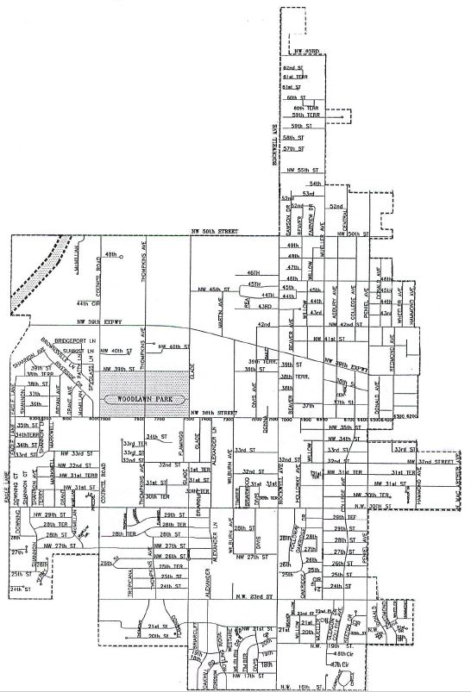
The City of Bethany

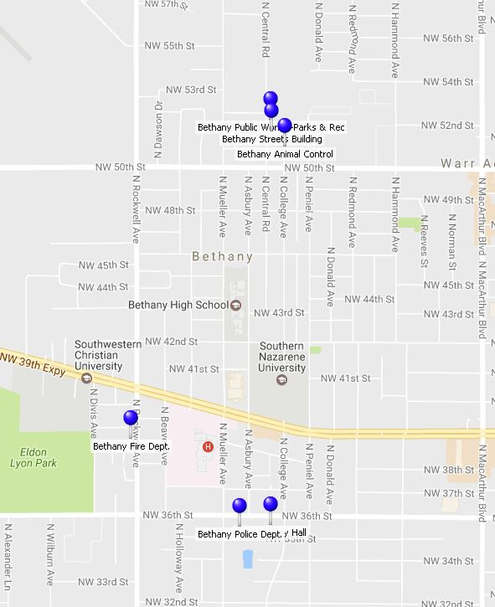
City of Bethany Public Facilities

City of Bethany
Emergency Task Assignments and Responsibilities
P = Agency with Primary Responsibility for Task A = Agency Assisting with Task
Responsible or Assisting Department / Office / Agency / Organization
Task | City of Bethany Administration & Departments |  |  |  |  |  |  |  |  |  |  | Other Local Agencies |  |  |  |  |  |  | State of Oklahoma Agencies and Departments |  |  |  |  |  |  |  |  |  |  |  | Federal Agencies
Task | Mayor | City Manager | Community Development | Economic  Development Authority | Emergency Management | Fire | Finance/City Clerk | Information Technology | Legal | Police | Public Works | Bethany EMS Contractor | Oklahoma County  Commissioners | Oklahoma County Emerg. Mgt. | Oklahoma County Sheriff | American Red Cross | Bethany Public Schools / Putnam City Schools | VOAD/NGO | Governor | ODEM | Medical Examiner | Health Dept. OSDH | ODMHSAS | Human Services DHS | Military Dept / National  Guard | 63rd WMD Civil Support  Team | ODOT | DPS | Homeland Security | ODEQ | FEMA | FBI | Homeland Security | Small Business  Administration | Housing & Urban  Development
Access control of restricted areas |  |  |  |  |  |  |  |  |  | P | A |  | A |  | A |  |  |  |  |  |  |  |  |  | A |  |  | A
Animal victim collection, mass care, return |  |  |  |  |  |  |  |  |  |  | P
Business relocation & recovery assistance |  |  | A | P |  |  |  |  |  |  |  |  |  |  |  |  |  |  |  |  |  |  |  |  |  |  |  |  |  |  |  |  |  | A
Cemetery lot coordination |  |  | P |  |  |  |  |  |  |  | A
Command post operations |  |  |  |  | A | P |  | A |  | P |  |  |  |  |  |  |  |  |  |  |  |  |  |  |  |  |  | A
Command post planning |  |  |  |  | P | A |  | A |  | A |  | A |  |  |  |  |  |  |  |  |  |  |  |  |  |  |  | A
Communications systems operations |  |  |  |  | A |  |  | A |  | P
Communications systems planning |  |  |  |  | P | A |  | A |  | A | A | A
Condemnation of non-repaired property |  | A | P
Continuity of local government | A | A |  |  | P |  |  |  |  |  |  |  |  | A
Counseling / disaster mental health |  |  |  |  |  | A |  |  | A | A |  |  |  |  |  | A |  | A |  |  |  |  | P | A
Damage assessment - private property |  |  |  |  | P |  |  |  |  |  |  |  |  | A |  | A
Damage assessment - public property |  |  |  |  | P |  |  |  |  |  |  |  | A | A
Debris clearance - private property |  | P
Debris clearance - public property |  |  |  |  |  |  |  |  |  |  | P |  | A
Debris removal - immediate from streets |  |  |  |  |  |  |  |  |  |  | P |  | A |  |  |  |  |  |  |  |  |  |  |  |  |  | A
Deceased victim operations |  |  |  |  |  |  |  |  |  | A |  | A |  |  |  |  |  |  |  |  | P | A
Decontamination |  |  |  |  |  | P |  |  |  |  |  | A |  |  |  |  |  |  |  |  |  | A |  |  |  | A |  |  |  | A
Disaster declaration - local | P | A |  |  | A |  | A
Disaster declaration - state | A |  |  |  |  |  |  |  |  |  |  |  |  |  |  |  |  |  | P | A
Disaster management & coordination - overall |  | A |  |  | P |  |  |  |  |  |  |  |  | A
Disaster public education |  |  |  |  | P | A |  |  |  | A |  |  |  | A |  | A |  |  |  | A |  |  |  |  |  |  |  |  |  |  | A
Disaster welfare inquiry operations |  |  |  |  |  | A |  |  |  | A |  |  |  |  |  | P |  |  |  |  | A
Donations management |  |  |  | A |  |  |  |  |  |  |  |  |  |  |  |  |  | P
Emergency Management planning |  | A |  |  | P | A |  |  |  | A |  |  | A | A |  |  |  |  |  | A |  |  |  |  |  |  |  |  | A |  | A |  | A
Emergency medical transport |  |  |  |  |  | A |  |  |  |  |  | P |  |  |  |  | A
Emergency medical treatment |  |  |  |  |  | A |  |  |  |  |  | P
Emergency medical triage |  |  |  |  |  | A |  |  |  |  |  | P
Emergency public information |  | A |  |  | A | P |  |  |  | P |  |  |  |  |  |  |  |  |  | A
Emergency purchasing |  | A |  |  |  |  | P
Engineering services and advice |  |  | P |  |  |  |  |  |  |  | A |  | A
EOC communications |  |  |  |  | P |  |  | A |  |  |  |  |  |  |  |  |  |  |  | A
EOC operation |  | A |  |  | P |  |  | A |  |  |  |  |  |  |  |  |  |  |  | A
EOC planning |  | A |  |  | P |  |  | A |  |  |  |  |  |  |  |  |  |  |  | A
Epidemic control coordination |  |  |  |  |  |  |  |  |  |  |  |  |  |  |  |  |  |  |  |  |  | P
Exercise planning |  |  |  |  | P | A |  |  |  | A |  |  |  | A
Financial coordination |  | A |  |  |  |  | P
Fire mitigation |  |  |  |  |  | P
Fire suppression |  |  |  |  |  | P |  |  |  |  | A |  |  |  |  |  |  |  |  | A
Food supply inspection |  |  |  |  |  |  |  |  |  |  |  |  |  |  |  |  |  |  |  |  |  | P
Funeral home coordination |  |  |  |  |  |  |  |  |  |  |  |  |  |  |  |  |  |  |  |  | P
Garbage disposal |  |  |  |  |  |  |  |  |  |  | P
Hazardous materials mitigation |  |  |  |  | A | P |  |  |  |  |  |  |  |  |  |  |  |  |  |  |  |  |  |  |  |  |  |  |  | A
Hazardous materials operations |  |  |  |  |  | P |  |  |  |  |  |  |  |  |  |  |  |  |  |  |  |  |  |  |  | A |  |  |  | A
Information Systems planning |  |  |  |  | A | A |  | P |  | A
Information Systems maintenance & repair |  |  |  |  |  |  |  | P

P = Agency with Primary Responsibility for Task A = Agency Assisting with Task
Responsible or Assisting Department / Office / Agency / Organization
Task | City of Bethany Administration & Departments |  |  |  |  |  |  |  |  |  |  | Other Local Agencies |  |  |  |  |  |  | State of Oklahoma Agencies and Departments |  |  |  |  |  |  |  |  |  |  |  | Federal Agencies
Task | Mayor | City Manager | Community Development | Economic  Development Authority | Emergency Management | Fire | Finance/City Clerk | Information Technology | Legal | Public works | Police | Bethany EMS Contractor | Oklahoma County  Commissioners | Oklahoma County Emerg. Mgt. | Oklahoma County Sheriff | American Red Cross | Bethany Public Schools / Putnam City Schools | VOAD/NGO | Governor | ODEM | Medical Examiner | Health Dept. OSDH | ODMHSAS | Human Services DHS | Military Dept / National  Guard | 63rd WMD Civil Support  Team | ODOT | DPS | Homeland Security | ODEQ | FEMA | FBI | Homeland Security | Small Business  Administration | Housing & Urban  Development
Law enforcement |  |  |  |  |  |  |  |  |  |  | P |  |  |  | A |  |  |  |  |  |  |  |  |  | A |  |  | A |  |  |  | A
Legal coordination |  | A |  |  |  |  |  |  | P
Long term recovery |  |  |  |  |  |  |  |  |  |  |  |  |  |  |  | A |  | P |  |  |  |  |  |  |  |  |  |  |  |  |  |  |  |  | A
Mapping (GIS) |  |  | A |  | A | A |  | P
Mass care operations |  |  |  |  |  |  |  |  |  | A |  |  |  |  |  | P | A | A
Mass care planning |  |  |  |  | A |  |  |  |  |  |  |  |  | A |  | P
Mass inoculation |  |  |  |  |  |  |  |  |  |  |  |  |  |  |  |  |  |  |  |  |  | P
Portable restrooms |  |  |  |  |  |  |  |  |  | P
Resource coordination - Federal |  |  |  |  | A |  |  |  |  |  |  |  |  | A |  |  |  |  |  | A |  |  |  |  |  |  |  |  |  |  | P
Resource coordination - local |  |  |  |  | P |  |  |  |  |  |  |  |  | A |  |  |  |  |  | A |  |  |  |  |  |  |  |  |  |  | A
Resource coordination - State |  |  |  |  | A |  |  |  |  |  |  |  |  | A |  |  |  |  |  | P |  |  |  |  |  |  |  |  |  |  | A
Sanitary standards enforcement |  |  |  |  |  |  |  |  |  |  |  |  |  |  |  |  |  |  |  |  |  | P
Search & rescue operations |  |  |  |  |  | P |  |  |  | A | A |  |  |  |  |  |  |  |  |  |  |  |  |  |  |  |  |  |  |  | A
Security of vital data |  | A | A | A | A | A | A | P | A | A | A
Security of vital facilities |  |  |  |  |  |  |  |  |  |  | P |  |  |  | A |  |  |  |  |  |  |  |  |  | A |  |  | A |  |  |  | A
Severe weather observation |  |  |  |  | P
Storm drain maintenance & repair |  |  |  |  |  |  |  |  | A | P
Street & bridge repair |  |  |  |  |  |  |  |  |  | P |  |  | A |  |  |  |  |  |  |  |  |  |  |  |  |  | P
Terrorism mitigation |  |  |  |  | A | A |  |  |  |  | P |  |  |  | A |  |  |  |  | A |  |  |  |  | A |  |  | P | A |  | A | P | A
Terrorism operations/response |  |  |  |  | A | P |  |  |  |  | P | A |  |  | A |  |  |  |  | A |  | A |  |  |  | A |  | P | A | A | A | P | A
Terrorism preparedness |  |  |  |  | P | A |  |  |  |  | P |  |  |  | A |  |  |  |  | A |  |  |  |  |  |  |  | A | P |  | A | A | P
Terrorism recovery |  |  |  |  | A |  |  |  |  |  | P
Traffic control |  |  |  |  | A |  |  |  |  | A | P |  |  |  | A |  |  |  |  |  |  |  |  |  | A |  |  | A
Transportation of non-injured victims |  |  |  |  |  |  |  |  |  | A |  |  |  |  |  |  | P
Vehicle maintenance |  |  |  |  |  |  |  |  |  | P
Victim lodging assistance |  |  |  |  |  |  |  |  |  |  |  |  |  |  |  | P |  | A
Victim monetary assistance |  |  |  |  |  |  |  |  |  |  |  |  |  |  |  | A |  | A |  | A |  |  |  |  |  |  |  |  |  |  | P |  |  | A
Victim provisions assistance |  |  |  |  |  |  |  |  |  |  |  |  |  |  |  | P |  | A
Volunteer manpower resource management |  |  |  |  |  |  |  |  |  |  |  |  |  |  |  | A |  | P
Warning system maintenance - local |  |  |  |  | P |  |  |  |  | A
Warning system operation - local |  |  |  |  | P | A |  |  |  |  | A
Wastewater collection system maint. & repair |  |  |  |  |  |  |  |  |  | P
Water production/distribution system repair |  |  |  |  |  |  |  |  |  | P
Water supply inspection |  |  |  |  |  |  |  |  |  | P |  |  |  |  |  |  |  |  |  |  |  |  |  |  |  |  |  |  |  | P

Disaster Task Assignments
by City of Bethany Department
Department/Agency Primary Tasks Assisting Tasks
City of Bethany Mayor | Disaster declaration - local | Continuity of local government
 |  | Disaster declaration - state
City of Bethany City Manager | Debris clearance - private property | Legal coordination
 |  | Disaster declaration - local
Disaster management & coordination -
overall
 |  | Financial coordination
 |  | Emergency Management planning
 |  | Condemnation of non-repaired property
 |  | Continuity of local government
 |  | EOC operation
 |  | EOC planning
 |  | Emergency Public Information (PIO)
Security of vital data

Cemetery lot coordination
City of Bethany Community Development Dept. | Condemnation of non-repaired property | Security of vital data  Cemetery lot coordination
City of Bethany Community Development Dept. | Engineering services and advice | Security of vital data  Cemetery lot coordination
City of Bethany Community Development Dept. | Mapping (GIS) | Security of vital data  Cemetery lot coordination
City of Bethany Finance Dept./ Economic Development Authority | Business relocation & recovery assistance | Donations management
 |  | Security of vital data
City of Bethany Emergency  Management | Command post planning | Command post operations
City of Bethany Emergency  Management | Communications systems operations | Disaster declaration - local
City of Bethany Emergency  Management | Communications systems planning | Emergency public information
City of Bethany Emergency  Management | Continuity of local government | Hazardous materials mitigation
City of Bethany Emergency  Management | Damage assessment - private property | Information systems planning
City of Bethany Emergency  Management | Damage assessment - public property | Mapping (GIS)
City of Bethany Emergency  Management | Disaster management & coordination -  overall | Mass care planning
City of Bethany Emergency  Management | Disaster public education | Resource coordination - federal
City of Bethany Emergency  Management | Emergency Management planning | Resource coordination - State
City of Bethany Emergency  Management | EOC communications | Security of vital data
City of Bethany Emergency  Management | EOC operation | Terrorism mitigation
City of Bethany Emergency  Management | EOC planning | Terrorism operations/response
City of Bethany Emergency  Management | Exercise planning | Traffic control
City of Bethany Emergency  Management | Resource coordination - local
City of Bethany Emergency  Management | Severe weather observation
City of Bethany Emergency  Management | Warning system maintenance - local
City of Bethany Emergency  Management | Warning system operation - local
City of Bethany Emergency  Management | Terrorism preparedness
City of Bethany Emergency  Management | Terrorism recovery
City of Bethany EMS  Contractor | Emergency medical transport | Deceased victim operations
City of Bethany EMS  Contractor | Emergency medical treatment | Decontamination
City of Bethany EMS  Contractor | Emergency medical triage | Terrorism operations/response

Disaster Task Assignments
by City of Bethany Department
City of Bethany Finance and  Accounting Dept. | Emergency purchasing | Disaster declaration - local
City of Bethany Finance and  Accounting Dept. | Security of vital data | Financial coordination
City of Bethany Fire Dept. | Decontamination | Emergency medical transport
City of Bethany Fire Dept. | Fire mitigation | Emergency medical treatment
City of Bethany Fire Dept. | Fire suppression | Emergency medical triage
City of Bethany Fire Dept. | Hazardous materials mitigation | Disaster public education
City of Bethany Fire Dept. | Hazardous materials operations | Exercise planning
City of Bethany Fire Dept. | Search & rescue operations | Terrorism preparedness
City of Bethany Fire Dept. | Command post operations | Command post planning
City of Bethany Fire Dept. | Emergency public information | Communications systems planning
City of Bethany Fire Dept. | Terrorism operations/response | Counseling / disaster mental health
 |  | Warning system operation - local
 |  | Terrorism mitigation
 |  | Emergency Management planning
 |  | Information systems planning
 |  | Disaster welfare inquiries
 |  | Security of vital data
City of Bethany Information  Technology Dept. | Information systems planning | Command post planning & operations
City of Bethany Information  Technology Dept. | Information systems maintenance & | Communications systems planning & ops
City of Bethany Information  Technology Dept. | Security of vital data | Engineering services and advice
 | Mapping (GIS) | EOC Communications & Operation
City of Bethany Legal Dept. | Legal coordination
City of Bethany Public Works Dept. | Portable restrooms | Mass care operations
City of Bethany Public Works Dept. |  | Security of vital data
 |  | Cemetery lot Coordination
 |  | Damage assessment - public property
 |  | Debris Removal-Immediate from streets
 |  | Transportation of non-injured victims
City of Bethany Police Dept. | Access control of restricted areas | Disaster public education
City of Bethany Police Dept. | Law enforcement | Exercise planning
City of Bethany Police Dept. | Security of vital facilities | Warning system operation - local
City of Bethany Police Dept. | Traffic control | Command post planning
City of Bethany Police Dept. | Terrorism preparedness, mitigation, and  response | Communications systems planning
 | Command post operations | Counseling / disaster mental health
 | Emergency public information | Information systems planning
 |  | Search & rescue operations
Animal victim collection, mass care,
return
 |  | Security of vital data
 |  | Emergency Management planning
City of Bethany Public Utilities  Dept. | Storm drain maintenance & repair | Engineering services and advice
City of Bethany Public Utilities  Dept. | Water production/distribution system  repair | Security of vital data
City of Bethany Public Utilities  Dept. | Wastewater collection system maint. &  repair | Fire Suppression
Water Supply Inspection
City of Bethany Public Works  Dept. |  | Access control of restricted areas
City of Bethany Public Works  Dept. | Debris clearance - public property | Cemetery lot coordination
City of Bethany Public Works  Dept. | Debris removal - immediate from streets | Communications systems planning
City of Bethany Public Works  Dept. | Garbage disposal | Engineering services and advice
City of Bethany Public Works  Dept. | Vehicle maintenance | Security of vital data
City of Bethany Public Works  Dept. | Street & bridge repair | Search & rescue operations
City of Bethany Risk  Management Dept. |  | Damage assessment - public property
 |  | Security of vital data

Disaster Task Assignments
by County Department/Local Agency
Department/Agency Primary Tasks Assisting Tasks
American Red Cross  Heart of Oklahoma Chapter | Counseling / disaster mental health | Victim monetary assistance
American Red Cross  Heart of Oklahoma Chapter | Disaster welfare inquiry operations | Damage assessment - private property
American Red Cross  Heart of Oklahoma Chapter | Long term recovery | Disaster public education
American Red Cross  Heart of Oklahoma Chapter | Mass care operations | Volunteer manpower resource management
American Red Cross  Heart of Oklahoma Chapter | Mass care planning
American Red Cross  Heart of Oklahoma Chapter | Victim lodging assistance
American Red Cross  Heart of Oklahoma Chapter | Victim provisions assistance
Oklahoma County  Commissioners |  | Access control of restricted areas
 |  | Damage assessment - public property
 |  | Debris clearance - public property
 |  | Debris removal - immediate from streets
 |  | Emergency Management planning
 |  | Engineering services and advice
 |  | Street & bridge repair
Oklahoma County  Emergency Management |  | Continuity of local government
 |  | Damage assessment - private property
 |  | Damage assessment - public property
Disaster management & coordination -
overall
 |  | Disaster public education
 |  | Emergency Management planning
 |  | Exercise planning
 |  | Mass care planning
 |  | Resource coordination - federal
 |  | Resource coordination - local
 |  | Resource coordination - State
Oklahoma County Sheriff |  | Access control of restricted areas
 |  | Law enforcement
 |  | Security of vital facilities
 |  | Terrorism mitigation
 |  | Terrorism operations/response
 |  | Terrorism preparedness
 |  | Traffic control
Bethany Public Schools /  Putnam City Schools | Transportation of non-injured victims | Mass care operations
Voluntary Organizations  Active in Disaster | Donations management | Counseling / disaster mental health
Voluntary Organizations  Active in Disaster | Long term recovery | Mass care operations
Voluntary Organizations  Active in Disaster | Volunteer manpower resource  management | Victim lodging assistance
 |  | Victim monetary assistance
 |  | Victim provisions assistance

Disaster Task Assignments
by State Agency
Department/Agency Primary Tasks Assisting Tasks
Oklahoma Governor’s Office | Disaster declaration - state
Oklahoma Emergency | Resource coordination - State | Disaster declaration - state
Management Dept. |  | Disaster public education
 |  | Emergency Management planning
 |  | Emergency public information
 |  | EOC communications
 |  | EOC operation
 |  | EOC planning
 |  | Fire Suppression
 |  | Resource coordination - federal
 |  | Resource coordination - local
 |  | Terrorism operations/response
 |  | Terrorism preparedness
 |  | Victim monetary assistance
 |  | Warning system maintenance - local
 |  | Warning system operation - local
Oklahoma Dept. of  Environmental Quality |  | Decontamination
 |  | Hazardous materials mitigation
 |  | Hazardous materials operations
 |  | Terrorism operations/response
 |  | Water supply inspection
Oklahoma State Health  Dept. | Epidemic control coordination
Oklahoma State Health  Dept. | Food supply inspection | Decontamination
Oklahoma State Health  Dept. | Mass inoculation | Terrorism operations/response
Oklahoma State Health  Dept. | Sanitary standards enforcement
Oklahoma Homeland | Terrorism preparedness | Emergency Management planning
Security Dept. |  | Terrorism mitigation
 |  | Terrorism operations/response
Oklahoma Dept. of Human  Svcs |  | Counseling / disaster mental health
Oklahoma Medical  Examiner’s Office | Deceased victim operations | Disaster welfare inquiry operations
Oklahoma Medical  Examiner’s Office | Funeral home coordination
Oklahoma Dept. of Mental  Health and Substance Abuse Services | Counseling / disaster mental health
Oklahoma National Guard |  | Access control of restricted areas
 |  | Law enforcement
 |  | Security of vital facilities
 |  | Terrorism mitigation
 |  | Traffic control
Oklahoma National Guard -  63rd Weapons of Mass Destruction Civil Support |  | Decontamination
 |  | Hazardous materials operations
 |  | Terrorism operations/response
Oklahoma Dept. of Public  Safety | Terrorism mitigation | Access control of restricted areas
Oklahoma Dept. of Public  Safety | Terrorism operations/response | Command Post operations
 |  | Law enforcement
 |  | Security of vital facilities
 |  | Terrorism preparedness
 |  | Traffic control
Oklahoma Dept. of  Transportation | Street & bridge repair | Debris removal - immediate from streets

Disaster Task Assignments
by Federal Agency
Department/Agency Primary Tasks Assisting Tasks
Federal Bureau of  Investigation | Terrorism mitigation | Law enforcement
Federal Bureau of  Investigation | Terrorism operations/response | Security of vital facilities
 |  | Terrorism preparedness
Federal Emergency  Management Agency | Resource coordination - federal | Disaster public education
Federal Emergency  Management Agency | Victim monetary assistance | Emergency Management planning
 |  | Resource coordination - local
 |  | Resource coordination - State
 |  | Search & rescue operations
 |  | Terrorism mitigation
 |  | Terrorism operations/response
 |  | Terrorism preparedness
Federal Homeland Security | Terrorism preparedness | Emergency Management planning
Dept. |  | Terrorism mitigation
 |  | Terrorism operations/response
Federal Housing & Urban  Development | Long term recovery
Federal Small Business  Administration |  | Business relocation & recovery assistance
 |  | Victim monetary assistance

Interface Between Local, State, and Federal Emergency Planning
Plan Location |  |  | Lead Agency and/or Department
Federal & State Emergency Support Function | Annex | City of Bethany | State of Oklahoma | United States Government
1-Transportation | E | Bethany Public Schools / Putnam City Schools | Dept of Transportation | US Dept. of Transportation
2-Communications | B,C | Emergency Management | Dept of Emergency Management | Dept of Homeland Security/National Communications System
3-Public Works & Engineering | J | Public Works Dept | Dept of Transportation | Dept of Defense/US Army Corps of Engineers
4-Firefighting | K | Fire Dept | Dept of Agriculture | US Dept of Agriculture/Forest Service
5.Emergency Management | A,D,EP, A | Emergency Management | Dept of Emergency Management | Federal Emergency Management Agency
6-Mass Care, Emergency Assistance, Housing, and Human Services | F | American Red Cross,  Heart of Oklahoma Chapter | Dept of Emergency Management | Federal Emergency Management Agency
7-Logistics Management and Resource Support | N | Emergency Management | Dept of Emergency Management | General Services Admin.
8-Public Health & Medical Services | H | Oklahoma County Health Dept | State Dept of Health | Dept of Health & Human Services
9-Search & Rescue | K | Fire Dept | Dept of Public Safety | Federal Emergency Management Agency
10-Oil and Hazardous Material Response | H, K | Fire Dept | Dept of Environmental Quality | Environmental Protection Agency
11-Agriculture and Natural Resources | J | Public Works | Dept. of Agriculture | Dept of Agriculture
12-Energy |  | Emergency Management | Corporation Commission | Dept of Energy
13-Public Safety & Security | I | Police Dept | Dept of Public Safety | Dept of Justice
14-Long-Term Community Recovery | P | Emergency Management | Dept of Emergency Management | Federal Emergency Management Agency
15-External Affairs | D | Police and Fire Dept. | Dept of Emergency Management | Dept of Homeland Security
16-Volunteer and Donations Management | N | VOAD/NGO | Dept of Emergency Management | Federal Emergency Management Agency

Appendix 5 to the Bethany, OK Emergency Operations Plan
OKLAHOMA INTRASTATE MUTUAL AID COMPACT
The “Oklahoma Intrastate Mutual Aid Compact” (63 O.S. 2006, Section 695.1) created a system of intrastate mutual aid between participating jurisdictions, including Sovereign Tribal Nations, in the State of Oklahoma.

This Compact is for all resources that may be available in a jurisdiction during an emergency or disaster including Law Enforcement, Fire Service, Emergency Medical Service, Public Works, Emergency Management and others.

Each jurisdiction must designate an authorized representative and alternates to request assistance from other jurisdictions and to authorize deployment of resources to other jurisdictions.

Emergencies transcend political jurisdictional boundaries and intergovernmental coordination is essential for the protection of lives and property and for best use of available assets both public and private. This Compact provides for mutual assistance among the participating jurisdictions in the prevention of, response to, and recovery from, any disaster that results in a formal state of emergency in a participating jurisdiction subject to that participating jurisdiction’s criterion for declaration. This compact also provides for mutual cooperation among the participating jurisdictions in conducting disaster-related exercises, testing or other training activities outside actual declared emergency periods.

This Compact provides no immunity, rights or privileges for any individual responding to a state of emergency that is not requested and/or authorized to respond by a participating jurisdiction.
All jurisdictions within the state are automatically a part of the statewide mutual aid system. A jurisdiction within the state may elect not to participate or to later withdraw from the system upon enacting an appropriate resolution by its governing body declaring that it elects not to participate in the statewide mutual aid system and providing a copy of the resolution to the Oklahoma Department of Emergency Management. This Compact does not preclude participating jurisdictions from entering into supplementary agreements with another jurisdiction and does not affect any other agreement to which a jurisdiction may currently be a party or decide to be a party to.

Many disasters begin as emergencies where local jurisdictions require fire service and/or law enforcement assistance. These services would normally be requested and provided at the department level as normal day-to-day operations with no reimbursement. If an incident response expands beyond a normal day-to-day emergency into a disaster situation, reimbursement for mutual aid services may be necessary and will be in accordance with the Federal Emergency Management Agency reimbursement policy.

In support of the Emergency Management Compact, Section 684.1 et seq of Title 63 of the Oklahoma Statutes, the Governor or the Governor’s representative may request mutual aid assistance from local jurisdictions for other states or their jurisdictions. In such situations, the assisting local jurisdiction shall be considered an agent of the State.

On behalf of the chief elected officer of each jurisdiction participating in the Compact, the legally designated jurisdiction official who is assigned responsibility for emergency management will be responsible for the formulation of the appropriate plans and procedures necessary to implement the Compact.

- Each jurisdiction has the responsibility to formulate procedural plans and programs for interjurisdictional cooperation in the performance of the responsibilities listed in this Compact. In formulating such plans, and in carrying them out, the jurisdictions, insofar as practical, shall:

  - Review individual jurisdictional hazards analyses and, to the extent reasonably possible, determine all those potential emergencies the jurisdictions might jointly suffer, whether due to natural or man-made disasters or emergencies;

  - Review jurisdictions’ individual emergency plans and develop a plan that will determine the mechanism for the interjurisdictional management and provision of assistance concerning any potential emergency;

  - Develop interjurisdictional procedures to fill any identified gaps and to resolve any identified inconsistencies or overlaps in existing or developed plans;

  - Assist in warning communities adjacent to or crossing the jurisdictional boundaries;

  - Protect and assure uninterrupted delivery of services, medicines, water, food, energy and fuel, search and rescue, and critical lifeline equipment, and resources, both human and material;

  - Inventory and set procedures for the interjurisdictional loan and delivery of human and material resources, together with procedures for reimbursement or forgiveness; and

  - Provide, to the extent authorized by law, for temporary suspension of any statutes or ordinances that restrict the implementation of the above responsibilities.

  - All jurisdictions should use and conform to the current national standard for on-scene management and command systems.

- The authorized representative of a jurisdiction (appointed/authorized by the jurisdiction) may request assistance of another jurisdiction by contacting the authorized representative of that jurisdiction. The provisions of the Oklahoma Intrastate Mutual Aid Compact shall apply only to requests for assistance made by and to authorized representatives. Requests may be verbal or in writing. If verbal, the request shall be confirmed in writing within thirty
(30) days of the verbal request. Requests shall provide the following information:

- A description of the emergency service function for which assistance is needed, including, but not limited to, fire services, law enforcement, emergency medical, transportation, communications, public works and engineering, building inspection, planning and information assistance, mass care, resource support, health and medical services, and search and rescue;

- The amount and type of personnel, equipment, materials and supplies needed and a reasonable estimate of the length of time they will be needed; and

- The specific place and time for staging of the assisting party's response and a point of contact at that location.

- There shall be frequent consultation between jurisdiction officials who have assigned

emergency management responsibilities and other appropriate representatives of the jurisdictions with affected jurisdictions, with free exchange of information, plans, and resource records relating to emergency capabilities.

- Jurisdictions shall not be obligated under the Compact to send the requested assistance, and assistance may be withdrawn at any time in the sole and absolute discretion of the jurisdiction.

- Any jurisdiction requested to render mutual aid or conduct exercises and training for mutual aid shall take such action as is necessary to provide and make available the resources covered by the Oklahoma Intrastate Mutual Aid Compact in accordance with the terms hereof; provided that it is understood that the jurisdiction rendering aid may withhold resources to the extent necessary to provide reasonable protection for its own jurisdiction.

- Each jurisdiction shall afford the emergency forces of any jurisdiction, while operating within its jurisdictional limits under the terms and conditions of the Compact, the same powers, duties, rights, and privileges as are afforded forces of the jurisdiction in which they are performing emergency services. Emergency forces will continue under the command and control of their regular leaders, but the organizational units will come under operational control of the emergency services authorities of the jurisdiction receiving assistance and must report to the incident check-in location for assignment.

- Whenever any person holds a license, certificate, or other permit issued by any jurisdiction evidencing the meeting of qualifications for professional, mechanical, or other skills, and when such assistance is requested by the receiving jurisdiction, such person shall be deemed licensed, certified, or permitted by the jurisdiction requesting assistance to render aid involving such skill to meet a declared emergency or disaster, subject to such limitations and conditions as the requesting jurisdiction may prescribe by executive order or otherwise.

- Officers or employees of a jurisdiction rendering aid in another jurisdiction pursuant to the Oklahoma Intrastate Mutual Aid Compact shall be considered within the scope of employment of the requesting jurisdiction for tort liability and immunity purposes. No jurisdiction or its officers or employees rendering aid in another jurisdiction pursuant to the Compact shall be liable on account of any act or omission in good faith on the jurisdiction of such forces while so engaged or on account of the maintenance or use of any equipment or supplies in connection therewith. Good faith shall not include willful misconduct, gross negligence, or recklessness.

- Each jurisdiction shall provide for the payment of compensation and death benefits to injured members of the emergency forces of that jurisdiction and representatives of deceased members of such forces who sustain injuries or are killed while rendering aid pursuant to the Oklahoma Intrastate Mutual Aid Compact, in the same manner and on the same terms as if the injury or death were sustained within its own jurisdiction.

- Any jurisdiction rendering aid in another jurisdiction pursuant to the Oklahoma Intrastate Mutual Aid Compact shall be reimbursed by the jurisdiction receiving such aid for any loss or damage to or expense incurred in the operation of any equipment and the provision of any service in answering a request for aid and for the costs incurred in connection with such requests; provided, that any aiding jurisdiction may assume in whole or in part such loss, damage, expense, or other cost, or may loan such equipment or donate such services to the receiving jurisdiction without charge or cost; and provided further, that any two or more jurisdictions may enter into supplementary agreements establishing a different allocation of

costs among those jurisdictions. Compensation expenses shall not be reimbursable under this section.

- Plans for the orderly evacuation and interjurisdiction reception of portions of the civilian population as the result of any emergency or disaster of sufficient proportions to so warrant, shall be worked out and maintained between the jurisdictions of the Oklahoma Intrastate Mutual Aid Compact and the emergency management or services directors of the various jurisdictions where any type of incident requiring evacuations might occur.

Such plans shall be put into effect by request of the jurisdiction from which evacuees come and shall include the manner of transporting such evacuees, the number of evacuees to received in different areas, the manner in which food, clothing, housing, and medical care will be provided, the registration of evacuees, the providing of facilities for the notification of relatives or friends, and the forwarding of such evacuees to other areas or the bringing in of additional materials, supplies, and all other relevant factors.

- Requests for aid will be documented using the following form at Appendix 1 that designates the Requesting Jurisdiction, the resources requested, Assisting Jurisdiction, and the available resources and applicable costs for reimbursement, if any, signed and dated by both jurisdictions.

Glossary and Acronyms
63rd WMD-CST | Oklahoma National Guard asset that supports civil authorities at a domestic CBRNE incident site by identifying CBRNE agents/substances, assessing current and projected consequences, advising on response measures, and assisting with requests for additional support.
9-1-1 | Universal telephone number to reach dispatch centers for emergency response agencies such as law enforcement, fire and rescue, and emergency medical services.
ABLE | Oklahoma Alcohol, Beverage, and Liquor Enforcment Agency
AED | Automatic External Defibrillators
AFRCC | United States Air Force Rescue Coordination Center is the single point of contact for the coordination of federal resources involved in search and rescue (SAR) missions in all 48 Continental United States (CONUS), and in some cases, provides mutual assistance to US Coast Guard, Canada, and Mexico. Headquarters are in Langley, VA.
ALARA | As Low As Reasonably Achievable. A principle that states all efforts be aimed at keeping radiation exposure as low as reasonably achievable.
All-Hazards Plan | An all-hazards plan is an emergency operations plan (EOP). It recognizes flexibility in disaster and hazards planning and the need to combine hazard specific activities with a core approach that encompasses responses that are appropriate to all hazards. Refer to Federal Emergency Management Agency (FEMA) publication, Guide for All-Hazards Emergency Operations Planning: State and Local Guide SLG 101. Contributed by Tom May. (USA)
ALO | Agency Liaison Officer: Persons appointed by Director of designated state agencies who shall operate under the Director, Department of Civil Emergency Management, during emergency periods to coordinate an agency's actions for providing effective relief and assistance in accordance with this plan and Public Law 93-288.
Amateur Radio Emergency Service  (ARES) | A volunteer emergency radio communication service provided by ham radio operators  worldwide whenever there is disaster. ARES provides communications support for private entities such as American Red Cross and The Salvation Army for disaster preparedness and recovery.
APRS | Automatic Position Reporting System is a component of amateur (ham) radio where a device  such as Global Positioning System is fitted to a radio such that the location of the device is constantly transmitted without human intervention.
ARC | American Red Cross
Atmosphere-Supplying Respirator | A respirator that supplies the respirator user with breathing air from a source independent of the ambient atmosphere, and includes supplied-air respirators (SARs) and self-contained breathing apparatus (SCBA) units.
Attraction Search | Search based on the idea that the victim is alive, willing to be found and will, upon hearing or seeing signs of rescue, make them self and their position known.
Basic Life Support (BLS) | Level of emergency medical care, which by Oklahoma State Health Department regulations includes cardiopulmonary resuscitation (CPR) and utilization of Semi-Automated advisory defibrillator (SAAD)
B-NICE | Five categories of terrorist incidents: Biological, Nuclear, Incendiary, Chemical, and Explosives.
CAD | Computer Aided Dispatch. Commonly used at radio communications dispatch centers and terminals.
Catastrophic Disaster | An event that results in large numbers of deaths and injuries; causes extensive damage or destruction of facilities that provide and sustain human needs; produces an overwhelming demand on State and local response resources and mechanisms; causes a severe long-term effect on general economic activity; and severely affects State, local, and private-sector capabilities to begin and sustain response activities.
Catastrophic Disaster Response  Group (CDRG) | CDRG's purpose is to coordinate operations of those Federal departments and agencies with  functional responsibilities during disaster operations under the Federal Response Plan (FRP, q.v.). Lead agency is the Federal Emergency Management Agency (FEMA).
CBRNE | Chemical, Biological, Radiological, Nuclear or Explosives.
CB-RRT | Chemical Biological Rapid Reponse Team. Public Law 104-201, Section 1414 et seq. mandates that the Department of Defense organize a Chemical and Biological Rapid Response Team to be a joint organization to provide chemical and biological defense support to civil authorities.
OCSO | Oklahoma County Sheriffs Department

Centers for Disease Control and Prevention (CDC) | A federal agency in the Department of Health and Human Services (HHS). The National Pharmaceutical Stockpile (NPS, q.v.) is a function of the CDC. Contributed by Tom May. (USA)
CERT (1) | Community Emergency Response Team. A team of local citizens, with or without an organizational affiliation, trained in a range of basic emergency response skills and techniques to assist their community in times of disaster or other emergency. CERT training is local to national standards that are available from the Federal Emergency Management Agency (FEMA). CERT is one of the Citizen Corps programs designated to help fulfill the President’s call for community service
CERT (2) | An Internet emergency response team. The Defense Advanced Research Projects Agency  (DARPA), sponsors of the Internet, established the CERT® Coordination Center (CERT®/CC) in 1988 at the Software Engineering Institute (SEI), a part of Carnegie Mellon University.  CERT®/CC serves the Internet community with a single organization that can coordinate responses to security incidents on the Internet. In response to a security incident CERT®/CC establishes and maintains communication with affected sites and engages experts who can diagnose and solve security problems.
CFR | Code of Federal Regulations
Chain of Command | A series of management positions in order of authority.
CHEMTREC | Chemical Transportation Emergency Center. A service operated by the Chemical Manufactures Association to provide information and other assistance to emergency responders.
CHIP | Capability and Hazard Identification Program
Civil Air Patrol (CAP) | Civil Air Patrol: Missions include: Aerial reconnaissance, airborne imagery, disaster relief, damage assessment, air and ground transportation, communications network, aerial search and rescue.
OCHD | Oklahoma County Health Department- An Oklahoma agency promoting and improving the health of the community by monitoring the health status of the community, identifying and responding the health threats, providing timely and accurate information to the public and partners, enforcing laws that protect health, and providing quality services to prevent and control disease.
Cold Zone | With respect to control zones for a hazardous materials incident and to the Emergency  Response Guide , the area where the command post and support functions that are necessary to control the incident are located. This is also referred to as the clean zone, green zone or support zone in other documents. EPA Standard Operating Safety Guidelines, OSHA 29 CFR  §1910.120, NFPA 472.
Command | The act of directing, managing and/or controlling personnel and resources by virtue of explicit  legal, agency or delegated authority. The term "command" is also used to describe the Incident Commander managing the incident, i.e., "Broadway Command".
Command Staff | Under the Incident Command System, a normalized Command Staff consists of an Information Officer, a Safety Officer, and a Liaison Officer. The positions on the Command Staff directly serve the Incident Commander. As distinct from a localized field incident, a disaster that activates an emergency response by a business entity or a governmental jurisdiction such as a city, county or school district may require a Command Staff that also includes a Legal Adviser, an Inspector General, a Fiscal Policy Officer, a Labor Relations Officer, and others as may be appropriate to emergency conditions for the Incident Commander, City/County Manager, or other executive officer to carry out authorized duties.
Community Shelter | A weather shelter designed for multiple persons, not all of the same family or living quarters. Compare with individual shelter.
Consequence Management | Measures to protect public health and safety, restore essential services and provide emergency relief to business and individuals affected by the consequences of a crisis, such as an act of terrorism. Compare with crisis management.
Contamination | The deposit of hazardous material (radioactive, chemical or biologic) on the surfaces of structures, areas, objects, animals, or people following an incident causing the release and distribution of such material. See also decontamination.
Continuity of Government (COG) | The internal efforts taken at the policy and/or executive level of a national, state or local governmental agency or entity to assure the continuity of essential functions across a wide range of potential emergencies by providing for: succession to office and emergency delegations of authority in accordance with applicable law; safekeeping of essential resources, facilities, and records; and establishment of emergency operating capabilities.

CPG | Civil Preparedness Guide. General series of FEMA publications designed for public education concerning emergencies and disasters.
Crisis Communication | A process of managing the provision of internal and external information to others during a crisis event. Crisis communications include managing the message, the timing, and the channels involved in crisis information dissemination. Good crisis management is necessary to communicate effectively with the media, employees, customers and stakeholders. The crisis communications function should facilitate the rapid de-escalation of the crisis through timely and effective communications methods
Crisis Management | Measures to identify, acquire, and plan the use of resources needed to anticipate, prevent,  and/or resolve a crisis or an act of terrorism. Compare with consequence management.
Crisis Relocation Plan | Regional plans developed during the Cold War for mass relocation of population away from high-risk target areas. CRP's are no longer valid plans.
Critical Processes, Functions or Data | Business processes or supporting data which could not be interrupted or unavailable for any significant period (generally 0-24 hours) without jeopardizing operation of the organization. Time frames depend on the organization but these generally represent activities that are vital to the operation of the organization. Sometimes called High Priority Tasks. Contributed by Steve Davis.
DAC | Disaster Application Center
Damage Assessment | The process of assessing the physical damages resulting from a disaster or emergency and the resulting recovery time and cost estimates. A damage assessment may also serve as the basis for the Governor’s request to the President for a declaration of Emergency or Major Disaster. Metrics a monetary figure for repair costs and a time estimate for recovery.
Damage, Destroyed | A classification for an item or building that is a total loss or is damaged to the extent that it is not usable and not economically repairable. Used by FEMA in damage assessments. Metrics Monetary value of loss.
Damage, Major | This term is used by the Federal Emergency Management Agency (FEMA) to categorize an item or a building that has been damaged to the extent that it is no longer usable and may be returned to service only with extensive repairs. Contributed by Steve Davis. ( International )
Damage, Minor | FEMA Category where an item or building is damaged and may only be used under limited conditions, but may be restored with minor repairs.
Declaration (Disaster Declaration) | The formal action by the President to make a State eligible for major disaster or emergency assistance under the Robert T. Stafford Relief and Emergency Assistance Act, Public Law 93- 288, as amended.
Decontamination | The reduction or removal of hazardous material (radioactive, chemical or biologic) from a structure, area, object, animal or person. Appropriate decontamination practice may be simple or complex. When complex, the need is for teams with specialized skills, equipment and supplies. Decontamination may be accomplished by: 1) treating the contaminated surfaces so as to remove or decrease the potency of the contaminating material, 2) letting the material stay in place until radioactivity is decreased as a result of natural decay, or until adverse chemical or biological properties naturally dissipate or dilute, 3) covering the contaminated surfaces, 4) flushing with water. Poor management of decontamination may result in wide spread contamination. A decontamination procedure that physically removes hazardous material should not transfer that same material to another critical site or object in concentrated form.
Delegation of Authority | A statement provided to the Incident Commander (IC) by the agency executive delegating authority and assigning reponsibility. Many agencies require written Delegation of Authority to be given to Incident Commanders.
DEMOB | Demobilization. Used under the Incident Command Systemn (ICS).
Department of Homeland Security (DHS) | Department of Homeland Security. A cabinet level agency of the U.S. Government. The Secretary of DHS is considered in the top tier of the President's cabinet, along with the Secretary of State, the Secretary of the Treasury, the Secretary of Defense, and the Attorney General.
Department of Justice (DOJ) | An agency under the Attorney General, a senior member of the President's cabinet. DOJ's Office for Domestic Preparedness (ODP, q.v.) is the program office for enhancing the capacity of state and local jurisdictions to respond to and mitigate the consequences of incidents of domestic terrorism.
DEQ | Oklahoma Department of Environmental Quality

DHS (Federal) | Department of Homeland Security. A cabinet level agency of the U.S. Government. The Secretary of DHS is considered in the top tier of the President's cabinet members, along with the Secretary of State, the Secretary of the Treasury, the Secretary of Defense, and the Attorney General.
DHS (Oklahoma) | Oklahoma Department of Human Services
Direct Effects | The immediate emissions of a nuclear burst considered most hazardous; namely, blast, heat, and initial nuclear radiation. Structural damage may occur from the blast effect and fires may occur from the heat effect. The initial nuclear radiation includes neutrons which are highly penetrating of most materials and exceedingly harmful to living tissue. In addition, neutron radiation will induce radioactivity in certain elements causing them to emit hazardous radiation thereafter. Radioactive fallout is an indirect rather than a direct effect.
Dirty bomb | A dirty bomb is a conventional explosive attached to radioactive material, which is spread when the device goes off.
Disaster Field Office (DFO) | A temporary office in proximity to a disaster scene for administration of assistance and recovery programs by the Federal Emergency Management Agency (FEMA) in coordination with the state response team. Relates to Emergency Operations Vehicle (EOV) and to Mobile Emergency Response Support (MERS).
Disaster Medical Assistance Team (DMAT) | DMAT is usually a regional group of volunteer medical professionals and support personnel with the ability to quickly move into a disaster area and provide medical care. Under the control of the U.S. Public Health Service, DMAT's can rapidly deploy for any type of disaster that requires an immediate medial response.
Disaster Recovery Center (DRC) | A center set up in the disaster area where individual disaster victims may receive information concerning available assistance, and apply for the programs for which they are eligible.  Disaster Recovery Center will house representatives of the federal, state, and local agencies that deal directly with the needs of the individual victim.
Disaster Recovery Period | The time period between a disaster and a return to normal functions, during which the disaster recovery plan is employed.
Disaster Unemployment Assistance (DUA) | DUA is administered by the Department of Labor (DOL, q.v.). Under the DUA program any individual who is unemployed as a "direct" result of a major disaster that is presidentially declared is entitled to benefit assistance while such individual is unemployed. the rules for such assistance are found in the Federal Register, Vol. 68, No. 44 (March 6, 2003) on pages 10932 to 10937 at www.access.gpo.gov.
Disaster, Catastrophic | An event which produces severe and widespread damages of such a magnitude as to result in  the requirement for significant resources from outside the affected area to provide the necessary response. A Catastrophic Disaster is defined as an event that results in large numbers of deaths and injuries; causes extensive damage or destruction of facilities that provide and sustain human needs; produces an overwhelming demand on organizational, state, and local response resources and mechanisms; causes a severe long-term effect on general economic activity; and severely affects public and private sector capabilities to begin and sustain response activities.
Disaster, Major | As defined under P.L. 93-288, any natural catastrophe, (including any hurricane, tornado, storm, flood, high water, wind-driven water, tidal wave, tsunami, earthquake, volcanic eruption, landslide, mudslide, snowstorm, or drought), or, regardless of cause, any fire, flood, or explosion, in any part of the United States, which in the determination of the President causes damage of sufficient severity and magnitude to warrant major disaster assistance under this Act to supplement the efforts and available resources of States, local governments, and disaster relief organizations in alleviating the damage, loss, hardship, or suffering caused thereby
Disaster, Oklahoma | A dangerous event that causes significant human and economic loss and demands a crisis  response beyond the scope of any single agency or service, such as the fire or police department. Disasters are distinguished from emergencies by the greater level of response required. Disaster requires resources beyond those available locally.
DMIA Task Force | Data Management Improvement Act Task Force. A federal task force activated early 2002 to advise and recommend on implementing an electronic tracking system that detects terrorists, criminals, and dangerous cargo at hundreds of United States ports of entry, i.e. airports, seaports and land border crossings. The goal is to enhance border security while avoiding a negative impact on commercial and non-commercial traffic. The Task Force includes six federal agencies, two state and local government organizations, and nine private sector organizations.

DMORT | Disaster Mortuary Operational Response Team. DMORT assists local authorities during a Mass Fatality Incident. A Mass fatality incident can be defined as, ‘An incident where more deaths occur than can be handled by local resources’. DMORT is a program of the US Dept. of Health and Human Services that responds ONLY when requested. DMORT may be requested by any municipality in need by going through the departmental procedures for requesting federal assistance
Dosimeter | An instrument that measures a cumulative dose of radiation to determine hazardous  conditions. It may be used to indirectly measure the dose rate. One style of dosimeter in widespread use records only gamma radiation. It requires a separate charging box.
DOT | Oklahoma Department of Transportation
DPS | Oklahoma Department of Public Safety
DWI | Disaster Welfare Inquiry. Health and welfare inquiries sent to alleviate distress when normal direct communication between family members are disrupted and attempts to reestablish contact have failed.
Electromagnetic Pulse (EMP) | A phenomenon of a nuclear detonation which disrupts electrical transmission and radio sets in a similar manner to a direct hit by lightning.
EMAC | Emergency Management Assistance Compact. A legally binding mutual aid agreement and partnership between states that allows them to assist one another during emergencies and disasters.
Emergency | While an emergency may have been devastating, it is a dangerous event that does not result in a request for State or Federal assistance.
Emergency (as proclaimed by the Governor) | Whenever, in the opinion of the Governor, the safety of Oklahoma and its citizens requires the exercise of extreme measures due to an impending or actual disaster, he may declare an emergency to exist in the state, or any part of the state, in order to aid individuals and local government.
Emergency Action Levels (EALs) | A matrix devised to grade response to an escalating event. Event triggers levels of action to respond. EALs are a management system from the Nuclear Regulatory Commission (NRC) and the Federal Emergency Management Agency (FEMA) designed to assure that emergency plans are adequate and capable of being implemented in the event of a radiological emergency. EALs have been adapted for use by other agencies.
Emergency Alert System (EAS) | The national public warning system for emergencies. EAS allows satellite, broadcast and cable to send and receive alerting information. EAS has multiple-source monitoring for emergency alerts and a standard protocol for messages. Relates to the Federal Communications Commission (FCC), the National Weather Service (NWS), and the Federal Emergency Management Agency (FEMA).
Emergency Locator Transmitter  (ELT) | Homing beacon radio device on board all aircraft which automatically activates upon a severe  jolt as during an accident.
Emergency Operations Center (EOC) | A centralized facility to be utilized by the governments for direction, control and coordination.
Emergency Operations Plan (EOP) | Emergency Operations Plan. A document that: describes how people and property will be protected in disaster and disaster threat situations; details who is responsible for carrying out specific actions; identifies the personnel, equipment, facilities, supplies, and other resources available for use in the disaster; and outlines how all actions will be coordinated. (Source FEMA SLG101)
Emergency Period | The period of time immediately before, and/or immediately following the impact of a  catastrophe when severe threats exist to human life, animals, other private and public property and/or the environment.
Emergency Period | The period of time immediately before, and/or immediately following the impact of a catastrophe when severe threats exist to human life, animals, other private and public property and/or the environment.
Emergency Preparedness | The discipline which ensures an organization, or community's readiness to respond to an emergency in a coordinated, timely, and effective manner.
Emergency Procedures | A plan of action to commence immediately to prevent the loss of life and minimize injury and property damage.
Emergency Protective Measures | Those efforts to protect life and property against anticipated and occurring effects of a disaster. These activities generally take place after disaster warning (if any) and throughout the incidence period.

Emergency Public Information (EPI) | EPI disseminates information primarily in anticipation of an emergency, or at the actual time of an emergency. In addition to providing information as such, EPI frequently directs actions, instructs, and transmits direct orders. It includes rumor-control processes.
Emergency Response Guidebook (ERG) | Information on hazardous materials handling. The Emergency Response Guide (ERG), aka North American Emergency Response Guide (NAERG), was developed jointly by the US Department of Transportation, Transport Canada, and the Secretariat of Communications and Transportation of Mexico (SCT) for use by firefighters, police, and other emergency services personnel who may be the first to arrive at the scene of a transportation incident involving a hazardous material. It is primarily a guide to aid first responders. Update versions will be published
Emergency Response Team (ERT)  (Federal) | An interagency team, consisting of the lead representative from each Federal department or agency assigned primary responsibility for an ESF and key members of the FCO’s staff, formed to assist the FCO in carrying out his/her coordination responsibilities. The ERT provides a forum for coordinating the overall Federal response, reporting on the conduct of specific operations, exchanging information, and resolving issues related to ESF and other response requirements. ERT members respond to and meet as requested by the FCO. The ERT may be expanded by the FCO to include designated representatives of other Federal Departments and agencies as needed. Contributed by Steve Davis. ( International )
Emergency Response Team (ERT) (Bethany) | Team within the Police Department specializing in high-risk entry and hostage rescue.
Emergency Support Function (ESF) | A functional area of response activity established to facilitate the delivery of Federal assistance required during the immediate response phases of a disaster to save lives, protect property and public health, and to maintain public safety. ESFs represent those types of Federal assistance which the State will most likely need because of the Overwhelming impact of a catastrophic or significant disaster on its own resources and response capabilities, or because of the specialized or unique nature of the assistance required. ESF missions are designed to supplement State and local response efforts.
EMI | Emergency Management Institute. A part of the Training Division of the Preparedness, Training and Exercise Directorate of the Federal Emergency Management Agency (FEMA). The EMI is located at Emmitsburg, Maryland, USA at the National Emergency Training Center (NETC).  Training is conducted by FEMA instructors on-campus and under auspices of training authorities in the various states.
EMS | Emergency Medical Service. Also known as ambulance service, local government function that  provides emergency medical triage, treatment, and transport to hospital facility.
EMWIN | Emergency Managers Weather Information Network
EPA | Environmental Protection Agency
EPCRA | Emergency Planning and Community Right to Know Act. Also known as Title III of SARA ... 42 USC 11001 et seq. (1986). EPCRA is a response to the environmental and safety hazards posed by the storage and handling of toxic chemicals. It was triggered by the 1984 disaster in Bhopal, India, in which more than 2,000 people suffered death or serious injury from the accidental release of methyl isocyanate. To reduce the likelihood of such a disaster in the United States, EPCRA places requirements on both states and regulated facilities.
ERV | Emergency Response Vehicle. Terminology used by the American Red Cross to describe their standardized emergency response vehicles.
Escape Gas Mask | A gas mask that consists of a half-mask facepiece or mouthpiece, a canister, and associated connections, and that is designed for use during escape-only from hazardous atmospheres. NIOSH Definition Source OSHA
EST | Emergency Support Team: Interagency group of federal personnel formed by the Director, Federal Emergency Management Agency, Region VI, and deployed in a declared major disaster area to assist the federal coordinating officer in carrying out his responsibilities.
Evacuation Assembly Point | Building or area to which evacuees are directed for transportation.
Exercise | A simulated emergency condition involving planning, preparation, and execution; carried out for the purpose of testing, evaluating, planning, developing, training, and/or demonstrating emergency management systems and individual components and capabilities, to identify areas of strength and weakness for improvement of emergency plans.

Expedient Shelter | A shelter constructed or used in an emergency or crisis on a crash basis by individuals, families, or small groups. And, possibly, large groups. The term is commonly applied to shelters that are intended to protect the occupants against radiation from radioactive fallout. A culvert under a roadway might be considered an expedient shelter.
FAA | Federal Aviation Administration. The FAA operates the US aviation system. It is responsible for the safety and certification of aircraft and pilots, for the security of US airports, and for the around-the-clock operation of the US's air traffic control system.
Fallout Shelter | A habitable structure, facility, or space used to protect its occupants from radiation emitted by radioactive fallout. Criteria for standardized shelter design include a Protection Factor (PF, q.v.) of 40 or greater, and a minimum of 10 square feet of floor space and 65 cubic feet of living space per person.
Fallout, Radioactive | Fallout, Radioactive. The process or phenomenon of the fallback to the earth's surface of particles contaminated with radioactive materials from the cloud formed by a nuclear burst. The term is also applied in a collective sense to the contaminated particulate matter itself. Early (or local) fallout is defined, somewhat arbitrarily, as those particles which reach the earth's surface within 24 hours after a nuclear burst. The delayed (or worldwide) fallout consists of smaller particles which rise into the upper troposphere and into the stratosphere and are carried by winds to all parts of the earth. Delayed fallout descends to the earth's surface mainly in rain or snow, over extended periods ranging from months to years.
FBI | Federal Bureau of Investigation
FCC | Federal Communications Commission.
FCO | Federal Coordinating Officer: The person appointed by the President of the United States to operate under the Director, Region VI Federal Emergency Management Agency to coordinate federal assistance in a declared major disaster area under the provisions of Public Law 93-288.
Federal / State Agreement | The agreement signed by the Governor and the Regional Director of the Federal Emergency Management Agency, specifying the manner in which federal assistance will be made available for a Presidential Declaration of Emergency, Fire Suppression, or Major Disaster, and containing terms and conditions consistent with applicable laws, executive orders, and regulations as the Administrator of FEMA may require.
Federal Assistance | Aid to disaster victims or state or local governments by federal agencies authorized to provide  assistance under federal statutes.
Federal Response Plan (FRP) | A signed agreement among 27 federal departments and agencies, which includes the American Red Cross, that provides the mechanism for coordinating delivery of federal assistance and resources to augment efforts of state and local governments overwhelmed by a major disaster or emergency. To be superceded by the National Response Plan, which is more interactive with respect to state and local agencies, NGO's, and business and industry.
FEMA | FEMA plays a multi-faceted central role in the national disaster program in terms of preparedness, response, recovery and mitigation by federal, state and local governments, business and industry, individuals and families, and ngo's. FEMA is a part of the Directorate of Emergency Preparedness and Response (EPR, q.v.) which, in turn, is a major component of the Department of Homeland Security (DHS, q.v.). Prior to 2003 FEMA was a stand alone agency
Four Phases of Emergency  Management | Mitigation, Preparedness, Response and Recovery
FPS | US Federal Protective Service. A police agency that protects federal facilities and serves to protect and serve federal communities. The FPC is a part of the Bureau of Immigration and Customs Enforcement which is a major component of the Department of Homeland Security (DHS).
Freedom of Information Act (FOIA) | A document or software is FOIAble when it is subject to release to a member of the public in accordance with a properly prepared and presented request. Sensitive or classified documents may not be FOIAble, or may be FOIAble after a time lapse.
Enhanced Fujita Scale | System developed by Dr. Theodore Fujita to classify tornadoes based on wind damage. Scale is from F0 for weakest to F5 for strongest tornadoes. In 2007, updated wind speeds within each category. Now the scale is EF 0 – EF 5.

GAO | General Accounting Office. The audit, evaluation, and investigative arm of the US Congress. GAO exists to support the Congress in meeting its Constitutional responsibilities and to help improve the performance and ensure the accountability of the federal government for the American people. GAO examines the use of public funds, evaluates federal programs and activities, and provides analyses, options, recommendations, and other assistance to help the Congress make effective oversight, policy, and funding decisions.
GAR | Governor's Authorized Representative: The person appointed by the Governor of Oklahoma in the Federal/State Disaster Assistance Agreement as his authorized representative to act in cooperation with the Federal Coordinating Officer.
Geiger Counter | An instrument that measures the dose rate of gamma radiation. Used in nuclear and radiological emergencies to determine hazardous conditions. Some instruments also measure beta radiation. The dose rate may be indicated by an analog dial or digital readout as well as audio output. Geiger coiunters come in many architectural styles with many names such as Radiac, etc
GEMS | Global Emergency Management System. A function of the Federal Emerency Management  Agency (FEMA). An online, searchable database containing links to websites in a variety of categories that are related in some way to emergency management.
Geographic Information System (GIS) | A computerized database for the capture, storage, analysis and display of locationally defined information. Commonly, a GIS portrays a map on which this information is overlaid.
Global Positioning System (GPS) | GPS is a worldwide radio-navigation system formed from a constellation of 24 satellites and their ground stations. The satellites are reference points to calculate positions accurate to a matter of meters. By using advanced forms of GPS, measurements are better than a centimeter. In effect, each square meter on the planet has a unique address.
Grantee | The state agency that is eligible to receive federal dollars in a Presidential Disaster.
Hazard | A situation or condition that presents the potential for causing damage to life, property, and/or the environment an event or physical condition that has the potential to cause fatalities, injuries, property damage, infrastructure damage, agricultural loss, damage to the environment, interruption of business, or other types of harm or loss. May be biological, chemical, or physical agents capable of causing adverse health effects or property damage given a particular environment or location See also Threat.
Hazard Assessment or Hazard Vulnerability Analysis | The process of estimating, for defined areas, the probabilities of the occurrence of potentially- damaging phenomenon of given magnitudes within a specified period of time. A systematic approach used to analyze the effectiveness of the overall (current or proposed) security and safety systems at a particular facility. Hazard assessment involves analysis of formal and informal historical records, and skilled interpretation of existing topographical graphical, geological geomorphological, hydrological, and land-use maps. The analysis first determines the objectives of the facility’s physical protection system. Next, it identifies the physical protection elements in place (or proposed) to prevent or mitigate security concerns. Finally, it analyzes the system design against the objectives in a systematic, quantitative manner in order to determine if the physical protection system is effective and acceptable for that facility.  Similar Terms Vulnerability Analysis, Risk Assessment, Threat Assessment.
Hazard Mitigation | The process of alleviating hazards or reducing the risk of hazards by the use of proactive measures. (FEMA’s Disaster Mitigation Act) Any sustained action taken to reduce or eliminate the long-term risk to human life and property from hazards.
Hazard Mitigation Grant Program | Federal government may contribute up to 75 percent of the cost of hazard mitigation measures which the President has determined are cost-effective and which substantially reduce the risk of future damage, hardship, loss, or suffering in any area affected by major disaster. Source : Stafford Act, Sec. 404.
Hazardous Material (HAZMAT) | Any material which is explosive, flammable, poisonous, corrosive, reactive, or radioactive (or any combination), and requires special care in handling because of the hazards posed to public health, safety, and/or the environment.

HEICS (2) | Hospital Emergency Incident Command System. Also known as Healthcare Emergency Incident Command System. Modeled on the Incident Command System (ICS, q.v.). The Hospital Emergency Incident Command System (HEICS) is an emergency management system that employs a logical management structure, defined responsibilities, clear reporting channels, and a common nomenclature to help unify hospitals (and healthcare facilities) with other emergency responders and the larger community.
HEPA | High Efficiency Particulate Air. A descriptive acronym for certain personal protective equipment such as a common NIOSH N-95 face mask.
HERO | Oklahoma Hazardous Material Emergency Response Organization
HHS | Department of Health and Human Services.
HIPAA | Health Insurance Portability and Accountability Act of 1996 (amended 2003). Sets standards under 45 CFR parts 160 and 164 for Civil Rights on Privacy of Individually Identifiable Health Information. HIPAA privacy standards apply under disaster conditions.
Homeland Security Advisory System (HSAS) | A five-level, color-coded alert warning system for national use to announce the risk of terrorist attack. Preplanned actions are indicated for each risk level.
Homeland Security Council (HSC) | The HSC performs a critical national security function. It was established by Homeland Security Presidential Directive-1 dated October 29, 2001 to ensure coordination of Federal, State, and local agencies to reduce the potential for terrorist attacks and to mitigate damage when an attack occurs. It is further to ensure coordination of all homeland security-related activities among executive departments and agencies and promotes the development and implementation of all homeland security policies
Homeland Security Exercise and  Evaluation Program | HSEEP is a national exercise program of financial and direct support to assist state and local  governments with the development and implementation of a state exercise and evaluation program to assess and enhance domestic preparedness. The Office for Domestic Preparedness (ODP), a component of the Department of Homeland Security, publishes a series of HSEEP documents as guidance on the design, conduct, and evaluation of terrorism threat- and performance-based exercises
Hot Zone | With respect to Control Zones (q.v.) for a hazardous materials incident and to the Emergency  Response Guide (ERG, q.v.), the area immediately surrounding a dangerous goods incident which extends far enough to prevent adverse effects from released dangerous goods to personnel outside the zone. This zone is also referred to as exclusion zone, red zone or restricted zone in other documents. EPA Standard Operating Safety Guidelines, OSHA 29 CFR  §1910 120 NFPA 472
HVAC | Heating, Ventilating, Air Conditioning.
IAB | Interagency Board (IAB) for Equipment Standardization and InterOperability. The IAB establishes and coordinates local, state and federal standardization, interoperability, and responder safety to prepare for, respond to, mitigate and recover from any incident by identifying requirements for Chemical, Biological, Radiological, Nuclear or Explosives (CBRNE) incident response equipment. The IAB is an advisory board to the Attorney General of the United States and the Director of Military Support
IACP | International Association of Chiefs of Police.
IAEA | International Atomic Energy Agency. The world's central intergovernmental forum for scientific and technical co-operation in the nuclear field, and as the international inspectorate for the application of nuclear safeguards and verification measures covering civilian nuclear programmers.
IAEM | International Association of Emergency Managers. A non-profit educational organization dedicated to promoting the goals of saving lives and protecting property during emergencies and disasters.
IAFC | International Association of Fire Chiefs.
IC | Incident Commander. Under the Incident Command System , the person assigned to have overall charge of the field response to an incident.

ICS | Incident Command System. A structured system of organizing for and managing emergency response and recovery. ICS has the combination of facilities, equipment, personnel, procedures, and communications operating within a common organizational structure with responsibility for the management of assigned resources to effectively accomplish stated objectives pertaining to an incident. ICS has five Essential Management Functions applicable to any emergency: command, operations, planning/intelligence, logistics and finance/administration. Other basic principles include: organizational flexibility - modular organization; organizational unity and hierarchy of command or management; action planning; management by objectives; common terminology; integrated communications; resources management; and span of control. Refer to Multi-agency Coordination (MAC) and Span-of- Control. Relates to Incident Management System (IMS), National Incident Management System (NIMS), Standardized Emergency Management System (SEMS), and Hospital/Healthcare Emergency Incident Command System (HEICS).
IDLH | Immediately Dangerous to Life or Health (IDLH): Acute respiratory exposure that poses an immediate threat of loss of life, immediate or delayed irreversible adverse effects on health, or acute eye exposure that would prevent escape from a hazardous atmosphere. NIOSH Definition. Source OSHA
IED | Improvised Explosive Device. A bomb, usually made outside of a military/civil engineering production facility using improvised parts and explosives.
Ignition source | An ignition source includes heat, sparks, flames, static electricity and friction. With respect to a hazardous materials incident and to the Emergency Response Guide (ERG, q.v.), ignition sources should always be eliminated.
Incident Command Post | The forward location, in the vicinity of the incident, from which the Incident Commander directs operations.
Independent Study Program (ISP) | A distance learning program of the Emergency Management Institute which is a training arm of FEMA. ISP consists of free-of-chargeself-paced courses for both the general public and people who have emergency management duties.
Individual Assistance | Financial or other aid provided to private citizens to help alleviate hardship and suffering, and intended to facilitate resumption of their normal way of life prior to disaster.
Individual Shelter | A weather shelter designed for a single family. Compare with community shelter.
Information Officer/PIO | Under the Incident Command System (ICS) a member of the Command Staff responsible for interfacing with the public, media, and other agencies requiring information directly from the incident. There is only one Information Officer per incident. The Information Officer is also known as the Public Information Officer (PIO).
Initial Action | The actions taken by resources which are the first to arrive at an incident.
Interoperability | The ability of systems or communications to work together.
Joint Information Center (JIC) | The primary field location for the coordination of multiple entity public information activities.
JTTF | Joint Terrorism Task Force. An activity of the Federal Bureau of Investigation (FBI).
KISS | Keep It Simple Stupid. An acronym used to remind professionals not to over complicate their planning.
LEPC | Local Emergency Planning Committee. The enabling federal legislation is designed to help communities prepare for and respond to emergencies involving hazardous substances. LEPCs must develop an emergency response plan, review it at least annually, and provide information about chemicals in the community to citizens. LEPCs and the State Emergency Response Commissions (SERCs) are supported by the Chemical Emergency Preparedness and Prevention Office (CEPPO) which is a part of the U. S. Environmental Protection Agency (EPA). Refer to Emergency Planning and Community Right-to-Know Act (EPCRA).
Level A (PPE) | (eng) This level of protection should be worn when the highest level of respiratory, skin, eye, and mucous membrane protection is needed. It consists of fully encapsulating, chemical resistant clothing and self-contained breathing apparatus.
Level B (PPE) | This level of prtection should be used when the highest level of respiratory protection is required, but a lesser level of skin and eye protection is sufficient.
Level C (PPE) | This level of protection can be used when proper respiratory protection can be afforded by air- purifying, canister-equipped protective breathing devices. It provides the same level of skin protection as Level B, but a lower level of respiratory protection.
Level D (PPE) | This protective ensemble consists primarily of a standard work uniform. It provides no respiratory protection and affords only minimal skin protection.

LFA | Lead Federal Agency.
Live Fuel Moisture (LFM) | Describes moisture levels (expressed in precentage) found in brush and trees.
Local Government | Any county, city or incorporated town in the State of Oklahoma.
Loss Reduction | The technique of instituting mechanisms to lessen the exposure to a particular risk. Loss reduction is intended to react to an event and limit its effect. Examples of Loss Reduction include sprinkler systems, insurance policies, and evacuation procedures.
LZ | Landing Zone. A location designated as a safe landing or takeoff area for aircraft, usually helicopters.
MAC/MACS | Multi-agency (or Interagency) Coordination (MAC). Sometimes, Multi-agency Coordination System (MACS). A basic principle under the Incident Command System (ICS) as an integral part of the functioning of a local entity's Emergency Operations Center (EOC). The EOC is staffed by representatives of the local entity's departments and agencies who, in accord with MAC, share information and facilitate communications, and develop consensus on priorities, resource allocations, and response strategies. Liaisons from outside agencies such as special district governments, volunteer agencies, private services, and business and industry may participate.
Mass (Congregate) Care | The temporary housing, feeding, and care at suitable facilities of populations displaced by a disaster. Although mass care is a duty and obligation of local government generally handled in large part by the American Red Cross as a supporting federal agency, in large scale disasters the many functions involved are typically performed by such organizations as The Salvation Army, churches, food banks and numerous other NGO's which may or may not be members of a local VOAD (q.v.), as well as by business and industry and spontaneous volunteer groups.
Mass Care Facility | A place selected locally to provide care for individuals dislocated during the emergency period. Services provided are lodging, feeding, registration, first aid and other social services.
Medical Reserve Corps (MRC) | A Department of Health and Human Services (HHS) program, with funding to community- based organizations. MRC units help local communities prepare and respond in the event of a public health emergency. Units are composed of local volunteers who are trained to respond to health crises. Their duties includes emergency response, logistical planning, records keeping, assisting in public health and awareness campaigns, and public communications
MERC | Medical Emergency Reponse Center. The MERC is designed to coordinate a public health or medical emergency in their region for hospitals and emergency medical services. Each MERC is outfitted to handle incoming communications and track response information as well as coordinate medical resources. In a state declared emergency, the MERCs would report health and medical information back to the OSDH Situation Room. The Oklahoma City area MERC is located in the Oklahoma City-County Regional EOC.
MERS | Mobile Emergency Response Support. A mobile unit of the Federal Emergency Management Agency (FEMA). The MERS team consists of 20 to 25 personnel assigned with a large Emergency Operations Vehicle (EOV, q.v.) for temporary field use in catastrophic disasters until a Disaster Field Office (DFO) is established and operating.
MFD | City of Bethany Fire Department
Mitigation | Mitigation is any action of a long-term, permanent nature that reduces the actual or potential risk of loss of life or property from a hazardous event.
MMRS | The Metropolitan Medical Response System (MMRS) programs assist the Oklahoma City and Tulsa areas to develop plans, conduct training and exercises, and acquire pharmaceuticals and personal protective equipment, to achieve the enhanced capability necessary to respond to a mass casualty event caused by a WMD terrorist act. This assistance supports the jurisdictions' activities to increase their response capabilities during the first hours crucial to lifesaving and population protection, with their own resources, until significant external assistance can arrive.
MOPP | Mission Oriented Protective Posture. MOPP practices and equipment apply when treating casualties in a contaminated environment. Relates to training programs initiated by USAMRIID and USAMRICD.
MOU | Memorandum of Understanding.
MPD | City of Bethany Police Department
Multi-Jurisdiction Incident | An incident requiring action from multiple agencies that have a statutory responsibility for incident mitigation. Under the Incident Command System (ICS) these incidents will be managed under Unified Command.

Mutual Aid | As between two or more entities, public and/or private, the pre-arranged rendering of services in terms of human and materiel resources when essential resources of one party are not adequate to meet the needs of a disaster or other emergency.
Mutual Aid Agreement | A pre-arranged agreement between two or more entities, public and/or private, to render services in terms of human and materiel resources when essential resources of one party are not adequate to meet the needs of a disaster or other emergency. Financial aspects for post- disaster or post-emergency reimbursements may be incorporated into the agreement. Many functional needs other than those of first responders may be served such as lending of personnel etc
National Response Plan (NRP) | To supercede Federal Response Plan . Using the National Incident Management System with  regard to response to domestic incidents, the NRP provides the structure and mechanisms for national level policy and operational direction for federal support to state and local incident managers. Interactive with state and local governments, business and industry, and non- governmental organizations. See Homeland Security Presidential Directive/HSPD-5.
National Response Team | A team consisting of 16 Federal agencies to develop policy and publications for the National Response System and to coordinate the national response for releases of oil and hazardous materials. Chair is the Environmental Protection Agency with vice-Chair the US Coast Guard.
National Warning System (NAWAS) | NAWAS is a protected full-time voice communications system that provides warning information throughout the nation.
National Weather Service (NWS) | Provides weather, hydrologic, and climate forecasts and warnings for the United States.
Natural Threats or Natural Disasters | Events caused by nature causing disruptions to an organization hurricane, tornado, earthquake, etc.
NAWAS | National Warning System: A protected full-time voice communications system which provides warning information throughout the nation.
NBC | Nuclear, Chemical, Biological.
NCIC | National Crime Information Center. NCIC is a nationwide computerized criminal justice information system, which includes files on missing and wanted persons, stolen property, and criminal histories.
NCS | National Communications System. A consortium of 23 federal member departments and agencies responsible for ensuring the availability of national security and emergency preparedness communications. It is one many federal agencies that officially became part of the Department of Homeland Security (DHS) on March 1 2003.
NFIP | National Flood Insurance Program. A program administered by the Federal Emergency Management Administration (FEMA).
NFIRS | National Fire Incident Reporting System. A comprehensive method to collect, track and analyze fire, emergency, and related incident responses and data. Uses Internet-based technologies.
NFPA | National Fire Protection Association. NFPA is an international nonprofit organization to reduce the worldwide burden of fire and other hazards on the quality of life by providing and advocating scientifically-based consensus codes and standards, research, training and education.
NGO | Non-governmental organization. A non-profit organization, engaged in activities which may be taxable or not, typically for religious, educational, or charitable purposes. Among the thousands of ngo's, many are functional for disaster response and a number are active prior to disaster as members of a local, state, or national group known as Voluntary Organizations Active in Disasters (VOAD).
NIIMS | National Interagency Incident Management System. Superceded in 2003 by National Incident  Management System (NIMS).
NIMS | National Incident Management System. NIMS' objective is to ensure that all levels of government across the Nation have the capability to work efficiently and effectively together, using a national approach to domestic incident management. See ICS, SEMS, NIIMS, HEICS.
NIOSH | The National Institute for Occupational Safety and Health. The federal agency responsible for conducting research and making recommendations for the prevention of work-related disease and injury. The Institute is part of the Centers for Disease Control and Prevention (CDC)

NIPC | National Infrastructure Protection Center. A part of the Information Analysis Directorate which, in turn, is a major component of the Department of Homeland Security. NIPC has signed memoranda of understanding or operating agreements with several Information Sharing and Analysis Centers (ISACs, q.v.), each representing a major segment of the national infrastructure.
NIST | National Institute of Standards and Technology. A non-regulatory agency in the Technology  Administration component of the US Department of Commerce. NIST develops and promotes measures, standards, and technology. Cooperative programs help improve the national capacity to handle disasters.
NOAA | National Oceanic & Atmospheric Administration. Parent organization of the National Weather Service.
Nonessential Records | Records or documents which, if irretrievably lost or damaged, will not materially impair the organization's ability to conduct business.
Nowcast | A short-term weather forecast, generally out to 6 hours or less.
NRC | Nuclear Regulatory Commission.
NRCS | National Resources Conservation Service
NTSB | National Transportation Safety Board. An independent US Federal agency charged with investigating every civil aviation accident in the United States and significant accidents in the other modes of transportation -- railroad, highway, marine and pipeline -- and issuing safety recommendations aimed at preventing future accidents.
NUDET | Nuclear Weapons Detonation
NVOAD | National Voluntary Organizations Active in Disaster.
NWR | NOAA Weather Radio (NOAA All-Hazards Radio)
NWS | National Weather Service
OCFD | Oklahoma City Fire Department
OCPD | Oklahoma CIty Police Department
ODEM | Oklahoma Dept. of Emergency Management: The agency responsible for preparation and execution of emergency functions to prevent, minimize and repair injury and damage resulting from hostile actions or natural disasters as stated in the Oklahoma Civil Defense and Emergency Resources Management Act of 1967.
ODOT | Oklahoma Department of Transportation
Office for Domestic Preparedness (ODP) | The ODP, formerly The Office for State & Local Domestic Preparedness, is the program office within the Department of Justice (DOJ) for enhancing the capacity of state and local jurisdictions to respond to and mitigate the consequences of incidents of domestic terrorism. The DOJ is under the Attorney General, who is a senior member of the President's cabinet.
OHP | Oklahoma Highway Patrol
OIC | Officer In Charge
OKVOAD | Oklahoma Volunteer Organizations Active in Disaster
OLETS | Oklahoma Law Enforcement Telecommunications System
OPSEC | Operational Security.
OSA | Oklahoma Statutes Annotated
OSBI | Oklahoma State Bureau of Investigation
OSC | On-Scene Coordinator
OSDH | Oklahoma State Department of Health
OSHA | The Occupational Safety and Health Administration, part of the Department of Labor.
PDA (1) | Preliminary Damage Assessment. Early post-disaster surveys and reports on the physical results of a disaster.
PDA (2) | Personal Digital Assistant. Typically, a hand or palm sized computer.
PEL | Permissible Exposure Limits. A standard set by OSHA as a guide to acceptable levels of chemical exposure.
PIO | Public Information Officer
Positive Pressure Respirator | A respirator in which the pressure inside the respiratory inlet covering exceeds the ambient air pressure outside the respirator. OSHA Definition. Source OSHA
PPE | Personal protective equipment. Equipment to protect a person working in a hazardous environment.
PPPPP | Prior Planning Prevents Poor Performance.
Preliminary Damage Assessment (PDA) | Early post-disaster surveys and reports on the physical results of a disaster.
Preparedness | Those activities, programs, and systems that exist prior to an emergency that are used to support and enhance response to an emergency or disaster.

Prepositioned Equipment Program (PEP) | Prepositioned Equipment Program. PEP consists of specially selected equipment to sustain response efforts to terrorists attacks. Standardized pods are strategically placed to be delivered to state and local emergency management authorities anywhere in the country within 12 hours. The program allows for an adequate, sustained response to a major terrorist incident regardless of the states or localities facing a major CBRNE event. PEP is supported by the Equipment Support Branch, Office for Domestic Preparedness (ODP), Department of Homeland Security (DHS) which manages several ODP equipment programs.
Primary Federal Agency (PFA) | Primary Federal Agency. With respect to the National Response Plan, a PFA is a federal department or agency with special expertise in a functional area that is designated to manage operations in a specific functional area.
Protection Factor (PF) | Protection Factor. A number that expresses the ratio between the amount of gamma radiation from radioactive fallout that would be received by a person in a completely unprotected location and the amount that would be received by a person in a protected location. PF is one of the criteria for a Fallout Shelter.
PSAP | Public Safety Answering Point. A communications facility serving as a public safety answering and/or dispatch center for emergency response agencies such as law enforcement, fire and rescue, and emergency medical services. Commonly, a PSAP receives calls from the general public to the call-in number 9-1-1.
PTSD | Post Traumatic Stress Disorder. A psycological condition induced by close or prolonged exposure to profoundly disturbing conditions.
Public Assistance | Financial or other aid provided to political subdivisions and Indian tribes to facilitate restoration of public facilities to pre-disaster functions and capabilities.
Public Facility | Any flood control, navigation, irrigation, reclamation, public power, sewage treatment and collection, water supply and distribution, watershed development, or airport facility, any non- federal aid street, road or highway and any other public building, structure or system.
Public Information Officer (PIO) | Public Information Officer. Under the Incident Command System (ICS), a member of the Command Staff responsible for interfacing with the public, media, and others as to information about an incident.
RACES | Radio Amateur Civil Emergency Service. A volunteer organization of amateur radio operators licensed by the Federal Communications Commission (FCC). Established to provide auxiliary emergency communications on behalf of local, state or federal government, under authority granted in 47 CFR, Part 97, subpart E. RACES is sponsored by the Federal Emergency Management Agency (FEMA) and is administered by state emergency management agencies.
RADEF | Radiological Defense. Acronym widely adopted in early 1950's after the first thermonuclear burst resulted in radioactive fallout with an extended stay time, by California Office of Civil Defense circa 1953.
Radioactivity | With respect to a hazardous materials incident and to the Emergency Response Guide (ERG, q.v.), the property of some substances to emit invisible and potentially harmful radiation.
Radiological Dispersal Device (RDD) | RDD refers to a so-called "dirty bomb" which is designed to contaminate an area with radioactive materials.
Rapid Response Teams (RRT) | Teams comprised of trained individuals in specific fields (law enforcement, fire, public works, building officials, etc.). RRT's are organized from local governments when activated, operates under the state as an operating unit of the State Emergency Response Team.
REACT | Radio Emergency Association of Communication Teams. Group of radio-equipped volunteers similar to ham radio operators.
Recovery (Federal) | Activities traditionally associated with providing Federal supplemental disaster recovery assistance under the Presidential Major Disaster Declaration. These activities usually begin within days after the event and continue after the response activities cease. Recovery includes individual and public assistance programs, and mitigation; The process of planning for and/or implementing expanded operations to address the less time-sensitive business operations immediately following a disaster
Recovery (general) | Recovery refers to those non-emergency measures following disaster whose purpose is to  return all systems, both formal and informal, to as normal as possible.
Recovery Period | That period of time subsequent to an emergency when economic recovery from disaster damage takes place, including the use of any available local, state, federal government and private resources.

REL | Recommended Exposure Limit. An 8- or 10-hour time-weighted average (TWA) or ceiling (C) exposure concentration recommended by the National Institute for Occupational Safety and Health (NIOSH) that is based on an evaluation of the health effects data. NIOSH Definition. Source OSHA
Response | Emergency response activities are conducted during the time period that begins with the detection of the event and ends with the stabilization of the situation following impact.
RESTAT | Resource Status. In practice, an acronym for Resources Unit. Under the Incident Command System, RESTAT is that part of the Planning Section for tracking resources assigned to an incident. RESTAT maintains the status of all resources, primary and support, for an incident. It achieves this through development and maintenance of a master list of all resources, including check-in, status, current location, etc. RESTAT also prepares parts of the Incident Action Plan and compiles the entire plan in conjunction with other members of the Incident Command System
Risk Analysis | The determination of the likelihood of a negative event and the consequences of its  occurrence. Risk analyses are conducted for the purpose of comparing possible risks and making risk management decisions. Metric Risk is quantified in terms of probability of occurrence and impact in terms of dame amount and duration of disruptions.
Risk Assessment | The process of identifying the vulnerabilities associated with a business process, and how to mitigate the damage these vulnerabilities can cause. Also Hazard Vulnerability Analysis.
Risk Communications | The exchange of information, concerns, perceptions, and preferences within an organization and between an organization and its external environment, which ties together the functions of risk assessment and risk management.
Risk Management (2) | The process of intervening to reduce risk and reduce the threat to life, property, and the environment posed by hazards. Note transferring, avoiding, financing or mitigating the risk may be used as a risk management tactic.
River Forecast Center (RFC) | A branch of the National Weather Service that presents definitions of technical terms, acronyms, and abbreviations relating to the study and movement of water.
RMRS | In 2005, Oklahoma created an innovative program to reflect the beneficial MMRS qualities in a rural setting. A pilot test was conducted in Oklahoma's Homeland Security Region (HSR) 3.  Great collaboration with the new RMRS and hospital systems emerged making it a valuable resource in preparedness and response efforts. Since that time, the Oklahoma State Department of Health (OSDH) has worked to establish this system in other regions of the state.
ROC | Regional Operations Center.
RRT | Radiological Response Team
Safety Officer | Under the Incident Command System (ICS), a member of the Command Staff responsible for identifying and giving notice on undue risks. The Safety Officer, when acting on behalf of the Incident Commander, may enforce best practices for personal safety in the conduct of a response to an incident.
SAR | Search and Rescue
SARA | Superfund Amendments and Reauthorization Act of 1986 (PL 99-499). Extends and revises Superfund authority (in Title I & II). Title III of SARA includes detailed provisions for community planning and Right-To-Know systems.
SCBA | Self Contained Breathing Apparatus. An atmosphere-supplying respirator for which the breathing air source is designed to be carried by the user. Source OSHA
SCO | State Coordinating Officer. The person appointed by the Governor for the purpose of coordinating state and local disaster assistance efforts with those of the federal government.
Secondary device | A device designed to harm responders to the initial incident by exploding close by or contaminating them.
SERC | State Emergency Response Commission. Designated by the Governor, responsible for establishing hazardous material planning districts and appointing/overseeing LEPCs.
Severe Thunderstorm | A strong thunderstorm with wind gusts in excess of 58 mph (50 knots) and/or hail with a diameter of 3/4 inch or more. A thunderstorm with winds greater than 39 mph (35 knots) and/or hail greater than a 1/2 inch is defined as approaching severe.

Shelter-in-place (SIP) | SIP is a response to chemical, biological or radiological contaminants released accidentally or intentionally into the environment. Shelter-in-place is a precaution to be safe from such hazardous materials by remaining indoors rather than evacuating an area at risk of contamination. At work, home or play, SIP means taking refuge in a relatively small room preferably in the interior of a building and with no or few windows. SIP does not mean sealing off an entire building. While shelter-in-place should be considered as protection for a short time, the room or rooms should be selected in advance. Survival supplies should be handy.  Ultimately, an evacuation to designated sites (hopefully pre-planned) may be indicated. SIP may also be a strategy during an active shooting, terrorist, or other criminal event.
SITREP | Situation Report.
SITSTAT | Situation Unit. Under the Incident Command System (ICS), a unit within the Planning Section responsible for keeping track of incident events. Source NIIMS.
Span of Control | A basic principle of the Incident Command System (ICS). Managing with a reasonable span of control is the responsibility of each supervisor at all levels of ICS. ICS development established a one to seven ratio as the maximum span of control under emergency response conditions. A one to five ratio was established as an optimum. In an emergency response organization, one supervisor should have direct supervisory authority over no more than five subordinate positions . For greatest management efficiency, span of control should be routine in day-to-day activities for an easy adaptation to emergency conditions.
Stack Effect | Buoyancy-driven vertical air flow between floors of a building, caused by a temperature difference between indoor and outdoor air; e.g. if indoor air is warmer than outdoor air, it will tend to rise and escape through the upper parts of the building shell, and be replaced by air entering the lower part of the building; the reverse occurs if indoor air is cooler than outdoor air. Source LBNL/PUB-51959
Stafford Act | Provides authority for response assistance under the Federal Response Plan, and which  empowers the President to direct any federal agency to utilize its authorities and resources in support of state and local assistance efforts. Source: ("Robert T. Stafford Disaster Relief and Emergency Assistance Act" P.L. 93-288, as amended)
Staging Area | A temporary site, often outside of but proximate to a disaster area, for the assembly and dispatch of essential human and/or materiel resources. In a particular disaster there may be many staging areas, each serving special needs. Preferred sites have well functioning transportation and communication facilities as well as nearby accommodations for site staffs.
Stakeholder | An individual, group, or organization impacted by the decisions and actions of an organization. Stakeholders provide input to vulnerability/risk assessment, risk management decisions and business area impact analysis.
Standard Operating Procedure (SOP) | A written set of instructions detailing the normal procedures for operating - the way something is normally done. Serves as a ready and continuous reference to those roles, relationships and procedures within an organization which are used for the accomplishment of broad or specialized functions which augment the Comprehensive Emergency Management Plan; Set of instructions having the force of a directive, covering features of operations which lend themselves to a definite or standardized procedure without loss of effectiveness, and implemented without a specific direct order from higher authority.
Standardized Equipment List (SEL) | The SEL is a publication of the InterAgency Board (IAB) for Equipment Standardization and InterOperability for use as a guideline when developing and acquiring WMD response equipment.
Storm Prediction Center (SPC) | Located in Norman, this office is responsible for monitoring and forecasting severe convective weather in the continental US, including the issuance of Tornado and Severe Thunderstorm Watches.
Strategic National Stockpile (SNS) | SNS is a function of the Centers for Disease Control and Prevention (CDC). CDC manages strategically located "push packages" ready for immediate deployment to ensure availability of life-saving pharmaceuticals, antidotes and other medical supplies and equipment necessary to counter the effects of nerve agents, biological pathogens and chemical agents. Additional lots of pharmaceuticals and caches of medical materiel are maintained by manufacturers under contract. A CDC team of technical advisors, known as a Technical Advisory Response Unit (TARU), deploys at the same time as the first shipment.
Strike Team | Specified combinations of the same kind and type of resources, with common communications and a leader.

Subsidence or Land Subsidence | The loss of surface elevation due to removal of subsurface support. This may be due to natural or man-made causes that lead to erosion of subsurface materials.
Support Agency (SA) | With respect to the National Response Plan, a SA is a federal department or agency with special expertise in a functional area that is designated to support operations in a specific functional area. Relates to Primary Federal Agency.
Sustained Wind | The wind obtained by averaging observed value over a one minute period.
Task Force | A combination of single resources assembled for a particular tactical need, with common communications and a leader.
T-CARD | Under the Incident Command System, a T-shaped colored card used by RESTAT to record the status of personnel and resources on an incident and to assist in Demobilization (DEMOB).
Technological Hazard or Technical Threats | A hazard or threat that may cause and emergency event regardless of any human elements. This includes critical systems failures, hazardous chemical releases, explosions, data or system failures, etc.
Temporary Flight Restrictions | Temporary Flight Restrictions. Temporary airspace restrictions for non-emergency aircraft in an incident area.
Terrorism | The Federal Emergency Management Agency (FEMA) defines terrorism as "the use of force or violence against persons or property in violation of the criminal laws of the United States for purposes of intimidation, coercion or ransom. Terrorists often use threats to create fear among the public, to try to convince citizens that their government is powerless to prevent terrorism, and to get immediate publicity for their causes." While the federal government has defined Terrorism by statute, few of the states have done so. Thus, federal law appears to be controlling
The Salvation Army (TSA) | The Salvation Army. Also listed as SA (Salvation Army). A faith-based organization active in a  series of disaster functions to meet human needs without discrimination. Salvation Army disaster response teams, directed by commissioned officers with trained staff and supported by volunteers, are "on call" to serve at all disasters and civil disorders which place a community or its populace at risk or which may disrupt or destroy family security and well-being. The basic service unit of The Salvation Army, whether day-to-day activities or disaster response  functions is the corps
Threat Assessment | See Risk Assessment, Hazard Assessment.
Threat/Threat Agent | An indication of impending danger or harm. A threat agent actual causes damage or harm. Examples are earthquakes, terrorists, disgruntled employees, storms, flooding. See also Hazard, Risk, Threat Assessment.
Title III (or SARA) | The “Emergency Planning and Community Right-To-Know Act of 1986.” Specifies requirements for organizing the planning process of the State and local levels for specified extremely hazardous substances; minimum plan content; requirements for fixed facility owners and operators to inform officials about extremely hazardous substances present at the facilities; and mechanisms for making information about extremely hazardous substances available to citizens. Source: (42 USC annot., sec. 11001, et. seq.-1986).
TLV/TWA | Threshold Limit Value/Time Weighted Average. The maximum airborne concentration of a material to which an average healthy person may be repeatedly exposed for eight hours each day , forty hours each week, without suffering adverse effects.
Tornado | A violent rotating column of air in contact with the ground. When not reaching the ground, it is called a funnel cloud.
Tornado Warning | Issued by local offices of the National Weather Service to indicate that a tornado is imminent.
Tornado Watch | Issued by the SPC to indicate that conditions are favorable for the development of tornadoes.
Transfer Air | Air that passes from one ventilation zone to another due to HVAC system imbalance or other causes of pressure differences, e.g. imbalance caused by the stack effect. Source LBNL/PUB- 51959
Triage | The process of assessment and allocation of priorities by medical or paramedical staff at a disaster site or casualty clearing station prior to evacuation, or at a medical treatment station such as a hospital. A wider use of the word triage has been applied in other situations when a shortage of resources requires a process of assessment and allocation of non-medical resources according to priorities.
TSA (2) | Transportation Security Administration. A federal agency that is part of the Department of  Transportation.
TWA | Time-Weighted Average. See REL.

Unified Command | A method for all agencies or individuals who have jurisdictional responsibility, and in some cases those who have functional responsibility at the incident, to contribute to: Determining overall objectives for the incident, Selection of a strategy to achieve the objectives. Source NIIMS.
Unity of Command | The concept by which each person within an organization reports to one and only one designated person.
Urban Search and Rescue (USAR) | Search and Rescue activities carried out at collapsed structures.
USC | United States Code
USDA | United States Department of Agriculture
VOAD | Volunteer Organizations Active in Disaster
Volunteer Service Organization | Any organization which is nongovernment, nonprofit whose primary mission is to provide humanitarian support in times of need using public donated funds and volunteer personnel resources with or without a formal declaration of an emergency. (i.e: American Red Cross, Salvation Army, etc.).
Vulnerability | Susceptibility to a physical injury or attack. “Vulnerability” refers to the susceptibility to hazards.
Vulnerability Analysis | A determination of possible hazards that may cause harm. Should be a systematic approach used to analyze the effectiveness of the overall (current or proposed) emergency management, security, and safety systems at a particular facility.
Warm Zone | With respect to Control Zones (q.v.) for a hazardous materials incident and to the Emergency Response Guide (ERG, q.v.), the area between the Hot Zone and the Cold Zone where personnel and equipment decontamination and Hot Zone support take place. It includes control points for the access corridors thereby assisting in reducing the spread of contamination. Also referred to as the contamination reduction corridor (CRC), contamination reduction zone (CRZ), yellow zone or limited access zone in other documents. See EPA Standard Operating Safety Guidelines, OSHA 29 CFR §1910.120, NFPA 472.
Weapons of Mass Destruction (WMD) | WMD are those with capabilities to inflict mass casualties and destruction: nuclear, biological and chemical (NBC) weapons or the means to deliver them.

Annex A

DIRECTION AND CONTROL

PURPOSE
This annex establishes policy and procedures for the direction and control of response to emergencies and disasters within the City of Bethany. The purpose of these policies and procedures is to provide for maximum coordination of all responders; to maximize the use of available resources; and to maximize the safety of all responders to the emergency.

SITUATION AND ASSUMPTIONS
This plan assumes that direction and control of any emergency within the City of Bethany will initially be established at the local level. Further, this plan assumes that control will remain at the local level for the duration of the response, unless by mutual consent of both parties control is passed to another agency.

This plan also assumes that all outside agencies responding to the City of Bethany will recognize the direction and control structure that has been established. If deemed appropriate, a unified command system recognizing both City of Bethany and outside agency direction may be established.

In accordance with the Homeland Security Presidential Directive (HSPD) 5, all agencies, departments and organizations having responsibilities delineated in the Plan will utilize the National Incident Management System (NIMS). This system will allow proper coordination between local, state and federal organizations.

CONCEPT OF OPERATIONS
The City of Bethany will utilize the Incident Command System to establish field direction and control of all emergencies. ICS is employed to organize and unify multiple disciplines with multi-jurisdictional responsibilities on-scene under one functional organization. In general, this organization recognizes one person as the Incident Commander (IC), from which all responsibility for field operations flows.
Additional branches of intermediate responsibility may be established under the IC as necessary.

When the magnitude of the emergency exceeds the capabilities and resources of the IC or multiple jurisdictions become involved, the ICS command function can readily evolve into a Unified Command. Under Unified Command, a multi-agency command post is established incorporating officials from agencies with jurisdictional responsibility at the incident scene. Multiple agency resources and personnel will then be integrated into the ICS as the single overall response management structure at the incident scene.

The City may elect to additionally establish a higher level of direction, control, and coordination for emergencies involving a large scope. This will provide high-level policy and decision support, and will be established by the City Manager as an Emergency Operations Center.

TASK ORGANIZATION AND RESPONSIBILITIES
The first-arriving emergency response unit will establish supervision and command of the incident. This role may be passed to other responders upon their arrival. The command function may be established either by police or fire responders, and a joint/unified command function may be established if circumstances warrant.

The Incident Commander has the following responsibilities:
- Assess immediate priorities of the incident;
- Determine strategic goals and tactical objectives;
- Develop and implement an incident action plan;
- Develop a command structure appropriate for the incident. This may include the establishment of additional sub-command functions or branches such as:
  - Search and rescue;
  - Fire suppression;
  - Medical triage, treatment, and transport;
  - Scene security;
  - Police Emergency Response Team;
  - Resource staging and management;
  - Public information;
  - Logistics;
  - Planning;
  - Finance.
- Assess resource needs;
- Coordinates the overall emergency response activities;
- Ensures the safety of all responders;
- Authorizes information to be released to the media.

All other tasked organizations have the following responsibilities concerning field operations:
- Accept tasking from the Incident Commander;
- If requested, provide a senior representative to the Incident Commander or command area. This representative must have sufficient authority to commit resources and set departmental policy.
- Provide support to the IC as necessary.
- Coordinate with the PIO prior to releasing information to the media.

The Emergency Operations Center, if activated, serves as a centralized management center to facilitate policy making, coordination, and overall direction of responding forces in large-scale emergencies. As noted below, the City Manager has executive responsibility for the EOC, while operational responsibility belongs with the Emergency Manager.

The City Manager has the following responsibilities concerning the EOC:
- Orders full activation of the EOC, if deemed necessary;
- Directs all Department Heads or their alternates to report to the EOC;
- Convenes meetings as necessary;
- Is the final authority for all decisions concerning the event.

The Emergency Manager has the following responsibilities concerning the EOC:
- Develops and maintains all primary and secondary EOC communications, information systems, warning systems, and all other equipment and systems;

- Monitors the City’s status at all times and makes limited activations of the
EOC if necessary;
- Immediately notifies the City Manager, Police Chief, and/or Fire Chief of significant emergency situations;
- Manages EOC resources and directs EOC operations, including directing the following functions:
  - Information processing, including:
    - Maintaining a significant events log;
    - Message handling;
    - Aggregating damage information from all available sources;
    - Identifying and reporting overall resource needs;
    - Preparing summaries on status of damage;
    - Preparing briefings for senior management officials;
    - Displaying appropriate information in the EOC;
    - Preparing and submitting necessary reports when required, including situation reports to the State EOC, as appropriate.
  - Coordinating logistical support for response personnel and disaster victims,
  - Relocating staff to an alternate EOC if necessary.
  - Terminates operations and closes the EOC.
- Making action recommendations to the City Manager to protect the public from the life-threatening consequences associated with the emergency.

All other tasked organizations have the following responsibilities concerning the EOC:
- Maintain a control center to support and facilitate the organization’s response activities, including
  - Dispatch and manage personnel and resources;
  - Maintain an activity log;
  - Report information to the EOC.
- If the EOC is fully activated, send a senior representative to the EOC. This representative must have sufficient authority to commit resources and set departmental policy.
- Identify resource needs and report any unfilled needs to the information processing function of the EOC.
- Provide support to the IC as necessary.
- Coordinate with the PIO prior to releasing information to the media.

DIRECTION AND CONTROL
Final responsibility for protection of life and property within the City of Bethany belongs to the elected officials of the City. The Mayor and City Council serve as the decision-making group for all broad policy level decisions.

Executive responsibility for the Emergency Operations Center is vested in the City Manager. As chief administrative officer and head of the administrative branch of the city government, he shall execute the laws and ordinances and administer the government of the City. He is the Chief Executive Officer of the City, and will coordinate all departments of the City during response operations.

Operational responsibility for the Emergency Operations Center is vested in the Director of Emergency Management. He makes routine decisions and advises the City Manager, Mayor, and City Council on alternatives when major decisions are required. During emergency operations, he is responsible for the

proper functioning of the EOC and its staff. The EM Director also acts as liaison with other local, county, state and federal emergency management, mitigation, preparedness, response, and recovery agencies.

Operational responsibility for field operations is vested in the Incident Commander for the scene.

CONTINUITY OF GOVERNMENT
During any large scale emergency, the EOC may become the center for all local government control. It will be from this center that all decisions and direction will emanate to the public concerning the emergency.

The EOC and alternate locations should be developed as much as possible to be totally self-sufficient, recognizing that public utilities and other normal services may be interrupted by the emergency.

Lines of succession for all City Departments are required to be established in the Basic EOP, Section VI.

ADMINISTRATION AND LOGISTICS
The Emergency Operations Center for the City of Bethany is located at 6714 N.W. 36th Street, in the Police Department Complex. It contains adequate space in the briefing room, which includes the 9-1-1 dispatching center for the City. The court complex could provide additional space as required.

If large-scale EOC operations are necessary, the City Manager’s conference room will
be utilized in addition to the EOC.

Public briefings may be held in the City Manager’s conference room or in the council chamber.

The Staff may use the kitchenette facilities of the Police break room, eat at nearby restaurants or have food catered in as needed.

Should the primary EOC become unusable, an alternate EOC will be established using a command post provided by Mutual Aid agencies. Existing communications equipment will be used and will be augmented with any equipment that can be brought from the primary EOC. Additionally, mobile command posts belonging to the Oklahoma County Sheriff's Office, City of Norman, Oklahoma County Emergency Management Department, and the Oklahoma Department of Public Safety may be available.

During emergency operations it may be necessary to set up an incident command post to coordinate response activities at the onsite location. The Incident Commander for the event will be responsible for establishing such required command posts, with assistance from the Director of Emergency Management & Communications. Command posts should be established in an area not directly affected by the event.

PLAN DEVELOPMENT AND MAINTENANCE
The Emergency Management Department is responsible for the content of this annex and for its currency. All City Department Heads and Police/Fire Department supervisors must be familiar with its content.

AUTHORITY AND REFERENCES
FEMA, CPG 1-5, Objectives for Local Emergency Management. FEMA, CPG 1-20, Emergency Operating Centers Handbook.
FEMA, SLG-101, Guide for All-Hazard Emergency Operations Planning.

APPENDICES
Appendix 1 - City of Bethany Emergency Direction and Control Chart Appendix 2 - Sample Disaster Declaration
Appendix 3 – City of Bethany Organizational Chart Appendix 4 – City of Bethany Elected Officials Appendix 5 - City Ward Map
Appendix 6 - Description of State Incident Management Team

EMERGENCY DIRECTION & CONTROL

Emergency Operations Center Policy and Coordination
Chief Executive Officer
City Manager
Elected Officials
Mayor & City Council

Emergency Operations Center
Emergency Management

Operations Finance Legal

Warning Sheltering/Mass Care Damage Assessment

Public Information

Field Operations

Incident Command
Incident Commander

Operations Logistics Planning

Fire suppression Hazardous materials Emergency Medical
Law Enforcement

Search & rescue Evacuation
Emergency debris clearance

DISASTER EMERGENCY PROCLAMATION
CITY OF BETHANY, OKLAHOMA

WHEREAS, on (date), (disaster type) having occurred in the City of Bethany, Oklahoma, causing known fatalities and injuries, with considerable damage to public and private properties; and

WHEREAS, immediate attention is required to protect public health, reduce further damage, insure public safety and render emergency relief; and

WHEREAS, I , Mayor of the City of Bethany, Oklahoma, do find that the aforementioned conditions constitute a threat to the safety and welfare of the city, and create an emergency disaster situation within the meaning of Section 683.3, Oklahoma Emergency Management Act of 2003;

THEREFORE, I , MAYOR OF THE CITY
OF BETHANY, OKLAHOMA, acting under the power vested in me under the Charter and Code of Ordinances of the City of Bethany, declare the City of Bethany to be a disas ter area, entitled to aid, relief and assistance and do hereby direct the implementation of the City Emergency Operations Plan. This proclamation shall expire after seven days unless otherwise extended.

Mayor

IN WITNESS WHEREOF, I have hereunto set my hand and seal to this instrument on this day of in the year of our Lord, two thousand , at Bethany, Oklahoma.

City Clerk

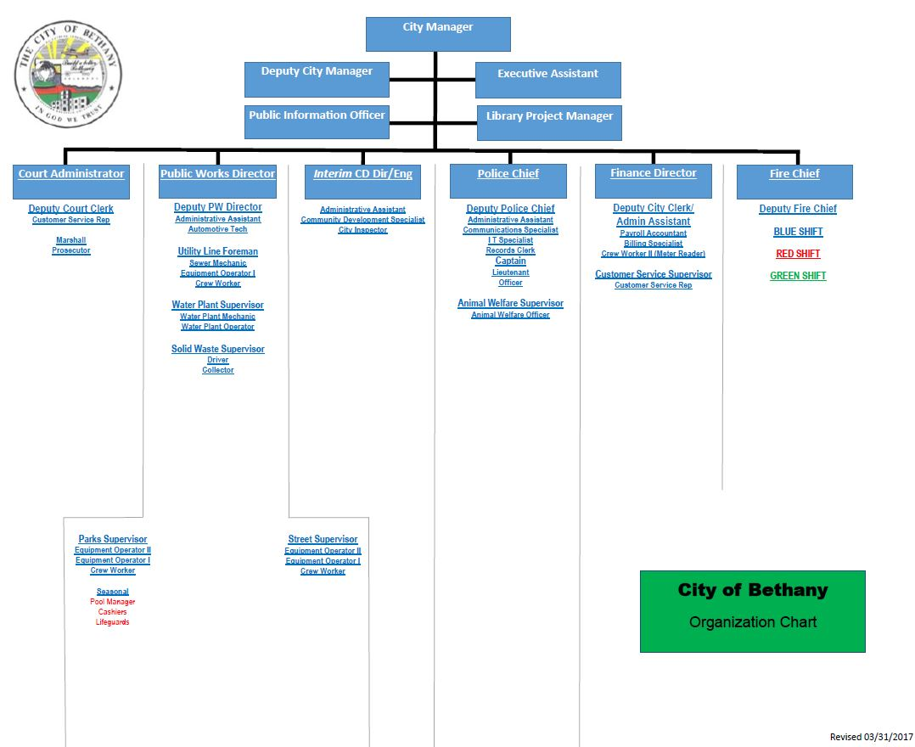
Annex A, Appendix 3
CITY ORGANIZATIONAL CHART

Annex A, Appendix 4

WARD 2
Matthew Goodwin
End of Term: 2023

(405) 470-9608
Steve Palmer
End of Term: 2025

(405) 367-3819
WARD 3
Kathy Larsen
End of Term: 2023

(405) 495-1230
Marilyn McPhail
End of Term: 2025

(405)
WARD 4
Jeff Knapp
End of Term: 2025

(405) 367-9558
Brian Magirowsky
End of Term: 2023

(405)
Nikki Lloyd, Mayor
End of Term: 2025

(405) 367-3889
WARD 1

Chris Powell
End of Term: 2025

(405) 367-3693
Amanda Sandoval
End of Term: 2023

(405) 498-2270

This page intentionally blank.

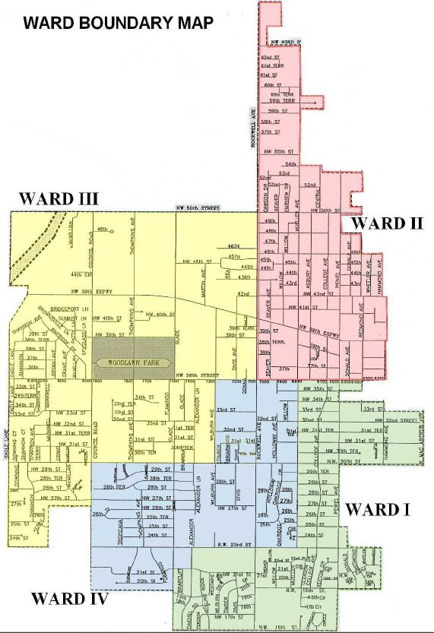
CITY OF BETHANY

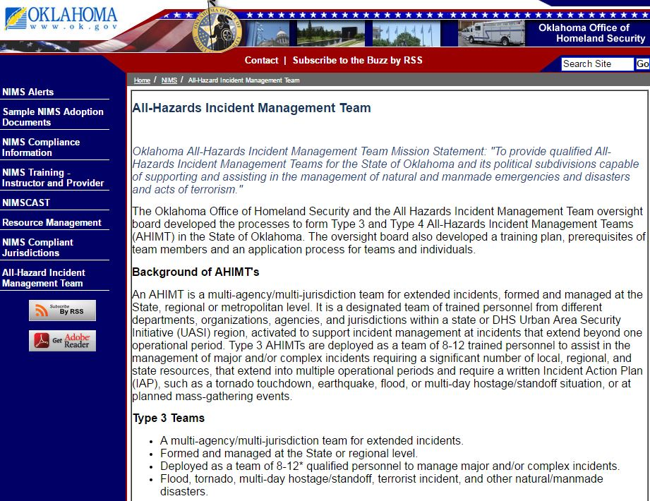

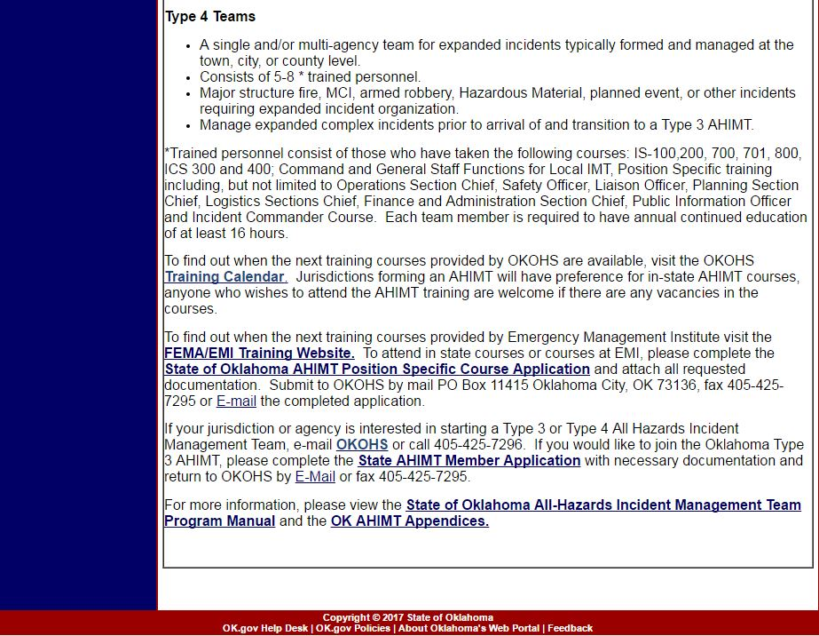

Annex B

COMMUNICATIONS

PURPOSE
This Annex provides information concerning communicating information and messages between responders, and between persons needing assistance and those able to provide assistance in the event of an emergency.

For the purposes of this section, “communications” will not include emergency public information as given to the media for public consumption, nor the control of rumors. Policy and information concerning emergency public information can be found in Annex D of this Plan. It also will not include messages or information concerning the provision of event warnings to the public; this form of communications is covered in Annex C of this Plan.

SITUATION AND ASSUMPTIONS
The City of Bethany utilizes many differing forms of communications for normal operations. These include:
- Verbal in-person communications (“face-to-face”);
- Voice and data communications via radio systems;
- Voice communications via traditional wired, wireless, and voice-over-IP systems;
- Data communications via texting, alpha paging, and other forms of short messaging;
- Data communications via e-mail and other forms of IP-based communications.

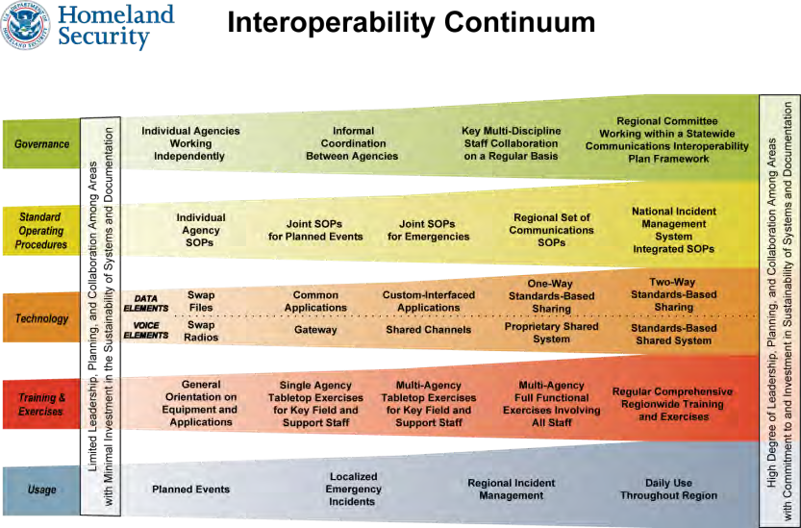
During emergencies, many differing agencies, disciplines, and jurisdictions must work together meet response
needs and guide the community towards recovery. This demands a high degree of communications interoperability – the ability for these agencies and jurisdictions to share vital data or voice information. As each of these groups have their own independent normal, day-to-day communications systems, interoperability can be a great challenge. The
elements guiding successful interoperability are illustrated in the accompanying Interoperability Continuum diagram.

Considerable work has been done in central Oklahoma to address public-safety communications interoperability, particularly for voice communications via radio. As

part of this work, a Tactical Interoperable Communications Plan (TIC-P) for the Central Oklahoma Urban Area has been developed. The TIC-P is intended to document what interoperable communications resources are available within the area, which controls each resource, and what rules of use or operational procedures exist for the activation and deactivation of each resource. In addition, an Oklahoma Field Operations Guide (OKFOG) has been developed to assist responders in determining what radio communications resources are available in other areas of the State.

It can be assumed that during any large-scale emergency, some forms of normal communications will be physically disrupted. Other forms of communications, while physically available, may be expected to be overwhelmed to the point of being unusable. This is particularly true for systems available to the general public, and particularly during the first several hours of the event.

It can be assumed that normal wireless telephone systems will quickly become overloaded during a large-scale emergency and will become unusable for immediate time-critical public safety communications. It should be noted that use of SMS (“texting”) rather than voice may be more reliable as SMS utilizes far less bandwidth, but all emergency communications plans should be developed so as not to rely on wireless telephone systems.

During the course of an emergency, several additional communications systems may become available. These include radio caches and temporary systems from the State and Federal governments; additional capacity and capabilities brought in by private communications carriers; and personnel, equipment, and systems from volunteer radio operators and clubs, such as amateur radio clubs and REACT teams.

CONCEPT OF OPERATIONS
The City’s emergency communications will be based upon using our normal everyday communications systems whenever possible. These may be augmented with other systems as necessary.

The City of Bethany’s public-safety departments operate on the Oklahoma Wireless Information Network (OKWIN). This is a forty-two site 800Mhz trunked radio system, which includes numerous talkgroups dedicated to the City of Bethany. It should be noted that all City of Bethany public-safety radios are programmed with the following zones:
- Zone 1 – Statewide Mutual Aid talkgroups (“SMA”) – coverage statewide within the system footprint
- Zone 2- Regional Mutual Aid talkgroups (“RMA”)– coverage in central Oklahoma
- Zone 3 – Central Oklahoma law enforcement agency main dispatch talkgroups
- Zone 4 – Central Oklahoma fire agency main dispatch talkgroups
- Zone 5 – Central Oklahoma EMS agency main dispatch talkgroups
- Zone 6 – Bethany Police Department talkgroups
- Zone 7 – Bethany Fire Department talkgroups
- Zone 8 – Midwest City EMS talkgroups
- Zone 9 – Bethany Emergency Management Department talkgroups
- Zone 10 – Bethany Public Works talkgroups

- Zone 11 – City of Norman Local Mutual Aid talkgroups (“LMA”)
- Zone 12 – National Interoperability channels (pre-rebanding) (“I-TAC”)
- Zone 13 – National Interoperability channels (post-rebanding) (“8TAC”)
See Appendix 1 for a list of individual talkgroups/channels. (Note: Zones 10 and 12 will be removed in 2014)

The City's non- public safety departments operate on a City-owned trunked 800mhz NEXEDGE radio system. Radios on this system are programmed with the following talkgroups:

- Utilities
- Sanitation
- Streets
- Animal Control
- Fleet Maintenance
- Building Maintenance
- Parks Maintenance
- Community Development
- Senior Center
- Special Events
- Dispatch

These radios also have a zone programmed with the National Public Safety Interoperability channels, and also the NEXEDGE system frequencies in a direct analog mode.

The National Interoperability channels operate in a direct analog mode, as opposed to through a proprietary trunking system. This means that these channels are available for use even if the OKWIN or NEXEDGE systems are not operational, although with far limited range.

When additional resources from outside of the City are ordered by the Incident Commander, the IC should identify and establish a Communications Unit Leader (COML) position within the Logistics Section in the ICS structure. The COML then becomes responsible for the following:
- Establishment of the Communications Unit and the Incident Communications Center;
- Determining communications interoperability pathways;
- Preparing the Incident Communications Plan;
- Ordering and managing communications personnel and equipment;
- Actively participating in the incident action planning.

As a generalized rule, communications interoperability pathways should be established using the following order:
- Use of common channels/talkgroups;
- Exchanging radios with other agencies to achieve common channels/ talkgroups;
- Establishment of patches between channels/talkgroups using dispatch console patches or fixed gateways;
- Utilization of national interoperability channels;
- Establishment of patches between channels/talkgroups using mobile gateways.
- Utilization of cache radios;
- Use of face-to-face methods.

If powered forms of communications are inoperable or overwhelmed, a face-to-face runner system may be implemented. In this case, all messages passed must be written, dated, and signed by the originator. The Incident Commander may waive this requirement for direct on-scene immediate-area communications.

Critical information will be displayed at both the Incident Command Post and the Emergency Operations Center. The information display will allow all personnel to review critical data, make corrections and updates as necessary, and ensure that all personnel are making decisions based on the same data. Display of critical information also lessens the demands upon the radio and wireless systems as well as the sender’s time, as critical information may be transmitted once for the benefit of many persons, rather than needing multiple redundant requests.

Another means of sharing critical information is via the State’s WebEOC system. This is a web-enabled crisis information management system and provides secure real-time information sharing among Oklahoma State agencies and local response managers. Information that is typically shared includes notification and status updates on working events, requesting of assets, status of shelters, etc.

TASK ORGANIZATION AND RESPONSIBILITIES
The City’s Emergency Management Director is responsible for:
- Oversight of all of the City’s communications systems which are required to support operations for both normal and emergency/disaster events;
- Development of a communications system to support crisis operations to include internal operations and external communications with adjacent jurisdictions and the Oklahoma State EOC.
- Development and oversight of information displays at the Incident Command Post and the Emergency Operations Center.

The City’s 9-1-1 Supervisor is responsible for:
- Training of communications specialists to handle emergency/disaster operations;
- Supervision of all communications center activities during emergency/disaster operations.

    - Dispatchers are responsible for:
      - Proper screening and routing of all incoming telephone calls.

All Radio Operators are responsible for:
      - Proper use of communications equipment and procedures at designated stations.
      - Proper handling of messages.

The City’s Information Services Manager is responsible for:
      - Development and maintenance of City electronic data communications systems which are required to support operations for both normal and emergency/disaster events.

All City Department Heads are responsible for:
      - Development and maintenance of communications systems that are required to support operations for both normal and emergency/disaster events.

DIRECTION AND CONTROL
Oversight of the City’s emergency communications systems is vested in the City’s Fire and Police Chiefs. Authority for 9-1-1 Center operations is vested in the Police Department.

During emergencies, all radio communications shall follow the incident command system model and will be directed through the Incident Commander, Department supervisor, net controller, or the designated on-scene communications officer.

During emergencies, any radio code systems used for brevity will be discontinued. Normal speech will be used to ensure comprehension during transmission, particularly between units from different agencies.

CONTINUITY OF GOVERNMENT
All City communications systems should be developed and maintained so as to be as redundant as possible. This includes the deployment of alternate power sources for all critical communications facilities.

Due to the vital role of communications during emergency operations, all locations having critical communications equipment should be always locked, with access limited to authorized City personnel. Access for service personnel may be granted only by authorized City personnel, and only after properly checking service personnel credentials. These locations include (but may not be limited to) the following:
      - 9-1-1 Emergency Communications Center;
      - Emergency Operations Center;
      - City hall telephone rooms;
      - Police and fire station telephone and radio rooms;
      - Police and fire radio repeater locations.

During emergencies, the Police Chief may assign police officers to provide security for key communications facilities. These include the communications center, police and fire repeater sites, and command posts.

Radio equipped vehicles, including the City’s command post and the Emergency Management Director’s vehicle, may also be used to augment communications requirements. The City of Oklahoma City, Warr Acres or Yukon and Oklahoma County EOCs may also assist.

ADMINISTRATION AND LOGISTICS
All communications equipment must have high maintenance priority and should be always operational.

Current lists of radio frequencies, telephone numbers, and other communications references shall be maintained in the EOP Resource Manual.

PLAN DEVELOPMENT AND MAINTENANCE
The Director of Emergency Management is responsible for maintaining and updating this Annex annually.

AUTHORITIES AND REFERENCES
      - US Department of Homeland Security/SAFECOM, “Interoperability Continuum”
      - Central Oklahoma Urban Area Tactical Interoperable Communications Plan (TIC-P), April 2006
      - Oklahoma Field Operations Guide
      - National Interoperability Field Guide

APPENDICES
Appendix 1 – Oklahoma County Radio Towers
Appendix 2 – OKWIN coverage map
Appendix 3 - Oklahoma City Area Fire Communications Interoperability
Appendix 4 - Oklahoma City Area Law Enforcement Communications Interoperability
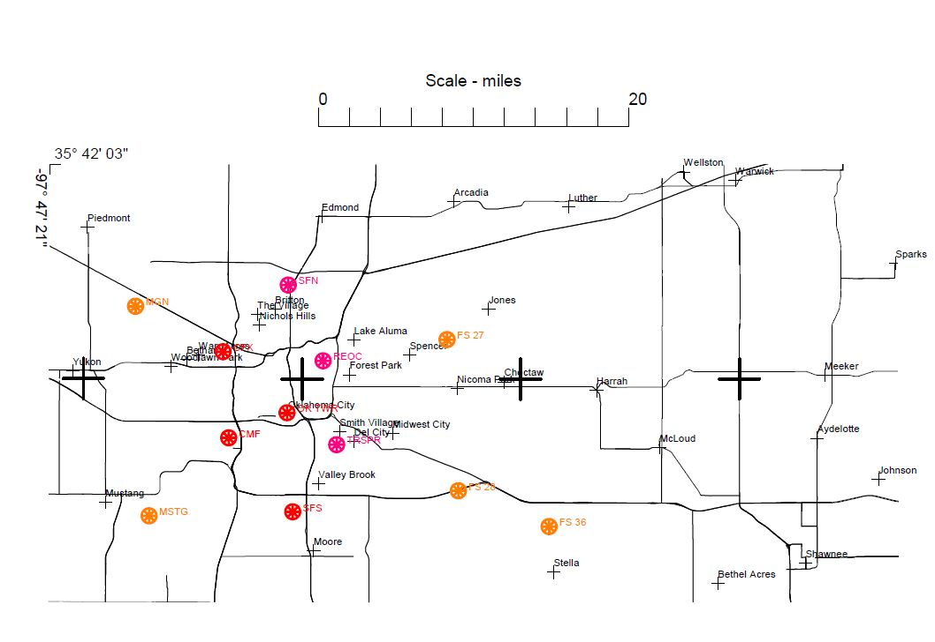
Oklahoma County Radio Towers

OKLAHOMA WIRELESS INFORMATION NETWORK RADIO SYSTEM "OKWIN"

CIMARRON

TEXAS

BEAVER

HARPER

ELLIS
Site | Name | RMA | Ch |  | Site | Name | RMA | Ch
1 | Tulsa 61st | NE | 28 |  | 18 | Chickasha | SW | 7
1 | Tulsa B | NE | 28 |  | 19 | Lawton | SW | 11
2 | Bristow | NE | 5 |  | 19 | Lawton E | SW | 11
3 | Muskogee | NE | 5 |  | 19 | Lawton W | SW | 11
4 | Carney | CN | 7 |  | 20 | Arbuckle | SE | 5
5 | Shawnee | CN | 7 |  | 28 | Fletcher | SW | 7
6 | Pink | CN | 7 |  | 29 | Bakers Peak | SW | 5
7 | Lexington | CN | 5 |  | 30 | Walters | SW | 5
8 | C DPS | CN | 17 |  | 31 | Coweta | NE | 6
8 | Bethany | CN | 17 |  | 32 | Kellyville | NE | 7
8 | C SE | CN | 17 |  | 33 | Grove | NE | 5
8 | Edmond C | CN | 17 |  | 34 | Ada | SE | 5
8 | Edmond Mid Dan | CN | 17 |  | 35 | Tishomingo | SE | 5
9 | Geary | CN | 6 |  | 36 | Thackerville | SE | 5
10 | Pryor | NE | 5 |  | 37 | Owasso | NE | 5
11 | Guthrie | CN | 6 |  | 38 | Ardmore | SE | 5
12 | Stillwater Ill | NE | 5 |  | 40 | Norman W | CN | 13
13 | Preston | NE | 6 |  | 40 | Norman E | CN | 13
15 | Big Cabin | NE | 5
16 | Eucha | NE | 6
17 | Miami | NE | 6
18 | Chickasha | SW | 7

WOODWARD

WOODS

ALFALFA

MAJOR

GRANT

GARFIELD

KAY

NOBLE

OSAGE

PAWNEE

NOWATA WASHINGTON

ROGERS
37
1

CRAIG
15

10
MAYES
17
OTTAWA
33

16
DELAWARE

DEWEY

BLAINE

KINGFISHER

LOGAN
PAYNE 12
11
4

32
CREEK 2

TULSA
1
31
WAGONER
53

51
CHEROKEE

ADAIR

ROGER MILLS

CUSTER

9
CANADIAN
8 8
8OKLAHOMA
8

LINCOLN
13
OKMULGEE

OKFUSKEE
53
MUSKOGEE 3 52

SEQUOYAH

BECKHAM

WASHITA
8 5
40 40 6

MCINTOSH

CADDO
OKLAHOMAPOTTAWATOMIE
HASKELL

HARMON

GREER

JACKSON

KIOWA

29 28
19 19 19
COMANCHE
18
GRADY

STEPHENS

MCCLAIN
7

GARVIN

20

MURRAY
SEMINOLE

34
PONTOTOC

HUGHES

COAL

PITTSBURG

LATIMER

LE FLORE

TILLMAN
30
COTTON

JEFFERSON

CARTER 38

JOHNSTON
35

MARSHALL

ATOKA
PUSHMATAHA

CHOCTAW

MCCURTAIN


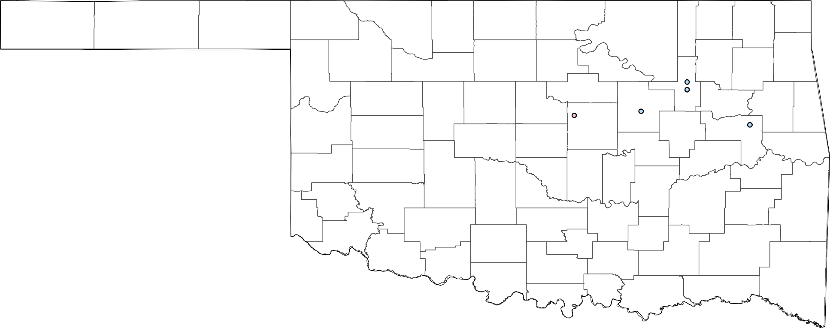

Site | Name | RMA | Ch
51 | Tahlequah | NE | 8
52 | Gore | NE | 6
53 | Muskogee P25 | NE | 7
53 | Muskogee P25 W | NE | 7

All repeater coverages shown are approximate, individual tower site ranges will vary.
LOVE
36
BRYAN

CENTRAL OKLAHOMA PRIMARY RADIO SYSTEMS - FIRE

ORLANDO FD
MARSHALL FD

MULHALL FD

CRESCENT FD

COYLE FD
TWIN LAKES FD

GUTHRIE FD

CASHION FD

SOONER FD

MERIDIAN FD

OAK CLIFF FD
WOODCREST FD

GEARY FIRE

OKARCHE FIRE
DEER CREEK FD PIEDMONT

EDMOND FD

LUTHER FD ARCADIA FD

CALUMET FIRE
RICHLAND FIRE

THE VILLAGE FD NICHOLS HILLS FD

JONES FDHICKORY HILLS FD

FCI
YUKON
WARR ACRES FD
FOREST PARK FD
HARRAH FD

EL RENO FIRE
BETHANY FD SPENCER FD
NICOMA PARK FDCHOCTAW FD

CEDAR LAKE FIRE

UNION CITY FIRE
OKLAHOMA CITY FD

MUSTANG
MIDWEST CITY FD DEL CITY FD
TINKER AIR FORCE FD

NEWALLA FD

MINCO FD

MOORE FIRE

HAROLD FD

TUTTLE FD

NEWCASTLE FD

NORMAN FIRE
LITTLE AXE FIRE

POCASSET FD
BRIDGE CREEK FD

AMBER FD

BLANCHARD FD

GOLDSBY FD
NOBLE FIRE CEDAR COUNTRY FIRE

COLE FD SLAUGHTERVILLE FIRE

Fire Agency Frequency Bands
ACOG_ESNs
NAPLES FD

ALEX FD

DIBBLE FD

WASHINGTON FD

PURCELL FD

ARMY GUARD LEXINGTON FIRE

FIRE_FREQ

LINDSAY FD
PAYNE FD WAYNE FD

ROSEDALE FD

BYARS FD





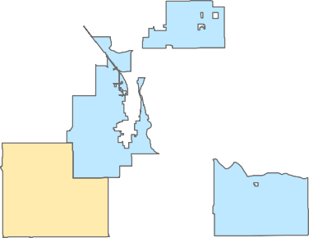
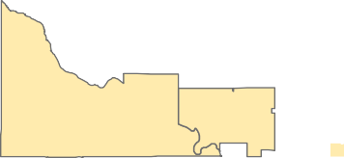


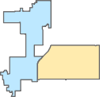






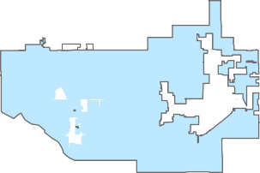


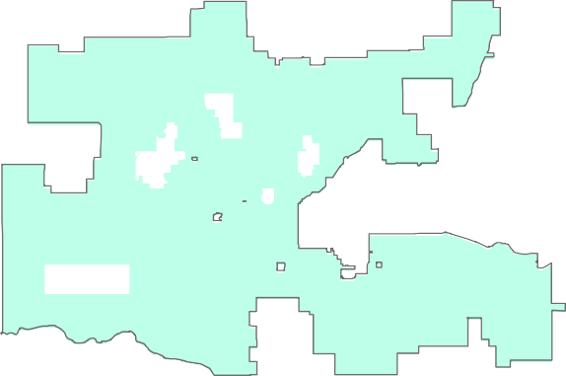

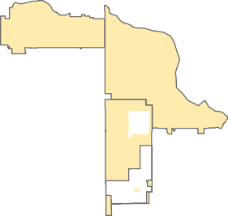

HARRIS OKWIN UHF VHF

CENTRAL OKLAHOMA PRIMARY RADIO SYSTEMS - LAW ENFORCEMENT

Marshall
Orlando Orlando

Mulhall

Crescent

LOGAN
Coyle
Langston

Cimarron CityCedar Valley
Guthrie
Tryon
Agra

Cedar Valley
Guthrie
Meridian

Carney

Kendrick

Piedmont Fallis
Stroud

Okarche
Piedmont
Chandler
LINCOLN
Davenport

Piedmont Piedmont
Edmond

Arcadia
Luther
WellstonWarwick
Chandler

Calumet

CANADIAN

The Village
Nichols Hills OKLAHOMA

Jones
Sparks

El Reno

Yukon
Yukon
Warr Acres Bethany
Forest ParkSpencer
Nicoma Park

Meeker

Prague

Union City
Oklahoma City

Mustang
Midwest City Choctaw Del City
Valley Brook
Harrah

McLoud

Bethel AcresShawnee

Johnson

Moore
Shawnee
Bethel Acres
Earlsboro

Newcastle

Norman

Pink
Pink

Pink

Tecumseh

Law Enforcement Frequency Bands

Blanchard

Cole

Goldsby Goldsby

OKLAHOMA

Noble

Purcell Slaughterville

Etowah

Tribbey
Brooksville
POTTAWATOMIE

Macomb

St. Louis

Maud

Harris
Dibble
Washington Purcell
Slaughterville

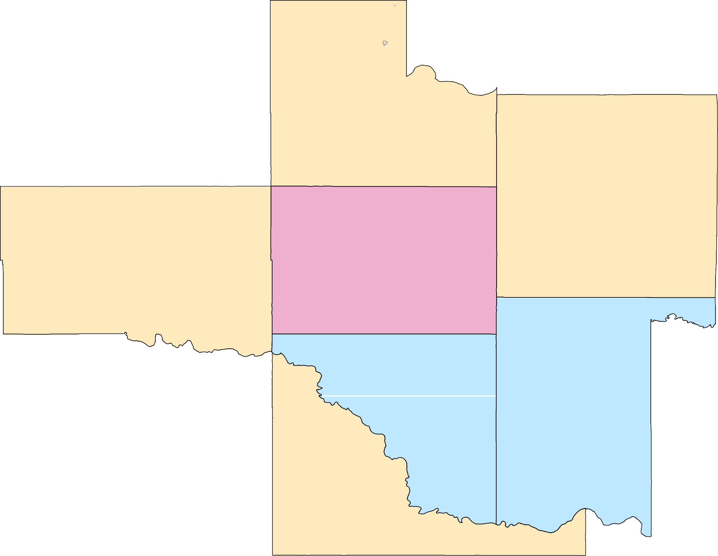
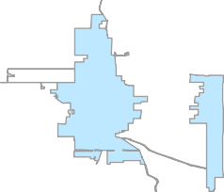






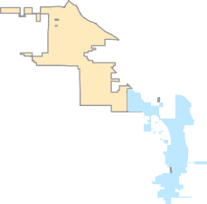
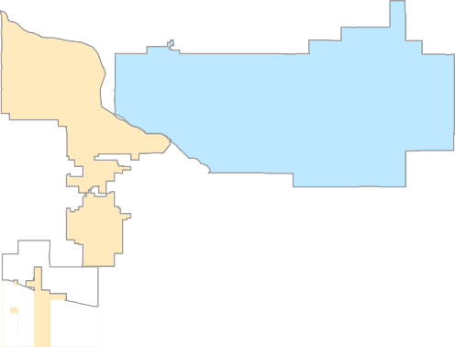



OKWIN UHF VHF

Dibble Dibble

MCCLAIN
Purcell
Lexington

Wayne

Rosedale

Wanette

Byars

Asher

Annex C
ALERT AND WARNING
PURPOSE
This Annex establishes an alert and warning system within the City of Bethany capable of disseminating adequate and timely warning to both City officials and the general public in the event of threatened or actual disaster.

SITUATION AND ASSUMPTIONS
Warning information is vital and must be made available in order to ensure that emergency responders and the public take appropriate protective actions to avoid death, injury, and/or damage to property. Of all emergency management activities, the combination of prior disaster education and timely warning can have the greatest mitigating effect on the number of injuries and fatalities due to a disaster

No one method of warning will reach all intended persons. In order to reach the greatest number of citizens, a multi-faceted system must be in place. In general, the greater number of warning systems that are available and activated the greater percentage of the public that will receive warning.

Warning systems exist at the local, State, Federal, and private sectors. Warning information must be coordinated to ensure the greatest effect.

Special needs groups such as hearing or vision impaired, physically disabled, or non-English speaking may require special attention to ensure that they are able to receive warnings.

Regardless of the warning, some people who are directly threatened by a hazard may ignore warning, or simply fail or refuse to take protective actions.

Warning information may be of limited value to persons without prior education concerning the emergency topic. For instance, when a tornado warning is issued, it may be of limited value if the person receiving the warning does not know what a tornado is or know what protective actions to take. This annex assumes that the various emergency response departments carry out a program of proper disaster education within the City.

Available Warning Systems
The following systems are in place and available to provide alerting and warning to the general public:
      - City of Bethany outdoor warning sirens. This is a network of 4 sirens spaced throughout the City. These sirens are capable of producing alerting tones, but lack pre-recorded digital voice, or live voice (public address). These sirens are controlled via two-way radio, with encoders available in the Police Department and Fire Department. Sirens operate from either commercial power or on-site batteries; Each unit is equipped with a diagnostics and status monitoring package, which reports any changes in the siren’s status to police dispatch and fire department.

      - The City of Bethany will utilize various forms of social media to distribute information during emergencies. Weather reports, Amber and Silver alerts and other pertinent information can be broadcast as changing conditions warrant.
      - NOAA All-Hazards Radio. The National Weather Service operates a system that broadcasts warning information concerning both weather and other civil emergencies via tone-alerted radios that can be purchased by the general public.
      - Broadcast television and radio. Several commercial broadcast television and numerous radio stations exist in the Oklahoma City area. Many of these stations interrupt their normal programming to provide warning information when emergencies are happening.
      - Paging. The State of Oklahoma Dept. of Emergency Management offers a program to send alpha-pages with warning information to emergency responders and certain special needs groups. Various other governmental and commercial entities also offer similar programs to the general public.
      - Internet. Various governmental and private entities offer programs to send email with warning information to subscribers. In addition, many internet web sites exist that have various forms of alerting and warning information on them. One example of this is the Homeland Security Alerting System that is commonly found on web sites concerning terrorism.
      - NAWAS – National Warning System. NAWAS is a protected, full time voice communication system interconnecting the National Warning Center(s) and numerous warning points in each state. The primary NAWAS point in Oklahoma is at the DPS Communications Center, with alternate points at the State EOC and at the Oklahoma Military Dept. EOC. There are approximately 30 secondary NAWAS points throughout the State.
      - EAS – Emergency Alert System. The EAS system provides a top-down network to disseminate warning information from various entry points to media outlets. The primary entry point for Bethany resides at the State EOC. A secondary point is at the National Weather Service in Norman.
      - Amber Alert. The Amber Alert system is a joint project of the Governor’s office, the Department of Public Safety, local law enforcement agencies, and various media outlets. The purpose of the Amber Alert system is to immediately saturate the media in the event of a child kidnapping. The primary entry point for the Amber Alert system is the DPS Comm Center.
      - Social Media. This includes several public services such as Facebook and Twitter. The City of Bethany has the ability to send messages via these systems to those who have “followed” various City accounts.

(It should be noted that the City of Oklahoma City and the City of Warr Acres also both operate networks of outdoor warning sirens, some of which can be heard within the city limits of Bethany.)

CONCEPT OF OPERATION
The general concepts of the alerting and warning system for the City of Bethany are:
      - Information is collected or received by the City of Bethany Emergency Operations Center concerning an impending or immediate threat to those within the city limits of Bethany.
      - The City's Emergency Management Director, either alone or in collaboration with the Police Chief, Fire Chief, City Manager, and/or a scene Incident Commander, determines that:
        - the information is valid;
        - there is a direct immediate threat to those within the city limits of Bethany, and;
        - persons receiving warning information might be able to take protective measures to limit their personal and property risk from the threat.
      - The Emergency Management Department determines which warning systems can provide the best alerting and warning for the particular situation, and activates these systems.
      - If necessary, the Emergency Management Department contacts officials responsible for non- City of Bethany warning systems and provides information to them such as to cause activation of these systems.
      - The Emergency Management Department ensures via the internal systems that City officials also have the warning information, and are aware of any other information that might be of note to prepare their Departments for potential effects of the emergency.

TASK ORGANIZATION AND RESPONSIBILITIES
The Emergency Management Department has the following alerting and warning responsibilities:
      - Develop, maintain, and operate systems to monitor and receive information on potential threats to the City of Bethany;
      - As appropriate, share information with the Police Chief, Fire Chief, City Manager, on-scene Incident Commanders, and/or other City officials;
      - As appropriate and timely, coordinate warning decisions with the above- mentioned persons;
      - Develop, maintain, and operate systems capable of warning the general public, and systems for internal warning;
      - Develop relationships with, share intelligence information, and coordinate warning decisions with officials responsible for the operation of non- City of Bethany warning systems;
      - Develop relationships with and share intelligence information with officials and agencies responsible for providing information that could adversely affect the City of Bethany;
      - Provide education programs for City officials and City communications personnel concerning the operation of warning systems, various actions to be taken prior to and during emergencies, and general disaster-related topics.
      - Provide education programs for the general public concerning the meanings of various warnings, personal protective actions that can be taken to minimize or mitigate the effects of impending emergencies, and general disaster- related topics.

The Police Chief has the following alerting and warning responsibilities:
      - Develop, maintain, and operate systems to monitor and receive information on potential terrorist and criminal threats to the City of Bethany;

      - As appropriate, share information with the Emergency Manager, Fire Chief, City Manager, on-scene Incident Commanders, and/or other City officials;
      - As appropriate and timely, coordinate terrorist and criminal warning decisions with the above-mentioned persons, and task the Emergency Management Director with activation of the various warning systems;
      - Authorize requests to activate the Amber Alert system for child kidnappings occurring within the City of Bethany;
      - Develop relationships with and share intelligence information with officials and agencies responsible for providing information that could adversely affect the City of Bethany;
      - Provide education programs for City officials and City communications personnel concerning various actions to be taken prior to and during terrorist and criminal emergencies.
      - Provide education programs for the general public concerning the meanings of various warnings, personal protective actions that can be taken to minimize or mitigate the effects of impending terrorist and criminal emergencies, and general terrorist and criminal emergency-related topics.

The Fire Chief has the following alerting and warning responsibilities:
      - Assist the Emergency Management Department with the operation of systems capable of warning the general public;
      - As appropriate and timely, coordinate fire and hazardous materials warning decisions with the above-mentioned persons, and task the Emergency Management Department with activation of the various warning systems;
      - Provide education programs for City officials and City communications personnel concerning various actions to be taken prior to and during fire and hazardous materials related emergencies;
      - Provide education programs for the general public concerning the meanings of various warnings, personal protective actions that can be taken to minimize or mitigate the effects of impending fire and hazardous materials related emergencies, and general fire and hazardous materials emergency-related topics.

The City Manager has the following alerting and warning responsibilities:
      - Ensure communications and coordination between the various public safety chiefs and managers in their intelligence sharing and warning decision making;
      - Liaison with the Mayor and City Council concerning received information and the various warning decisions that have been made;
      - Ensure that all city personnel receive disaster related education.

The City's Emergency Dispatchers have the following alerting and warning responsibilities:
      - Monitor the OLETS system for any emergency information that could potentially affect the City of Bethany;
      - As workload permits, monitor other agencies radio channels for emergency information that could potentially affect the City of Bethany;
      - Immediately notify the Emergency Management Director of all emergency information received that could potentially affect the City of Bethany;
      - Immediately notify the Police Chief of all terrorist or criminal related emergency information received that could potentially affect the City of Bethany;

      - In the absence of the Emergency Management Director or authorized and qualified EOC personnel, activate the various warning systems if necessary.

DIRECTION AND CONTROL
Final decision authority for activation of the City's warning systems for terrorist or criminal related emergencies rests with the Police Chief.

Final decision authority for activation of the City’s warning systems for all emergencies other than terrorist or criminal related rests with the Emergency Management Director/Fire Chief.

CONTINUITY OF GOVERNMENT
The following is the chain of command for activation of the City's alerting and warning systems:
- Emergency Management Director/Fire Chief or Deputy Director/Deputy Fire Chief;
- Police Chief or acting Chief;
- Battalion Chief or acting Battalion Chief, if neither of the above can be contacted in a timely manner;
- Senior on-duty Police Supervisor, if none of the above can be contacted in a timely manner;
- Senior on-duty Shift Commander if none of the above can be contacted in a timely manner;
- Senior on-duty Communications Dispatcher, only if none of the above can be contacted.

Care should be taken to balance the need for immediate warning versus validating the information any warning decision is based upon, and any inability to contact either the Emergency Management Director/Fire Chief or Police Chief.

ADMINISTRATION AND LOGISTICS
The City's outdoor warning systems are based on a two-way data system such that any change in a unit’s status is transmitted to Police Dispatch and Fire Department Console. Additionally the system is polled once per day. The outdoor warning systems are also audibly tested at noon on each Saturday, provided such testing is done in a manner that will not create fear or panic in the general public.

PLAN DEVELOPMENT AND MAINTENANCE
The Emergency Management Department is responsible for updating this Annex on an as needed basis.

AUTHORITY AND REFERENCES
Bethany Police Dept. Amber Alert Memo
FEMA, National Warning System (NAWAS) Operations Manual, CPG 1-16, Washington D.C..

APPENDICES
Appendix 1 – City of Bethany Outdoor Warning System map Appendix 2 – Outdoor Warning Devices Bordering Bethany

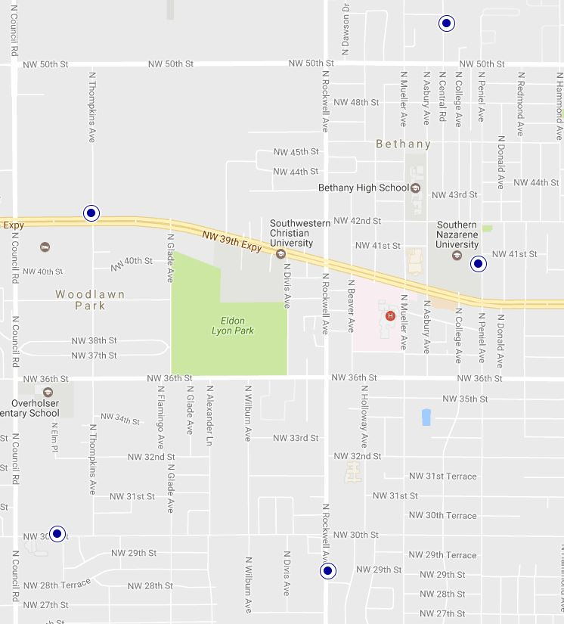
Bethany Outdoor Warning Devices

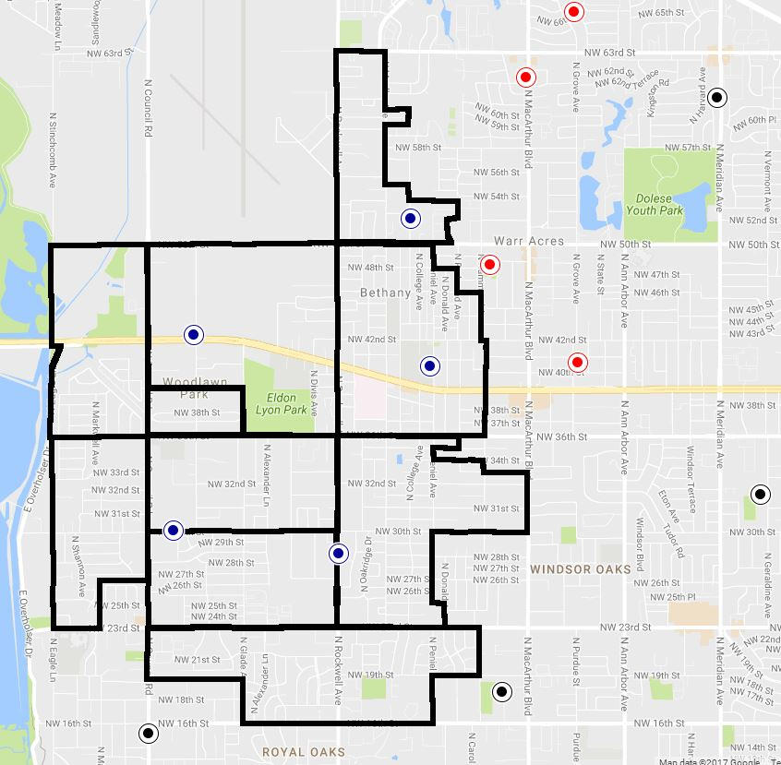
KEY
Bethany

Warr Acres

Oklahoma City
Outdoor Warning Devices bordering Bethany

Annex D
EMERGENCY PUBLIC INFORMATION
PURPOSE
This annex provides procedures for the effective collection, control, and dissemination of emergency public information. Long-term public educational efforts related to hazard awareness are also outlined in this annex.

SITUATION AND ASSUMPTIONS
The general public expects current and accurate information from the government during a disaster. It can be expected that the public will seek useful information and instructions during an emergency, and will turn to whatever source they can find that is providing information. Therefore, it is critical that the City of Bethany, in partnership with state and federal agencies, provide the public accurate, timely and useful instructions throughout the emergency period.

Emergency information efforts will focus on specific event-related information. This information should generally be
    - Instructional and/or informational in nature;
    - Periodic at regular intervals;
    - Positive but truthful.

Education efforts will be directed toward increasing public awareness about potential hazards and how people can deal with them.

All information and education efforts will rely heavily on the cooperation of commercial media organizations. It can be assumed that the media will respond immediately to any disaster scene, with television expected to be broadcasting live video of the disaster within minutes, and that live video will be distributed worldwide.

The media will be requesting current and accurate information upon their arrival at the disaster. If information is not received in a timely and comprehensive manner, it can be expected that the media will turn to other sources that cannot be controlled, and may not have a requirement to provide accurate information. Again, it is critical that the City provide the media with accurate, timely, and comprehensive information throughout the emergency period.

Social media not only allows for another channel of broadcasting messages to the public, but also for two way communication between the City and major stakeholder groups. Increasingly the public is turning to social media technologies to obtain up to date information during emergencies and to share data about the disaster in the form of geo data, text, pictures, video, or a combination of these media. Social media also can allow for greater situational awareness for emergency responders.
While social media allows for many opportunities to engage in an effective conversation with stakeholders, it also holds many challenges

It can be expected that rumors and inaccurate information will surface very quickly after the onset of the emergency. The City must act swiftly to establish credibility and timeliness in the provision of accurate information to counteract these rumors.

CONCEPT OF OPERATIONS
Emergency public information activities in the City of Bethany will be the responsibility of the City department having Incident Command of the emergency. This will likely be either the Fire or Police Departments. In addition, the City’s PIOs may assist with emergency public information efforts. Each of these departments have individuals (PIOs) tasked to public information efforts, and all of these individuals – from all departments – will work together in the provision of emergency public information.

When tasked by the Incident Commander, the PIOs will establish a joint information center (JIC) at or near the incident command post. This should be near to the information display of the CP is, to ensure that the PIOs are able to receive accurate and timely information.

The PIOs will further establish a media area, and meet with the representatives from the media as needed. During a long-term event, a media briefing schedule will be established.

During an event where a command post is not established or if the event is widespread, the PIOs may elect to establish the JIC at or near the Emergency Operations Center.

All information released concerning the event will be via the JIC, after consultation with the IC and/or City Manager (EOC executive).

TASK ORGANIZATION AND RESPONSIBILITIES
The Police Chief, Fire Chief, and Economic Development Director each have responsibility to
    - Assign and provide proper training for Public Information Officers, both primary and secondary;
    - Implement policy establishing the PIO as the single official point of contact for the media during an emergency.

The Public Information Officers have responsibilities to:
    - Develop and maintain public information operating procedures;
    - Develop working relationships with various local media personnel;
    - Develop working relationships with PIOs from other City departments and area agencies;
    - Upon notification of an emergency, respond to the command post and direct all emergency public information efforts.
    - Provide news releases for the media, upon approval for release by the IC and/or EOC executive;
    - Check all print media for accuracy of reports.
    - Monitor social media for information pertaining to the event, and to provide information and updates
    - Investigate rumors.
    - Check TV and radio broadcasts for accuracy of reports.
    - Maintain a recent record of events.

DIRECTION AND CONTROL
Operational responsibility for all field operations remains vested in the Incident Commander. The PIOs should work closely with the IC to ensure that information to be released is current, accurate, and is not of a nature to jeopardize ongoing field operations.

Executive responsibility for EOC operations remains vested in the City Manager. During a EOC-based operations, the PIOs should also work closely with the City Manager and Emergency Management Department to ensure that information to be released is current, accurate, and will not jeopardize ongoing field operations.

CONTINUITY OF GOVERNMENT
The Police, Fire, and Economic Development Departments should maintain a number of adequately trained personnel such that the emergency public information function may be maintained even in the absence of the primary PIO.

ADMINISTRATION AND LOGISTICS
The PIOs should keep copies of all press releases. In addition, copies of these releases should be sent to the EOC to be included in the event record.

PLAN DEVELOPMENT AND MAINTENANCE
The PIO will be responsible for the development and maintenance of emergency public information programs. Other persons or organizations specified in the Annex will work with the PIO as necessary.
AUTHORITIES AND REFERENCES APPENDICES
Appendix 1 Sample Boiling Water Notice Appendix 2 Sample Do Not Drink Notice

Appendix 1
Sample

WARNING
BOIL YOUR WATER BEFORE USING

The City of Bethany Water System is contaminated with fecal coliform/E. coli
Fecal coliform/E. coli bacteria were found in the water supply on [date]. These bacteria can make you sick and are a particular concern for people with weakened immune systems.

What should I do?
    - DO NOT DRINK THE WATER WITHOUT BOILING IT FIRST. Bring all water to a boil, let it boil for ten minutes, and let it cool before using, or use bottled water. Boiled or bottled water should be used for drinking, making ice, brushing teeth, washing dishes, and preparing food until further notice. Boiling kills bacteria and other organisms in the water.

    - Fecal coliform and E. coli are bacteria whose presence indicates that the water may be contaminated with organisms that can cause illness in humans. These organisms can cause diarrhea, cramps, nausea, headaches, or other symptoms. They may pose a special health risk for infants, young children, some of the elderly, and people with severely compromised immune systems.

    - Organisms in drinking water are not the only cause of the symptoms above. If you experience any of these symptoms and they persist, you may want to seek medical advice. People at increased risk should seek advice about drinking water form their health care providers.

What happened? What is being done?
The water distribution system was contaminated with fecal coliform. We are working the Department of Environmental Quality to investigate/resolve this issue. We are currently increasing the chlorination levels in the water system. In addition, we are evaluating all available information and conducting tests to confirm the extent of the contamination of the system. We will inform you when the tests show no bacteria and you no longer need to boil your water.

For more information, please contact [contact person] at [contact phone number]. More information is available from the EPA Safe Drinking Water Hotline at 1-800-426-4794.

Please share this information with all other people who drink this water, especially those who may not have received this notice directly. You can do this by posting this notice in a public place or distributing copies by hand.

This notice is being sent to you by the City of Bethany. Public Water System ID Number OK2005519. Date distributed [date].

Appendix 2
Sample

WARNING
DO NOT DRINK CITY WATER

[contaminant] found in the City of Bethany water supply on
[date]

Bottled water can be obtained at [location] 24 hours per day.

What should I do?
    - DO NOT drink the water.

    - Symptoms associated with [contaminant] include ……..[list symptoms]

    - If you or someone you know exhibits any of these symptoms, immediately contact your health care provider. In addition, please notify the Oklahoma Department of Health at [emergency phone number].

What happened? What is being done?
On [date], the water distribution system was contaminated with [contaminant]. We are working with law enforcement and the Oklahoma Department of Environmental Quality to investigate/resolve this issue. We have tested the water in various parts of the distribution system to verify the extent of the contamination. Based on these tests, we have isolated the portion of the system located [location of portion isolated]. Everyone in this portion of the system should not drink the water. We have implemented additional security procedures to protect the system against further contamination. Additional information will be provided 24 hours/day on [Channel [ ] – the local government television channel].

For more information, please contact [contact person] at [contact phone number]. More information is available from the EPA Safe Drinking Water Hotline at 1-800- 426-4794.

Please share this information with all other people who drink this water, especially those who may not have received this notice directly. You can do this by posting this notice in a public place or distributing copies by hand.

This notice is being sent to you by the City of Bethany. Public Water System ID Number OK2005519. Date distributed [date].

Annex E

EVACUATION / SHELTERING-IN-PLACE

PURPOSE
The purpose of this Annex is to provide policy and procedures for providing an area of safety for those in or about to be in an unsafe or hostile environment. This may include the ordering of sheltering-in-place (SIP), or ordering an evacuation of the area.

SITUATION AND ASSUMPTIONS
Emergencies typically cause affected areas to become unsafe. When this occurs, it is necessary to either evacuate persons from the affected area to an area of safety, or instruct persons to remain in the area but take additional positive measures to protect themselves from the environment. In some instances this may be possible prior to the event; however during most of the types of emergencies that may affect the City of Bethany, it is more likely that evacuation or sheltering-in-place will be carried out after the event has occurred.

As indicated in the Oklahoma Emergency Management Act of 2003, Oklahoma § Title 63, Supplement 2006, and the Oklahoma Attorney General Opinion 07-11 of April 23, 2007, the Governor and Political Subdivisions have the authority to require evacuation during an emergency for the health and safety of the public.

Evacuation may be spontaneous after an event, or an evacuation may need to be ordered by a local Incident Commander. The evacuation area may cover more than one jurisdiction, and may even be needed region-wide depending upon the nature of the event.

For some emergencies, it may be more advantageous to order sheltering-in- place, rather than moving persons from the affected area. Factors that may assist in determining which action to take may include:
  - Relative safety of remaining in place (with additional protective measures) vs. moving outside in a hostile environment;
  - Safety of responders assisting in the evacuation order;
  - Amount of time available prior to the environment becoming hostile or unsafe vs. the time needed to affect an evacuation;
  - Amount of time the environment will remain hostile or unsafe vs. the time needed to affect an evacuation.

At the time of evacuation/shelter-in-place order, most emergencies will still be in a confused state. Persons needing to take evacuation/protective actions will likely still be in a state of disbelief, fear, grief, etc. Responders will be struggling to bring the incident under control and save as many lives as possible. Some persons will forget
  - or ignore – the things they need to do to protect themselves. Additionally, it should be assumed that some of the public might not understand or be able to take the additional positive measures to protect themselves, and also that some people will refuse to evacuate, regardless of the threat.

Transportation may likely be needed between the affected area and the area of safety, as personal vehicles of the evacuees may be damaged or destroyed by the event.

Assistance with traffic control may be needed, as normal transportation routes may be affected by the event. Additionally, there may be a large volume of both pedestrians and vehicles evacuating an area. In addition to assisting with the volume, it may be necessary to implement additional traffic control to allow for orderly egress by evacuees and ingress by emergency workers.

Evacuees of a terrorism or criminal event may be witnesses to a crime, and need to be interviewed and/or segregated from other witnesses prior to and during evacuation.

Dependent upon the event, decontamination of evacuees may be needed prior to transport.

Evacuees from schools or daycares will need to be accounted for during all phases of evacuation or SIP, and dependent upon age and special needs, may likely require adult supervision during all phases.

During a terrorism or criminal event, armed security may be needed along the route and/or with the transport vehicles.

Security will be needed in areas that are evacuated to control both those wishing to return to their homes or businesses, and to reduce the chance for looting or criminal activity.

A great deal of timely and accurate emergency public information will be required to:
    - Provide both immediate and longer-term information and instructions to evacuees and those sheltering-in-place;
    - Provide information to relatives and/or friends of evacuees as to their status and location. This is particularly important when the evacuees are children.

CONCEPT OF OPERATIONS
As or after an emergency event occurs, the Incident Commander for the event will:
    - Determine if it is safe for persons to remain in the area affected;
    - Particularly during a terrorist or criminal event, determine if evacuation is immediately necessary, or if the surrounding area should be swept and deemed secure prior to evacuation;
    - Consult with other on-scene commanders and responders as necessary and determine the boundary of the unsafe area, using a conservative estimate of the threat or risk (meaning to err on the side of caution)
    - Weigh the advantages or possibilities of ordering sheltering-in-place as an alternative to evacuation.

If evacuation appears the best option, the IC, in consultation with the Police Department and Emergency Management Director/Fire Chief as necessary, will:
    - Consult with the senior Police representative to determine the actual area to be evacuated, based on both the unsafe area boundary, and also any natural or physical boundaries that will ease the manpower needs of the evacuation;

    - Determine if a temporary shelter or a longer-term mass care shelter will need to be established. If a temporary shelter will suffice and a suitable facility is readily available nearby, the IC will task the opening of the temporary location. If a temporary shelter location is not readily available, or a longer- term mass care shelter is needed, the IC will task the Emergency Operations Center with locating suitable facilities and the opening of them;
    - If evacuation is from a school, day care facility or otherwise involves a large number or children, establish a system of supervising and tracking all children.
    - Determine if there is a large population of persons with special needs have any assistance needed to properly evacuate;
    - Determine if transportation will be needed to a shelter facility. If so, the IC will task the Emergency Operations Center with the provision of such transportation.
    - Determine if an assembly area is needed for picking up persons to be transported and select its location;
    - Include information about arrangements for companion animals and livestock in evacuation messaging.
    - Determine if decontamination of evacuees is needed, and establish the decontamination process if necessary;
    - Determine if armed security is needed in the evacuation/assembly area, along the transportation route, and/or on any transportation.

Once the IC officially orders an evacuation, the Police Dept. will:
    - During a terrorist or criminal event, determine if evacuees need to be screened as potential suspects prior to transport or evacuation and implement such screening;
    - During a terrorist or criminal event, determine if evacuees need to be interviewed and/or segregated prior to or during transport or evacuation, and implement such actions;
    - Take actions to establish a secure perimeter, allowing egress from the area but ingress only to emergency workers as tasked by the IC;
    - Conduct a door-to-door sweep within the area. Note that some hostile environments might require those doing sweeps to wear specialized personal protective equipment. It should also be noted that although the Police Dept. will be tasked with establishing perimeters and performing sweeps, other agencies might actually provide the manpower to affect these.
    - Cite the specific dangers posed by the potential disaster to those persons refusing to evacuate. Make it clear to persons refusing evacuation that emergency responders may not be able to evacuate them later if conditions become too hazardous.
    - If possible, patrol the evacuated area for security and removal of unauthorized persons.
    - Per the IC, establish and implement procedures, as dictated by nature and status of the emergency, to allow persons back into the evacuated area to retrieve necessary items; assess, secure, and repair damaged property; and again exit the area if needed.

If sheltering-in-place appears the best option, the IC will:
    - Determine what protective measures those sheltering-in-place should take;
    - Task the Public Information Officers with providing the media with the SIP areas, additional protective actions to be taken, and the length of time SIP is anticipated to last;

    - Task the Emergency Operations Center with broadcasting the SIP information
via the City’s warning systems;
    - Monitor conditions to ensure that SIP continues to be the best protective action.
    - Determine if there is a large population of persons with special needs r and assist them as possible with taking proper actions.

TASK ORGANIZATION AND RESPONSIBILITIES
The Incident Commander has responsibility for all field events directly related to the emergency, including the ordering of evacuation or sheltering-in-place; determining the area to be evacuated; determining if transportation is needed; determining if an assembly area is required; and determining security needs.

The Emergency Management Director/Fire Chief has responsibility for all events outside of the emergency area, including the establishment of shelters and transportation.

The Police Department has responsibility for establishing the area perimeter and sweeping the evacuated area; security of the evacuated area; determining if special screening or handling of the evacuees is needed; armed security if needed along transportation routes or in transport vehicles.

The Public works Dept. has responsibility in providing shelters and assisting with their operation (see Annex F), and for assisting with transportation vehicles.

The Bethany Public Schools has responsibility for assisting with transportation vehicles, in accounting for and providing adult supervision for evacuees from school locations, and in assisting with providing shelter locations if needed.

Paddford has responsibility for providing medical transport vehicles, if necessary, for the evacuation of persons with special medical needs.

The City Animal Welfare Division has responsibility for providing sheltering locations for animals during an evacuation. See City of Bethany Animal Response Plan, Annex F, Appendix 2.

DIRECTION AND CONTROL
Operational authority is vested in the Incident Commander at the scene, and in the Emergency Management Director/Fire Chief in the EOC.

Executive authority remains with the City Manager.

The Superintendent of the Bethany Public Schools retains executive authority at school facilities.

The Animal Welfare Director retains authority over city facilities and animal sheltering operations.

CONTINUITY OF GOVERNMENT
All agency heads of the tasked agencies and departments will ensure that adequate backup personnel are familiar with these policies and procedures in the event that primary personnel are unavailable.

All City department heads will be familiar with the Continuity of Government section of the Basic Plan and be prepared to take all actions necessary to ensure the provision of emergency services should City Hall and/or other City facilities need to be evacuated.

ADMINISTRATION AND LOGISTICS
All schools, day care facilities, and facilities where there are large gatherings of people should develop and implement an accountability system for immediate emergencies. Information from these systems should be provided to the IC and/or Police Department upon arrival.

The City’s public safety departments will provide educational programs to the public concerning disasters, actions that may occur during evacuations, and information on needed supplies and actions during a shelter-in-place order.

PLAN DEVELOPMENT AND MAINTENANCE
Responsibility for updating and revising this Annex rests with the Emergency Management Director/Fire Chief

AUTHORITIES AND REFERENCES
Bethany Public Schools Crisis Management Plan.
Oklahoma Attorney General Opinion 07-11 (April 23, 2007) Oklahoma Homeland Security Regions 6 & 8 Evacuation Plan (draft)
FEMA SLG-101, “A Guide for All-Hazards Emergency Operations Planning”.
FEMA Emergency Management Institute Course E408 materials, “Terrorism Planning Course”.

Annex F

HUMAN SERVICES – MASS CARE

PURPOSE
This purpose of this annex is to plan for the provision of emergency public assistance
Including, the provision of temporary shelter, food, medical care, clothing, and other essential life support needs – to those displaced because of disaster or disaster threat situation.

SITUATION AND ASSUMPTIONS
The ultimate responsibility for sheltering operations rests with the local government; however, the Heart of Oklahoma Chapter of the American Red Cross (ARC) serves as the primary organization that manages and staffs sheltering facilities in the City of Bethany.

Sheltering operations may be necessary within the City of Bethany even if a disaster does not directly affect the City. It is likely that a large-scale disaster in either Warr Acres, Yukon or Oklahoma City could cause Bethany to become a “host” area.

The Bethany Library is the primary location for a sheltering facility. Various schools may also work as shelters; however, this use should be balanced versus the need to continue with normal class schedules. ARC Disaster response personnel, along with the City EM Department, will identify preferred locations and enter into emergency use agreements with these facilities.

Needs of those displaced may differ depending upon the type of disaster, age of those displaced, and the anticipated duration of the shelter stay.

Decontamination may be necessary prior to admission to the shelter.

If the disaster requires sheltering-in-place for an extended period, it may be necessary to assist persons in replenishing their essential supplies.

Persons will bring pets and other animals in their care with them to a shelter. The City’s Animal Welfare Division will provide animal sheltering arrangements per the City’s Animal Response Plan.

Distribution of water, snacks, and other essential supplies to both victims and responders will likely be needed throughout the affected area.

Sheltering and feeding of emergency workers may also be required, particularly if the affected area is widespread.

CONCEPT OF OPERATIONS
Three types of shelters may be established to support emergency and disaster events:
    - Warming/cooling shelters: These shelters are typically short-term operations established to provide warmth or cool to residents during times of power

outages. These shelters may also provide electricity to those who require power for medical assistance equipment, such as oxygen concentrators.
    - Temporary emergency shelters: These shelters are typically shorter-term operations established to provide immediate shelter to persons evacuated from the area of an ongoing emergency.
    - Mass care shelters: These shelters will likely be longer-term operations, providing temporary residence to persons whose permanent homes have been severely damaged or destroyed as result of a disaster.

As outlined in Annex E, the Incident Commander of an emergency or disaster will determine if sheltering will be needed, and task the Emergency Management Director to implement opening of such a facility.

Upon notification of tasking, the Emergency Management Director/ Fire Chief will immediately notify the ARC. ARC personnel will select the most appropriate shelter location (s).

The ARC will respond, finalize the shelter location, enter into an agreement with the facility owner, and begin shelter operations per normal ARC policy and training. This will include registration; provision of shelter, food, water, and security; provision of essential first-aid medical care; and provision of disaster mental health services.

The Bethany Police Department will provide or arrange for security for the shelter facility.

The Bethany Fire Department and/or Pafford will provide or arrange for decontamination of persons prior to admission to the shelter, if necessary.

The Animal Control Division of the Bethany Public Works Department will provide personnel, facilities and technical assistance in the housing and care of pets belonging to persons being sheltered.

The ARC and other VOAD and private organizations will provide food, water, and essential supplies in and around the disaster-affected area.

The Director of Public Works will arrange for portable toilet facilities in and around the disaster-affected area.

The ARC will establish and operate a disaster-welfare-inquiry (DWI) system within 72 hours of the onset of the disaster, in accordance with ARC policy and training.

TASK ORGANIZATION AND RESPONSIBILITIES
The Incident Commander is responsible for determining the need for shelters.

The Emergency Management Director/Fire Chief is responsible for notification to the ARC that a shelter is needed; finalization of shelter locations; and general oversight of the sheltering program.

The Heart of Oklahoma Chapter of the American Red Cross is responsible for staffing and management of shelters; arranging for essential first-aid and disaster mental health services; provision of food, water, and essential supplies in and around the disaster-affected area; and establishment and operation of a disaster welfare inquiry system within 72 hours of the onset of the disaster.

The Police Department is responsible for provision of security for the facility.

The Bethany Fire Department and/or Pafford will provide or arrange for decontamination of persons prior to admission to the shelter, if necessary.

The Director of Public Works is responsible placement of portable toilet facilities in and around the disaster affected area.

The Animal Control Division is responsible for management of pets and animals associated with persons being sheltered.

VOAD agencies and other private organizations are responsible for provision of food, water, and essential supplies in and around the disaster-affected area.

DIRECTION AND CONTROL
The American Red Cross will provide management of sheltering operations. Management of the Bethany Library Complex will remain with the Director of
Public Works.
CONTINUITY OF GOVERNMENT
All non-essential activities within the Library Complex will be suspended as necessary to provide for the needs of the shelter facility.

ADMINISTRATION AND LOGISTICS
The ARC will provide all administration and logistics necessary for operation of the shelter facility.

PLAN DEVELOPMENT AND MAINTENANCE
The Emergency Management Director/Fire Chief is responsible for maintaining and updating this Annex. Changes must be closely coordinated with the ARC Disaster Services Coordinator.

AUTHORITIES AND REFERENCES APPENDICES
Appendix 1 - Warming Shelter Instructions and Roster Form Appendix 2- City of Bethany Animal Response Plan

This page intentionally blank.

Annex F - Appendix 1
WARMING SHELTER ROSTER INSTRUCTIONS

When Persons are Arriving:
- Please maintain a simple roster of those who are in the shelter. This allows us to keep an idea of the number of persons and a rough idea of where they’re from.
- “Name” refers to the name of the primary person in a group of persons.
- “Number in Party” is the number of persons in the group.
- “Home City/State” is just an idea of where they’re from. IF LOCAL, please put their street address.
- “Contact Telephone Number” will allow us to contact them if necessary (like if they leave something here, etc)

When Persons are Leaving:
1. Please mark an “X” through the number in the far-left column.

When Shelter is Closed:
1. Please make sure all roster sheets are forwarded to the Emergency Management Department.

 | Warming Shelter Roster |  |  | Date:
 | Name | Number in Party | Home City/State | Contact Telephone Number
1
2
3
4
5
6
7
8
9
10
11
12
13
14
15
16
17
18
19
20
21
22
23
24
25
26

March 2021 City of Bethany Emergency Operations Plan Page 114

CITY OF BETHANY, OKLAHOMA
ANIMAL WELFARE DIVISON

Emergency Response Plan for Animals

April 2017



I. Contents
Emergency Response Plan for Animals 1
- Introduction 3
  - Mission Statement 3
  - Purpose 3
  - Assumptions 3
- Emergency/Disaster Related Activities 3
- Preparedness- no current or potential disasters 3
- Warning - A disaster is potentially threatening the local area. 4
- Response-period immediately following an incident 5
- Recovery 5
  - Volunteer Support 6
- Activation 6
  - Activation of the Emergency Response Plan for Animals 6
  - Set up of Emergency Animal Shelter 7
  - Record Keeping and Documentation 7
  - Communications 7
- Shelter Operations 7
  - Receiving Animals at the Emergency Animal Shelter 7
  - Emergency Care of Animals 7
  - Priority Care 8
  - Daily Care 8
  - Daily Reporting 8
- Facility Demobilization 8
  - Reduction of services 8
  - Demobilization 8
  - Documentation 9
Appendix A Resource Listing 10
Appendix B Volunteer Application 11
Appendix C Animal Intake Form 13

- Introduction
  - Mission Statement

To provide immediate care of animals during disaster situations, minimize animal suffering and human anguish by providing temporary shelter for companion and farm animals during disasters, provide emergency veterinary care to companion and farm animals injured during a disaster and provide a system for returning animals to their owners after a disaster event is over.

  - Purpose
It is the purpose of the City of Bethany Animal Welfare Division to protect animal safety and public health by providing personnel, expertise, and/or supervision during any incident that requires the evacuation and/or temporary housing of animals because of flooding, tornadoes, hazardous materials incidents, hurricanes, or any other emergency where animals are involved.

  - Assumptions
- Potential hazards such as flooding, tornadoes, hurricanes and hazardous materials incidents, may require the evacuation of citizens from selected areas of the city.

- Typically, human evacuation shelters do not admit companion animals.

- When possible, owners will receive advance notice about evacuating their animals, but some emergent situations require immediate evacuation.

- The City of Bethany Animal Welfare Division will continue to educate the public on animal disaster planning and preparedness.

- Emergency/Disaster Related Activities
- Preparedness- no current or potential disasters

  - Normal business hours and staffing levels.

  - Develop plans and procedures to provide shelter and care to displaced and/or injured animals during natural and man-made disasters.

  - Identify potential locations for fixed facility and temporary companion animal and livestock shelters based on electrical and sanitation requirements.

  - Recruit volunteers and assign key staff personnel to assist with operations at the shelter facilities.

  - Identify local resources for veterinary services, animal medical supplies and vaccines for use at these shelter facilities.

  - Identify local resources for pet and animal foods, cages and flea sprays/dips for use at these shelter facilities.

  - Prepare/obtain brochures and handout materials on animal disaster planning for community distribution to promote citizen awareness. Provide this information on the agency’s web site, at the shelter location, and other partner locations,.

  - Assist local animal owners with identifying evacuation locations for pets prior to an emergency or disaster occurs. These locations could be at an animal owner’s friend or relative’s residence, at the family’s veterinarian, or at a boarding facility, etc.

- Warning - A disaster is potentially threatening the local area.

  - Hours of operation remain normal at this point.

  - Review and update the emergency animal shelter plans as necessary.

  - Confirm task assignments and alert key personnel and volunteer groups to put them on Stand-By status.

  - Begin public service announcements in coordination with the City’s Public Information Officer.

  - Determine what additional supplies might be needed, identify sources and costs. Complete any necessary pre-purchase tasks.

  - Confirm the current availability of potential shelter sites, and resources.

  - Begin record keeping of disaster related expenses (to include hours worked by staff and volunteers) and continue for the duration of the event.

  - Ensure that all equipment is in proper working order and vehicles have adequate fuel.

- Response-period immediately following an incident

  - Response duties may supersede, but not completely replace, normal activities. Personnel may be placed on alternate schedules (i.e. - Rotating 12-hour shifts) until the response in concluded.

  - Animal Welfare liaison will report to the EOC.

  - Conduct thorough search, locate and rescue operations throughout the affected areas for lost, misplaced, abandoned and/or injured companion and farm animals.

  - Disaster related and emergency calls will be given first priority. Any other issues will be dealt with when possible.

  - Work with the Incident PIO to disseminate pet evacuation and sheltering, and other animal related emergency information through the appropriate media outlets.

  - Receive and care for evacuated pets and animals. Screen and register each animal and maintain accurate records on their status.

  - Pick up and transport displaced animals in the evacuation area(s) as needed.

  - Request animal response volunteers as needed. (Request through the EOC.)

  - Bethany Animal Welfare Volunteers
ii. Oklahoma County CART
iii. Other area CARTs
iv. State Department of Agriculture Resources

i. Provide timely situation reports of the Animal Welfare Division’s activities in the field and in the shelter to the EOC (or IC if EOC not activated) at least one time during each operational period.

- Establish lost and found resource listings through media and web site(s).

- Continue to receive and provide care for animals at the established shelters.

- Organize and deploy animal rescue teams.

- Respond to citizens’ requests for assistance with, or rescue of, their animals.

- Recovery

  - Begin to transition back to normal hours/staffing.

  - Continue to provide for the sheltering and care of displaced animals as long as required.

  - Continue to maintain lost and found resource listings.

  - Dispose of animals killed as a result of the disaster. Work in conjunction with the Department of Agriculture and/or Debris Removal Contractor as necessary.

  - Consolidate temporary animal shelters as soon as possible.

  - Deactivate temporary animal shelters and transfer any remaining animals to fixed shelter facilities in the City as soon as possible.

  - Collect, consolidate and report disaster related expenses to the Finance Section. Include costs for temporary shelter operations, veterinary supplies, associated personnel costs and any related expenses.

A. Volunteer Support
The City of Bethany Animal Welfare Division may engage volunteers to assist with shelter operations during disaster response. Volunteers must be screened and trained prior to working with Animal Welfare.

Spontaneous volunteers will be given just-in-time training when possible. It is always preferable to use pre-screened and trained volunteers such as established City of Bethany Animal Welfare Division. Affiliated volunteers will be given priority in assignments.

All Animal Welfare volunteers are responsible to the Director of Animal Welfare. AW Volunteers will respond only when called; tasks are limited to those assigned by the Animal Welfare Director.

Animal Welfare volunteers will not speak to the media or post to social media regarding response activities unless tasked to do so by Incident Command.

- Activation
  - Activation of the Emergency Response Plan for Animals
The City’s Director of Emergency Management is responsible for activating the Emergency Operations Center (EOC), and those parts of the City’s Emergency Operations Plan applicable to that disaster/emergency. Upon activation, the Animal Welfare Liaison will report to the EOC, and maintain communication with field personnel. When animal response needs exceed available response capability, the Animal Welfare Liaison at the EOC request additional resources.

  - Set up of Emergency Animal Shelter
The Animal Welfare Division will determine which site(s) to activate as emergency animal shelters. The selection of the site(s) will depend on the areas of the City impacted by the incident and the number and types of animals affected by the incident.

  - Record Keeping and Documentation
Record keeping and documentation are a critical part of any shelter operations. Daily reports will provide accountability and provide information about resource allocations

If an Emergency Animal Shelter receives monetary or other donations on site, the Shelter Coordinator will work with City finance/administrative personnel to document and track all items.

  - Communications
Communications between primary and support agencies will occur primarily by telephone, and cellular telephone transmissions, radio, email, and WebEOC.

- Shelter Operations
  - Receiving Animals at the Emergency Animal Shelter
- Each Emergency Animal Shelter shall have a designated area to receive animals.

- The shelter staff/volunteers and their designee(s) will check in all animals brought to the emergency animal shelter.

  - Each animal will have an Animal Intake Form completed at this time. See Appendix for Intake form.

  - Record animal intake number on all forms, on animal’s collar or tag, and cage.

  - Take a digital photograph of each animal, including the intake number. Include the animal’s owner, if present, and animal intake number.

- After the check in process is complete, shelter staff will take animal to the proper holding area.

  - Emergency Care of Animals

Shelter personnel will provide limited emergency care (first-aid) to all injured animals brought to the emergency animal shelter. Any injured animal that needs further medical care will be transferred off-site to a veterinary clinic (or examined by the on-site veterinarian if one is available) as soon as possible. Charges incurred for emergency treatment are the responsibility of the owner. At no time will the paperwork process hold up any emergency care that an animal needs.

If an animal requires transfer off site, keep a copy of the shelter record with the animal at all times, and log animal in and out of shelter.

- Priority Care
Police, SAR Dogs, and Service Animals will receive priority medical treatment if needed.

- Daily Care
Every animal housed at the emergency shelter will receive food, water, shelter, exercise daily. Shelter staff will treat every animal with compassion and kindness.

- Daily Reporting
The Shelter Coordinator will report to the EOC at least once per operational period. This report will include activities performed; resources used, current shelter population, and projected closing date.

- Facility Demobilization
  - Reduction of services
The assigned shelter coordinator is responsible to make the decision to operate the Emergency Animal Shelter at a reduced level of services based on the shelter population.

  - Demobilization

Shelter staff will make every attempt to reunite the animals with their owner(s) prior to taking alternative action.

The Animal Welfare Director or his/her designee, will make the decision to demobilize the shelter based on the shelter population and ongoing resource requests

Any animals not reclaimed from the City of Bethany Animal Welfare Division within thirty (30) days of the closing of the Emergency Animal Shelter will be considered abandoned and will become the property of the Animal Welfare Division who will make a disposition of the animal in accordance with State and City laws and the current Standard Operations Procedures (SOP).

  - Documentation
- All paperwork created by or received by the Emergency Animal Shelter(s) is the property of the City of Bethany Animal Welfare Division.

- The City of Bethany Animal Welfare Division will organize and maintain these records. All originals will remain on file with the Animal Welfare Division.

- Make copies of all documentation available to the Director of Emergency Management or Incident Documentation Unit Leader upon demobilization. Any other agencies requesting shelter paperwork will have to do so through the EOC.

- Copies of individual animal records may be given to the animal’s owner/custodian, but the original copies must remain on file for accountability.

- Shelter documentation may be subject to the Open Records Act.

Appendix A Resource Listing

Name | Phone | Website
Oklahoma County Medical Reserve Corps, | 405-794-1591 | www.okmrc.org
Oklahoma City Animal Welfare | 405-297-3100 | http://www.okc.gov/AnimalWelfare/index.html
Norman Animal Welfare | Emergency 405-321-  1600  Non-Emergency 405-  292-9736, | http://www.ci.norman.ok.us/content/animal- welfare
Oklahoma Department of Agriculture, Food and Forestry | 405-521-3864 | www.ag.ok.gov
Oklahoma Emergency Management | 405-521-2481  Resource Hotline 1-  800-800-2481 | www.oem.ok.gov
USDA APHIS | 405-751-1701 | www.aphis.usda.gov
Federal Emergency Management Agency |  | www.fema.gov
Tulsa Humane Society | 918-630-1666 | www.tulsapets.com
Oklahoma Humane | 405-286-1229 x 4 | www.okhumane.org
American Humane Association | 800-227-4645 | www.americanhumane.org

Appendix B

Bethany Animal Welfare and Adoption Center

THANK YOU for your interest in volunteering with the City of Bethany Animal Shelter! Tails are wagging and cats are meowing in excitement over your participation! Volunteers play a vital role within our organization. Without your support, we would not be able to assist nearly the number of animals who need help in our community.
Please complete the Volunteer Application below (you must be over 18 years to volunteer at the Bethany Animal Shelter, or at least 16 and accompanied by a guardian). Select volunteer activities that interest you, we will notify you of the dates for our next Volunteer Orientation. Specifics about each volunteer activity will be discussed further in the orientation meeting. Depending on the activities you choose, additional training may be required. Please print your responses clearly. Thank you again for your interest in the City of Bethany Animal Shelter!

VOLUNTEER APPLICATION
(Personal information is for Bethany Animal Shelter Use only)

Name________________________________________ Are you 18 or over? _______________

Address _______________________________________ Apt______________

City_____________________________ State ___________ Zip ________________

Home phone __________________________ Alt phone ___________________________

Email Address
_________________________________________________________________________

Please provide a contact person in case of emergency:

Contact name __________________________________ Relationship ______________________

Home phone ______________________________ Alt phone ________________________

Please choose your area(s) of interest from the following list:
Dog walking Events
Cat socializing Environment enrichment
Cleaning – general PetSmart adoption events
Grooming PetSmart cat care
Fostering Other (specify)_________________

How did you hear about the volunteer program at the Bethany Animal Shelter?

Do you have any experience working with animals? No Yes – please describe:

Must bring proof of current Tetanus vaccine.

Describe any present or previous volunteer work you have done:

Do you have pets? No Yes Are they spayed or neutered? No Yes
If no, have you or do you plan to breed them? No Yes

Employer

Describe the type of work you do: _________________________________________________________

List any special skills, training, or hobbies:

Please check the animals you are comfortable handing and working with:

Small/med dogs Med/large dogs Puppies Cat Kittens
Rabits, guinea pigs, or other small animals

List any other areas not listed above: ___________________________

Please indicate the times(s) you are available to volunteer:

Monday ____________ Tuesday ____________ Wednesday ____________ Thursday_________

Friday ______________ Saturday ___________ Sunday ___________ Anytime ___________

Many times, we need help transporting animals to and from special events, mobile adoption fairs, etc. Please answer the following questions, keeping in mind your responses will be held in the strictest confidence.
- Do you have a valid driver’s license? No Yes

- Do you have your own transportation? No Yes

Would you be willing to transport animals as part of your volunteer work? No Yes

- If yes, is the car you would be driving covered by liability insurance? No Yes

- Excluding traffic violations, have you ever been convicted of any criminal offense?
No Yes
  - If yes, please explain: ______________________________________________

Additional Comments: _______________________________________________________________________________

I give permission to the Bethany Animal Shelter to verify any of the above information.

Volunteer Signature Date

Appendix C
ANIMAL INTAKE FORM

Animal ID# Shelter: Take and save photo of animal with ID number

Entry – Intake Circumstances

Drop Off
Rescue
Seizure
Date of Arrival / Intake Date:

Location of Found / Rescued / Seized Animal:

Comments:

. Exit – Disposition of Animal at Departure
Reclaimed Placed to Exit Date:

Euthanized Date:

Reason:
. Comments:
. Animal Description
Kind of Animal: Dog Cat Other (Specify)

Breed:
Color:
Distinctive Markings:

Animal Name: Tag or Microchip#

Health or Behavior Issues:

. Birth Date: (if known) Weight: (estimate)
Sex: Male Neutered Female Neutered

Male Intact Female Intact

Owner/Agent Information

Name of Animal’s Owner/Agent:

Street Address:

City State Zip

Phone: Work Phone:

Other contact info: Type of ID and #:

Alternate Contact: Phone:

Intake Questions for Owner or Agent

Do you understand and agree to the Pet Owner Sheltering Agreement? Yes, I understand and agree to the Pet Owner Sheltering Agreement Owner/Agent Signature:
Witness (print):

- Has your pet been vaccinated?

Rabies 1 Yr 2 Yr Date Certificate with you? Yes No

Distemper/UR Date:

FeLV Date:

Other: Date:
Date:
Date:

- Is your pet currently on any medications?

Heartworm Prevention Flea/Tick Prevention

Other?

Name / Route / Dosage / Frequency:

Did you bring these medications with you? Yes No

- What is your pet’s normal diet? How much food and when each day?

Wet or Dry Brand

- What percentage of time do you estimate your pet normally spends outdoors? %

- Is your pet allergic to any drugs or medications? Yes No

Which ones?

- Any injury or illness in the past 30 days? Yes No

- Any history of seizures? Yes No (frequency)

- Any history of biting or other aggressive behavior? Yes _ No

- Has your pet exhibited recent changes in:
Appetite? Yes No
Bowel Movements? Yes No
Water Intake? Yes No
Urination? Yes No
Weight? Yes No
Behavior? Yes No

- Has your pet exhibited any of the following problems?
Lumps/Bumps? Yes No
Shaking Head? Yes No
Hair Loss? Yes No
Bad Breath? Yes No
Scratching? Yes No
Weakness? Yes No
Coughing? Yes No
Lameness? Yes No
Sneezing? Yes No
Stiffness? Yes No
Vomiting? Yes No
Difficulty Rising? Yes No

- Other special care instructions, questions, or concerns?

This page intentionally blank.

Annex H

HEALTH AND MEDICAL

PURPOSE
The purpose of this Annex is to establish procedures associated with the provision of health and medical services in disasters. For purposes of this Annex, health and medical services includes:
  - Emergency medical services (EMS);
  - Hospitals;
  - Public and environmental health;
  - Hazardous materials and chemical/biological response;
  - Mental health;
  - Disaster mortuary services;

SITUATION AND ASSUMPTIONS
It is assumed that disaster situations may cause sufficient casualties and/or fatalities to overwhelm the local medical, health, and mortuary services capabilities.

Large-scale emergencies and disaster threat situations such as chemical or bioterrorism may affect large areas of the State, requiring the coordinated use of mutual aid.

Many local health and medical resources may be impacted by the disaster or threat, particularly in the event of a bioterrorism event that may affect health and medical personnel prior to the identification of the emergency. Volunteers will come forward to help perform essential tasks, but their efforts must be anticipated and coordinated.

Emergency measures to protect life and health during the first 12 to 24 hours of the emergency will in all likelihood be dependent upon the resources of the immediate Oklahoma City area.

Emergency medical and public health services during a disaster will be an extension of normal duties. The magnitude of health/medical care will be adjusted to the size and type of disaster ranging from response to an isolated outbreak/crisis to numerous outbreaks of diseases that potentially threaten the health of the entire community.

Emergency Medical Services: Provision of emergency medical services for the City of Bethany is by EMS-STAT, which maintains ambulance units in Bethany at all times. EMS first-response is also provided by the Bethany Fire Department.

Hospitals: The nearest hospital services to the City of Bethany are at Integris Baptist Medical center, Deaconess Hospital, Mercy Hospital, Integris-Southwest Medical Center. A list of hospitals and their distance from Bethany can be found in Appendix 1

Public and Environmental Health: The Oklahoma County Health Department, which is a branch of the Oklahoma State Department of Health (OSDH), provides public and environmental health services.

Primary concerns of medical and public health officials include monitoring and evaluation of disease outbreaks as well as containment and treatment. This may range from the identification, isolation, and treatment of a small number of specific individuals in the county to evaluation, inoculation and treatment of the entire citizenship of the County. This may also involve assisting other agencies with maintaining a source of pure water and coordination of wastewater disposal under disaster conditions.

Hazardous Materials and Chemical/Biological: The Bethany Fire Department is capable to respond to hazardous materials emergencies at the Operations level. A major release or spill would require assistance from the Oklahoma City Fire Department which operates a CBRNE Hazardous Materials Unit, as a part of the Oklahoma Homeland Security Regional Response System. This unit operates a forty- foot self-driven apparatus, with fixed equipment including a command/research center, laptop computers, generator and an interoperable communication radio system. The capabilities of the unit include:
  - Identification of chemicals by use of sophisticated monitoring and identification equipment along with various reference/guide books;
  - Containment and mitigation of hazardous liquids and gaseous product from damaged cylinders and apparatus;
  - Gross and technical decontamination;
  - Basic emergency medical procedures;
  - Establishment of control zones;
  - Interoperable communications.
Personnel on the unit include approximately 20 team members with a minimum of 15 trained to the hazardous materials technician level and 5 trained to the hazardous materials operational level

The acute care medical system/officials will assume responsibility for “treatment of the ill” including transportation, hospital based evaluation, isolation, treatment, triage and, as appropriate, the development of a temporary morgue.

The public health system/officials will coordinate responsibility for “treatment of the well” including the capture of the local pharmaceutical assets, request and distribution of both the regional and national pharmaceutical stockpiles, inoculation of first responders and establishment of a distribution plan for treating the public in those instances where evaluation, inoculation and treatment of a large segment of the citizenship is required.

County-wide plans are in development for rapid establishment and implementation of mass vaccination sites.

A national Strategic National Stockpile (SNS) exists to provide access to large quantities of pharmaceuticals and medical supplies beyond those normally stocked at the local level. Chemical and nerve agent antidotes have been forward deployed into Oklahoma via the CHEMPACK program to allow rapid response to a chemical agent or radiological attack. SNS assets are available via the Oklahoma State Department of Health; CHEMPACK assets are available via notification to the Oklahoma Poison Control Center. See Appendices 5 & 6 for further information on these programs.

Mental Health: The Oklahoma Department of Mental Health and Substance Abuse Services provides disaster mental health services.

In mass casualty situations, funeral home directors and mental health professionals can be extremely useful for counseling victims of a disaster as well as the personnel conducting the response and recovery operations.

Disaster Mortuary Services: Disaster mortuary services are coordinated by the
Oklahoma Medical Examiner’s Office.

CONCEPT OF OPERATIONS
Immediate Emergency Medical Operations. The Fire Department and Pafford, under direction of the Incident Commander, will establish areas for medical triage and field treatment of disaster victims. Pafford will provide for transport of patients to area hospitals. In general terms, FD will do “hot zone” rescue and bring patients to triage; Pafford will do “warm zone” medical treatment and transport.

Other than during response to natural disasters, all immediate responders shall be cognizant that events may be terrorist or criminal in nature and that responders may be secondary, direct or indirect targets. Often, the initial call may not provide the true nature of the event. If necessary, medical responders will stage away from the immediate scene until Police personnel have cleared the scene for response.

If necessary, a field morgue will be initially be established by the Fire Dept. or Pafford.

The Fire Department, Oklahoma City CBRNE Hazardous Materials Unit, and/or Pafford will work to identify the agent causing injury or sickness during all calls. This is particularly important when the emergency involves multiple patients and the apparent cause of sickness is not readily apparent and multiple patients are involved.

The Fire Dept. and/or Pafford will be prepared to provide decontamination of patients and/or responders, as necessary.

Hospital Operations. Area hospitals will provide medical treatment to incoming patients per their plans and procedures.

Public and Environmental Health Operations. The Health Dept. will provide public and environmental health operations per their plans and procedures. The Health Dept. will coordinate with the Incident Commander on issues that involve emergency responders.

The Health Dept. will also coordinate with the PIOs in issuing health and medical advisories to the public on such matters as emergency water supplies, waste disposal, mass feeding services, disease vectors, immunizations, disinfection, and others.

Chemical/Bioterrorism Operations. If a chemical or bioterrorism event is suspected, the IC will request the Oklahoma City CBRNE Hazardous Material Unit or other resources of the Oklahoma Regional Response System. The Oklahoma City CBRNE Unit and personnel are equipped and trained to establish control zones, identify chemicals by use of sophisticated monitoring and identification equipment,

along with various reference/guide books, provide gross and technical decontamination, and contain and mitigate hazardous liquids and gaseous product from damaged cylinders and apparatus.

The Oklahoma Regional Response System consists of:
  - 5 regional hazardous materials response units, including the Oklahoma City CBRNE Unit;
  - 12 intermediate hazardous material response units;
  - 2 urban search and rescue units;
  - 9 intermediate technical rescue units;
  - 2 mass decontamination units;
  - 24 small decontamination units, and;
  - 6 agriculture cleaning and disinfecting units.
The procedure for activating these local units is located in Appendix 5.

Another asset for CBRNE events is the Oklahoma National Guard 63rd WMD-CST unit based in Norman. The mission of this unit is to support civil authorities at a CBRNE incident site by identifying CBRNE agents/substances, assessing current and projected consequences, advising on response measures, and assisting with requests for additional support.

The Health Dept. will assist in the identification of infectious diseases, take measures to control their spread, and report their presence to the appropriate State or Federal health or environmental authorities.

Mental Health Operations. The American Red Cross is tasked with the provision of disaster mental health programs. The ARC normally delivers these as part of their mass care sheltering operations.

Deceased Persons Operations. As noted above, the Bethany Fire Department or Pafford will establish field morgues. The Oklahoma Medical Examiners Office will assist with the identification, transportation, and disposition of the deceased per their plans and procedures.

TASK ORGANIZATION AND RESPONSIBILITIES
The Fire Department is responsible for rescue, initial field treatment, and decontamination of victims.

Pafford is responsible for the field treatment and transport of patients to area hospitals.

The American Red Cross is responsible for providing disaster mental health programs.

The Oklahoma State Dept. of Health is responsible for public health and environmental health operations and programs. They will also be responsible for liaising with the Strategic National Stockpile.

The Oklahoma Medical Examiners Office is responsible for the identification, transportation, and disposition of the deceased.

The 63rd WMD-CST is responsible for supporting the Fire Dept and Pafford during CBRNE events.

DIRECTION AND CONTROL
Normal direction and control of City operations will apply during field and EOC operations, as outlined in Annex A.

Direction and control of all public and environmental health activities is the responsibility of the Health Department.

CONTINUITY OF GOVERNMENT
The order of succession will be determined by each individual agency.

Each involved agency will be responsible for determining and maintaining the records that are essential for post disaster assignment.

The Emergency Management Department and City Manager will monitor chemical and bioterrorism events and take necessary measures to ensure that vital City services will continue to be provided. Non-essential City services may be suspended by the City Manager if deemed necessary.

ADMINISTRATION AND LOGISTICS
The Health Department will collect vital statistics as under normal operating procedures. Data related to disease out-break will also be collected and forwarded to appropriate state and federal officials.

All testing of materials or substances will be accomplished under normal procedures used by the Health Department or the Department of Environmental Quality.
Inspections will be conducted in normal fashion but with increased frequency.

PLAN DEVELOPMENT AND MAINTENANCE
The Emergency Management Director is responsible for maintenance of this Annex.

AUTHORITIES AND REFERENCES
Oklahoma Homeland Security Regional Response System
63rd Weapons of Mass Destruction – Civil Support Team Mission Statement FEMA SLG-101, “A Guide for All-Hazards Emergency Operations Planning”.
FEMA Emergency Management Institute Course E408 materials, “Terrorism Planning Course”.
Oklahoma County Mass Immunization and Prophylaxis Strategy Plan

APPENDICES
Appendix 1 – Oklahoma City Metro Hospitals
Appendix 2 – Oklahoma City Metro Ambulance Services
Appendix 3 – City of Bethany Continuity of Operations Plan – Epidemic/Pandemic Appendix 4 – Oklahoma Regional Response Unit System
Appendix 5 - Overview of Strategic National Stockpile Appendix 6 - Overview of CHEMPACK

Annex H, Appendix 1
OKLAHOMA CITY METRO HOSPITALS
Miles calculated from Bethany City Hall

General Medical Hospitals

Facility | Address | Distance from Bethany | Phone | ER | Website
St. Anthony Hospital North | 13401 N. Western Ave | 14 Miles | (405) 252-3400 |  | http://www.saintsok.com/Pages/default.aspx
St. Anthony Hospital | 1000 N. Lee | 8 Miles | (405) 272-7000
Integris Baptist Medical Center | 3300 NW Expressway | 5 Miles | (405) 949-3011 | (405) 949-3155 | http://integrisok.com/
Alliance Health Deaconess | 5501 N. Portland | 4 Miles | (405) 604-6000 |  | http://www.alliancehealthdeaconess.com/alliancehealth-deaconess/home.aspx
Mercy Hospital OKC | 4300 N. Memorial Rd. OKC | 9 Miles | (405) 755-1515 | (405) 752-3715 | https://www.mercy.net/practice/mercy-hospital-oklahoma-city
OU Medical Center | 700 NE 13th St. | 11 Miles | (405) 271-4700 | (405) 271-3667 | https://www.oumedicine.com/ou-medical-center

This page intentionally blank.

Annex H, Appendix 2 OKLAHOMA CITY METRO AMBULANCE SERVICES

Ambulance Service Provider | Address | Phone
Pafford | 4312 Wilburn | (405) 246-9226
Life Flight | Address | Phone
EagleMed LLC | 3300 NW Expressway | (800) 252-5022
MedFlight, Oklahoma | 700 NE 13th | (405) 271-7700

This page intentionally blank.

Annex H, Appendix 3
CITY OF BETHANY CONTINUITY OF OPERATIONS PLAN – EPIDEMIC/PANDEMIC

PURPOSE
The purpose of this Appendix is to establish procedures associated with the provision of continuity of operations for the City of Bethany during an epidemic/pandemic.

SITUATION AND ASSUMPTIONS
An epidemic is a disease occurring suddenly in humans in a community, region or country in numbers clearly in excess of normal. A pandemic is an epidemic of infectious disease that is spreading through human populations across a large region or even worldwide. Pandemics happen when a novel influenza virus emerges that infects and can be efficiently transmitted between humans. Pandemics have occurred intermittently over centuries. The last three pandemics, in 1918, 1957 and 1968, killed approximately 40 million, 2 million and 1 million people worldwide, respectively. Although the timing cannot be predicted, history and science suggest that we will face one or more pandemics in this century.

Depending on the virus strain, approximately 30 to 50% of the population may be affected. This includes employees of the City and their families.

The anticipated fatality rate may be significant.

An epidemic/pandemic may last approximately 10-15 weeks. They also will likely occur in waves separated by months of drops in the level of disease activity.

All levels of government, some schools, private businesses and other institutions may close or suspend operations. This will likely include critical suppliers of City equipment and resources.

Public information will be critical.

Capabilities of the health services – hospitals, clinics, doctors, EMS, pharmacies, etc
- will be stretched to the limit.

The Oklahoma County Health Department will be our lead agency for health-related issues during an epidemic/pandemic.

There are three levels of services that are provided by the City of Bethany:
  - Critical services – those relating to life safety which the community expects to be provided under all circumstances;
  - Essential support services – those other services which support the provision of the critical services;
  - Non-critical services – those services or support services that the City provides which are not critical to the immediate health, safety, or welfare of the community.

During an epidemic/pandemic, it may be expected that employees may be absent due to illness, illness of an immediate family member, and/or being required to

provide care for children whose school or day-care facility have closed. Therefore it should also be assumed that the City’s absenteeism rate may be higher than the rate of those affected by the illness.

The Bethany Public Schools survey absenteeism rates at their campuses on a daily basis, and works in conjunction with the Oklahoma County Health Department to monitor potential influenza outbreak issues. When the absentee rate at an individual school reaches 30%, MPS and CCHD will be working together to determine if school closure at that site is necessary. Again it should be noted that school closures in particular may directly affect absenteeism rates among City employees.

Titles referred to in this Plan such as Department Heads, City Manager, etc, refer to positions within the City, and not specific persons who normally hold those titles.
Therefore, tasks and responsibilities fall to the person currently acting in the position, regardless of whether they normally hold the position. This accounts for order of succession should any key person becomes ill and is unable to function.

CONCEPT OF OPERATIONS
Provision of Services.
The City will provide all services as normal when possible, dependent upon available of manpower and necessary resources.

All Department Heads will monitor absenteeism within their departments and facilities on a daily basis.

At such time where 20% or more of staff identified as Critical or Essential Support are absent within a department, the Department Head will assess whether services can still be adequately provided without degradation of quality. If necessary, the Department Head may suspend provision of non-essential services, with permission of the City Manager.

If services are suspended, available personnel may be reassigned to support the provision of Critical or Essential Support services as needed.

At such time where 30% of all facility-based staff at any city facility are absent for more than two days, the City Manager may consider the closing of the facility for all but Critical and Essential Support services.

A Department Head, with the concurrence of the City Manager, may allow staff to work from their homes, if connectivity and other services allow.

Protection of Employees and Customers.

Prevention. The City will take all steps possible to minimize exposure to viruses by employees and customers of the City.

The City shall encourage employees to be vaccinated for influenza, and provide for vaccination opportunities as available.

The City will provide information to all employees regarding prevention of influenza, and encourage all employees to follow good hand sanitizing, coughing or sneezing into the elbow, and other guidelines issued by the Health Dept and/or CDC.

The City shall encourage all employees to maintain the cleanliness of their work areas, including the encouragement of frequent cleaning multiple-user equipment such as telephones, keyboards, steering wheels, etc. In addition, custodial staff will be tasked to upgrade efforts in maintaining the cleanliness of public use areas.

The City will provide hand-sanitizer for use in employee work areas and in public areas.

The City will educate employees on and promote the concept of social distancing in contacts between co-workers and with the general public.

Other means of personal protection may be necessary and/or suggested by the Health Dept and/or CDC; these will be passed along and/or provided to employees as available.

Monitoring of Immediate Health. One of the best ways to reduce the spread of influenza is to keep sick people away from well people. Therefore, the City will monitor the current health of employees and encourage those who are ill to stay home. This shall take the form of the following three escalating steps:
- Employees who have symptoms of influenza-like illness are recommended to stay home and not come to work until at least 24 hours after their fever has resolved;
- Employees who are at work and appear to display symptoms of influenza-like illness will be requested or required to go home by their respective Department Head;
- Employees who are at work, are displaying symptoms of influenza-like illness, and are refusing to leave work may be required to leave by the City Manager.

All persons in City facilities may be observed for symptoms of influenza-like illness. Those persons displaying such symptoms may be asked to leave City facilities by City management staff.

TASK ORGANIZATION AND RESPONSIBILITIES
The City Manager will be responsible for:
  - Ensuring that all possible steps are taken to minimize exposure to influenza virus for City employees while at work and for all persons working in or visiting City facilities.
  - Ensuring that an order of succession has been established for all City command and supervisory positions.
  - Directing the Emergency Management Director to develop and maintain a continuity of operations plan for use by during an epidemic/pandemic.
  - Directing the Human Resources Director to ensure that employees are provided with information concerning the prevention of influenza, and that resources are made available to employees to follow prevention guidelines.
  - Directing City Department Heads to monitor their employees and work areas to ensure compliance with the provisions of this plan.
  - Coordinating with the Mayor concerning the need for issuance of a Disaster Emergency Proclamation.
  - While within the timeframe of a Disaster Emergency Proclamation, temporarily implementing and/or altering City policies as necessary.

  - Appointing a Public Information Officer responsible for all information tasks related to City activities concerning the epidemic/pandemic. All information requests shall be directed to this PIO or their staff.
  - Review all requests for reduction in services.
  - Consider the closing of facility for all but Critical and Essential Support services when 30% of all facility-based staff at any city facility are absent for more than two days; and review personnel availability and facility status on a daily basis

The Emergency Management Director will be responsible for:
  - Development and maintenance of this Plan.
  - Coordination with the Oklahoma County Health Department, Bethany Public Schools, Oklahoma State Department of Health, and all other agencies and entities to ensure City of Bethany efforts are aligned with the most current, accurate information available and with the efforts of others.
  - Monitor health surveillance external to the City.

The Human Resources Director will be responsible for:
  - Daily overall surveillance of absenteeism among City employees.
  - Providing hand sanitizer and other physical items as appropriate which help to limit the spread of influenza.
  - Ensure that the City of Bethany maintains a safe and healthy environment within its facilities for all employees and guests.

Each Department Head will be responsible for:
  - Reviewing all services provided to the community or to other City departments, and classify them as to Critical, Essential Support, or Non- Critical. It is important to note that this classification is based upon the criticality to life safety of the community.
  - Identifying personnel positions critical to the provision of Critical or Essential Support services, minimum staffing levels for those positions, and identify personnel to staff those positions. Each position should have personnel identified to a level of 100% of the minimum staffing.
  - Identifying any and all resources that are critical to supporting Critical and Essential Support operations. Each resource should be reviewed to determine if adequate supplies are on hand or immediately available from vendors, particularly remembering that vendors may be closed due to the epidemic/pandemic. Supplies should be ordered or alternate sources developed if it appears that resources may not be readily available.
  - Monitoring absenteeism within their Departments and facilities; monitoring the ability to provide services with degradation in quality; coordinating with the City Manager to suspend provision of non-essential services if necessary; and reviewing personnel availability and facility status on a daily basis.
  - Developing alternate schedules, reviewing work areas for social distancing, assessing services for possible reduction, determining personnel who might be able to work from alternate locations and the needs associated with such relocation, reassigning of personnel as needed to support Critical and Essential Support services, and any other tasks as necessary and appropriate to ensure the provision of Critical and Essential Support services.

Each City employee will be responsible for:
  - Sanitizing and overall cleanliness of individual work areas.
  - Following personal steps to preventing the influenza.

  - Staying home when sick.
  - Remaining cheerful and flexible during disruption of normal activities.

DIRECTION AND CONTROL
Normal direction and control of City operations will apply during field and EOC operations, as outlined in the City’s organizational chart and in Annex A of the City of Bethany Emergency Operations Plan.

Direction and control of all public and environmental health activities is the responsibility of the Oklahoma County Health Department.

The City Manager will retain executive responsibility for all City operations.

The Emergency Management Director or designee will serve as Incident Commander for City operations related to an epidemic/pandemic event.

The City Human Resources Director will serve as the City’s Safety Officer as related to employee and customer protection.

CONTINUITY OF GOVERNMENT
The City will provide all services as normal when possible, dependent upon available of manpower and necessary resources. Critical and Essential Support services must be provided.

All City Departments must identify an order of succession for each command and supervisory position which is at least 4 persons deep.

Each involved agency will be responsible for determining and maintaining the records that are essential for post disaster assignment.

ADMINISTRATION AND LOGISTICS
The Health Department will collect vital statistics as under normal operating procedures. Data related to disease out-break will also be collected and forwarded to appropriate state and federal officials.

PLAN DEVELOPMENT AND MAINTENANCE
The Emergency Management Department is responsible for maintenance of this Appendix.

AUTHORITIES AND REFERENCES
Oklahoma County Mass Vaccination Plan

Novel Influenza A H1N1 (Swine Influenza) in Oklahoma: http://www.ok.gov/health/Disease,_Prevention,_Preparedness/H1N1_Influenza_Upd ates_and_Alerts/index.html

Oklahoma Influenza View: http://www.ok.gov/health/Disease,_Prevention,_Preparedness/H1N1_Influenza_Upd ates_and_Alerts/OK_Influenza_View/index.html

Business and Employee Resources - Novel Influenza A H1N1 (Swine Influenza): http://www.ok.gov/health/Disease,_Prevention,_Preparedness/H1N1_Influenza_Upd ates_and_Alerts/Workplaces/index.html

2009 H1N1 Influenza: Situation Update: http://www.cdc.gov/h1n1influenza/update.htm#totalcases

www.influenza.gov

Oklahoma Office of Homeland Security
Regional Response System Overview


Johnny Vaughn, Regional Response Coordinator

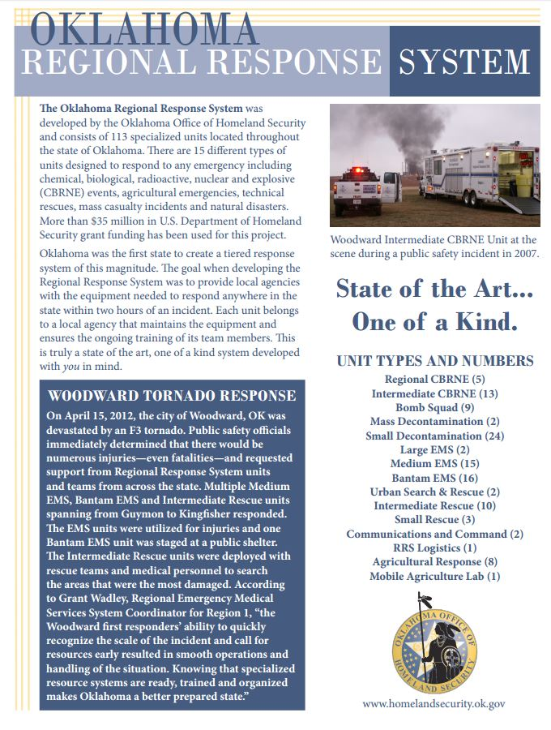

Regional CBRNE Units

The (5) Regional Chemical, Biological, Radiological, Nuclear and Explosive (CBRNE) Units are strategically located along the I-44 corridor. Each of the Regional CBRNE Units is a forty-foot self-driven apparatus. Fixed equipment on the unit includes a command and research center, laptop computers, a generator and an interoperable communication radio system. Each unit cost $ 750,000 to build and equip.

Capabilities

- Interoperable communications
- Establish control zones
- Identify chemicals by use of sophisticated monitoring and identification equipment, and reference and guide books
- Gross and technical decontamination
- Contain and mitigate hazardous liquids and gaseous product from damaged cylinders and apparatus
- Basic emergency medical procedures

Intermediate CBRNE Units

There are (13) Intermediate CBRNE Units strategically placed throughout the state. Each unit cost $450,000 to build and equip. Each of the Intermediate CBRNE Units has a 38-foot trailer equipped with a quad-cab four-wheel drive tow vehicle. Once on scene the tow vehicle can be disconnected from the trailer and be used for other needed functions such as transporting responders and equipment closer to the incident.

Additional fixed equipment includes a command and research center, laptop computers, satellite receiver, a light tower, a generator and an interoperable communications system.

Capabilities

- Interoperable communications
- Establish control zones
- Identify chemicals by use of sophisticated monitoring and identification equipment, and reference and guide books.
- Gross and technical decontamination
- Contain and mitigate hazardous liquids and gaseous product from damaged cylinders and apparatus
- Provide satellite connection for laptop computers (Internet connection)
- Basic emergency medical procedures
- Command center for emergency events

Mass Decontamination units

There are (2) Mass Decontamination units located in the state. Each of the Mass Decontamination units is a self-contained unit that contains the decontamination system within the unit. Each unit contains a generator, the ability to produce hot water and external decontamination shower heads. Each unit cost $280,000 to build and equip.

Capabilities

- Decontaminating victims and responders at a rate of 150-200 per hour
- Rest and recovery center
- Medical treatment and triage
- Personnel staging area

Small Decontamination

There are (24) Small Decontamination units throughout the state. The Small Decontamination trailer is a 14-foot trailer equipped with an electric generator, a decontamination tent, which can be used as a rehabilitation shelter and the associated decontamination equipment. Each unit cost $42,000 to build and equip.

These units work in conjunction with the Large and Intermediate Chemical, Biological, Radiological, Nuclear and Explosive (CBRNE) units to provide decontamination of victims and or responders exposed to hazardous substances. These units are not designed to clean up hazardous materials spills.

Capabilities

- Technical decontamination at a rate of approximately 50 per hour
- Command center capability
- Rehabilitation area for first responders
- Medical treatment and triage
- Personnel staging area

Bomb Squads

Oklahoma has (9) FBI Certified Bomb Squads. Each bomb squad has received a standardized bomb response robot and other equipment to ensure they have the latest state of the art equipment.

The Oklahoma Highway Patrol Bomb Squad has statewide jurisdiction and assists communities not already covered by a local jurisdiction. Team members will assist other bomb squads as requested. The bomb squads facilitate the capabilities of the Regional Response System to coordinate a response anywhere in the state of Oklahoma.

Capabilities

- Explosive detection, including X-Ray, chemical analyses, manual and K-9 search and recovery
- Commercial and military explosive recovery
- Disposal of explosives
- Pre and post blast evidence recovery
- Improvised Explosive Device (IED) mitigation and render safe practices
- CBRNE detection
- Emergency decontamination
- Crime scene
- Liaison with federal agencies (FBI, ATF, Military)
- Underwater explosive recovery

Urban Search and Rescue (US&R) Units

There are (2) Urban Search and Rescue (US&R) Units within the state. These two units have similar training and equipment to the FEMA regional US&R teams, including high level rescue capabilities. Each unit includes a 42-foot trailer and tow vehicle. The equipment cache is based on the that of the FEMA US&R requirements. Both teams have additional equipment including three quad-cab, four-wheel drive, one-ton trucks, a bobcat with attachments and a 27-foot enclosed trailer to transport the bobcat and any additional equipment. Each unit cost $1,700,000 to build and equip.

Capabilities

- Heavy structural collapse
- High angle rescue
- Confines space rescue
- Trench rescue
- Canine search for trapped victims

Intermediate Technical Rescue Units

There are (10) Technical Rescue Units across the state. Each unit cost around $450,000 to build. Each Technical Rescue Unit consists of a tow vehicle, a 38-foot trailer containing rescue equipment and a Small Rescue Unit.

The Small Rescue Unit is a multi-faceted, self-contained rescue trailer. A 44 horsepower diesel engine and a 20KVW generator powers each unit. Fixed equipment includes a full range of hydraulic core technology extrication tools, two 900-watt light towers, a breathing air compressor system, four cascade air tanks and storage for additional equipment. Once on scene the tow vehicle can be disconnected from the trailer and be used for other needed functions such as transporting responders and equipment closer to the incident.

Capabilities

- Interoperable communications
- Structural collapse operations
- High angle rescue
- Confined space rescue
- Trench rescue
- Provide O2 to refill cylinders and cascade system on other response units
- Provide electrical power to support emergencies
- Tower lighting capabilities
- Command center for emergency events

Small Rescue Unit

There are (3) stand alone Small Rescue Units across the state. Each Technical Rescue Unit also has a Small Rescue Unit as part of its equipment cadre. The Small Rescue Unit is a multi-faceted, self-contained rescue trailer. A 44-horsepower diesel engine and 20KVWgenerator powers each unit. The equipment fixed to the unit include a full range of hydraulic core technology extrication tools, two 900-watt light towers, a breathing air compressor system, four cascade air tanks and storage for additional equipment. All of the equipment is enclosed in the trailer and can be pulled easily by a 1-ton pick-up. Each unit cost $130,000 to build and equip.

Capabilities

- Rapid deployment of primary or secondary emergency equipment
- Extrication equipment for vehicular, agricultural and industrial incidents
- Lighting to assist in nighttime emergencies
- Provide breathing air to refill cylinders on the emergency scene
- Provide constant air source for air equipment needs
- Provide a source for electricity at incidents

Regional EMS System (REMSS)

The Regional EMS System (REMSS) program was developed in support of the Homeland Security Regional Response System by providing EMS medical equipment, personnel, and transportation capabilities during major events or disasters. There are currently 33 units strategically placed throughout the state. There are three types of units, , the Large, Medium and the Bantam.

Capabilities

Large EMS Units (2)

- Medical supplies and equipment capable of treating up to 200 patients

- Unit deploys with on board oxygen generation capability
- Satellite and interoperable communication
- Command post

Medium EMS Units (15)

- Medical supplies and equipment capable of treating 50-100 patients
- Units are climate controlled, and contain movable HEARS radios, a generator and outside lighting

Bantam EMS Units (16)

- Medical supplies and equipment capable of treating up to 25 patients
- Responds with oxygen and backboards
- Can be pulled by SUV or pickup

Additional Support

Additional support is provided by the Oklahoma Highway Patrol allowing them to utilize the Emergency Medical Service Unit (EMSU) to augment the Regional DMR teams. These troopers will provide triage, treatment and security assistance during a response.
Oklahoma Highway Patrol has assigned 20 troopers to the regional teams.

Agriculture Response Teams

In coordination with the Oklahoma Department of Agriculture, eight mobile cleaning and disinfecting units are strategically located across the state to facilitate the response to agricultural disaster or disease event. Agriculture Response Unit Teams will operate the mobile cleaning and disinfecting units during an animal disease outbreak or other agricultural emergency to disinfect transport vehicles and other equipment. In addition, one decontamination unit can be used to clean and disinfect equipment used during other Regional Response System emergencies. Each unit cost $80,000 to build and equip.

Capabilities

- Disinfecting contaminated equipment from an animal or plant disease outbreak
- Decontamination of equipment in a hazardous materials incident
- Rehabilitation shelter for first responders

Ag Mobile Laboratory

The State Department of Agriculture, Food and Forestry (ODAFF) received a Mobile Laboratory to assist the Agriculture Response Units in managing an incident. This laboratory can assist in other emergencies as well. The mobile laboratory can be deployed into the field for onsite testing of samples by state laboratory technicians during an animal

or plant disease outbreak or other emergency. The mobile laboratory cost $500,000 to build and equip.

Capabilities

- Mobile command post
- On-site testing for plant and animal diseases
- Rehabilitation center for first responders

Logistical Support Response Unit

The Logistical Support Response Unit is located at Oklahoma State University Fire Service Training in Stillwater, OK. The tractor-trailer contains a large air compressor, a large cache of self-contained breathing apparatus (SCBA) and extra SCBA cylinders. The unit is similar to the Regional and Intermediate CBRNE trailers with the fixed equipment cache and can be used to respond during a major incident to provide logistical to support responding Regional Response System units. The Logistical Support Response Unit cost $750,000 to build and equip. The Logistical Support Response Unit is staffed with a minimum of 12 team members who are IFSAC certified to the NFPA 472 Hazardous Materials Operations Level.

Capabilities

- Provide breathing air to refill cylinders and cascade system on other response units
- Provide electrical power to support other response units
- Portable and tower lighting capabilities
- Communication capabilities
- Additional personal protective equipment (PPE) to support emergency events

Mobile Communications and Command Units
The State of Oklahoma has (3) Mobile Communications and Command Units, referred to as Command-1, Command-2, and Command-3. All three Mobile Communications and Command Units are designed to handle large, multi-disciplinary, multi-jurisdictional events. Each unit is staffed with several team members. Each unit is staffed with several team members. Team members represent multiple agencies and possess communications, electronics and computer operations experience and have been trained to use the sophisticated computer and communications equipment on the units.

Command-1
Command-1 is a tractor-trailer unit designed to function as a command and communications unit available to respond during local or statewide disasters. It has the capability to bridge different city, county, tribal and/or state agency radio communications systems during a public safety event anywhere in the state. Command-1 is owned and maintained by the Oklahoma Highway Patrol

Command-2
Command-2 is a Mobile Communications and Command Unit that is also available for statewide deployment during a public safety event. The unit is based on a 2008 Ford F350 dual platform with a small camper-style attachment. It provides rapidly deployable communications for on-site cross-band radio net integration for VHF/UHF/800 MHz, military and amateur radio. It also provides on-site broadband Internet through and onboard satellite link, a satellite and cellular phone communications. This unit can be operated on a standalone basis with its onboard generator, and due to its small platform and four-wheel drive capability it can be used almost anywhere. Command-2 is owned and maintained by the Oklahoma Highway Patrol.

Command-3
Command-3 is owned and maintained by the Department of Agriculture and is available for deployment statewide during a public safety incident. This unit is a Chevrolet Silverado 3500HD 4WD pickup truck containing a large communications camper-style shell. Command-3 is equipped with multiple VHF, UHF and 800 MHz public safety radio systems, mobile repeaters, a mobile satellite communications system and telephone systems, among other capabilities. The design of Command-3 allows it to traverse rough terrain and operate in confined areas with a minimal amount of personnel. Command-3 was recently developed using funds from the Public Safety Interoperable Communications (PSIC) Grant Program.

Incident Resource Hotline

24/7 phone number for resource acquisition
1-800-800-2481

Johnny Vaughn, Regional Response Coordinator Office of Homeland Security
405-425-7274
johnny.vaughn@okdhs.ok.gov
www.ok.gov/homeland/index.html

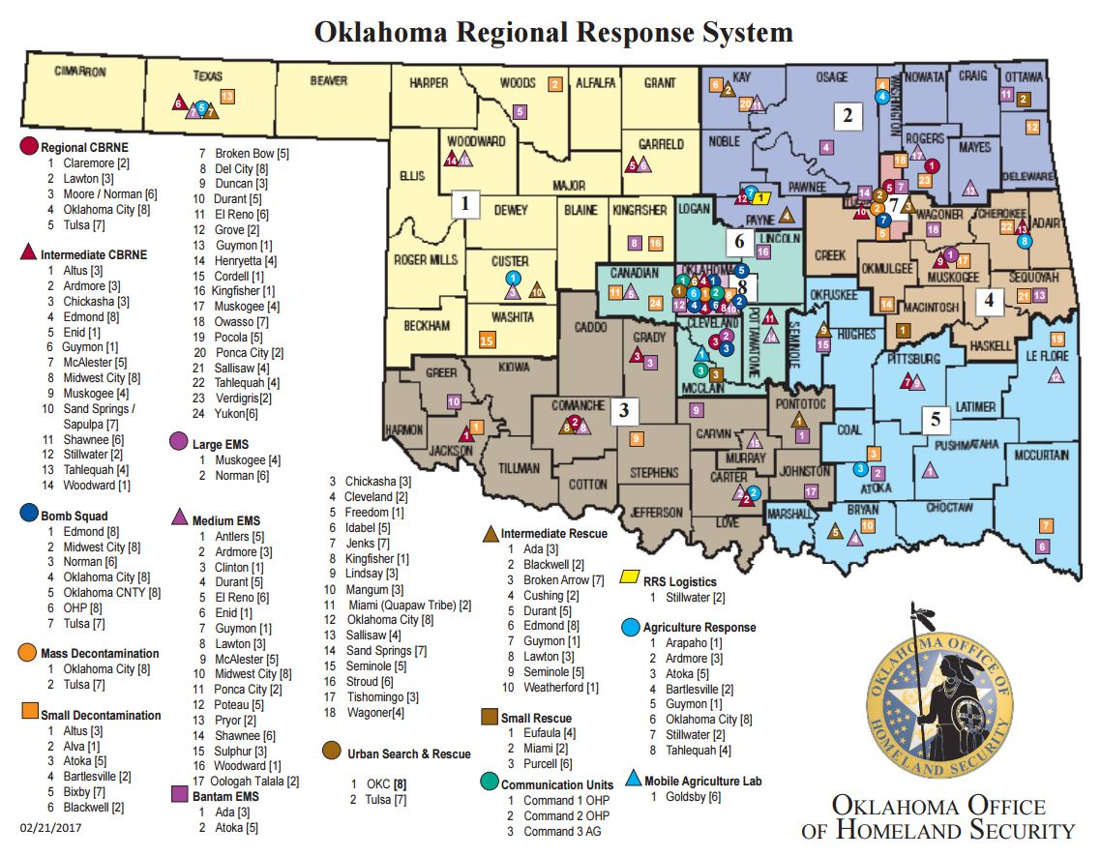

This page intentionally blank.

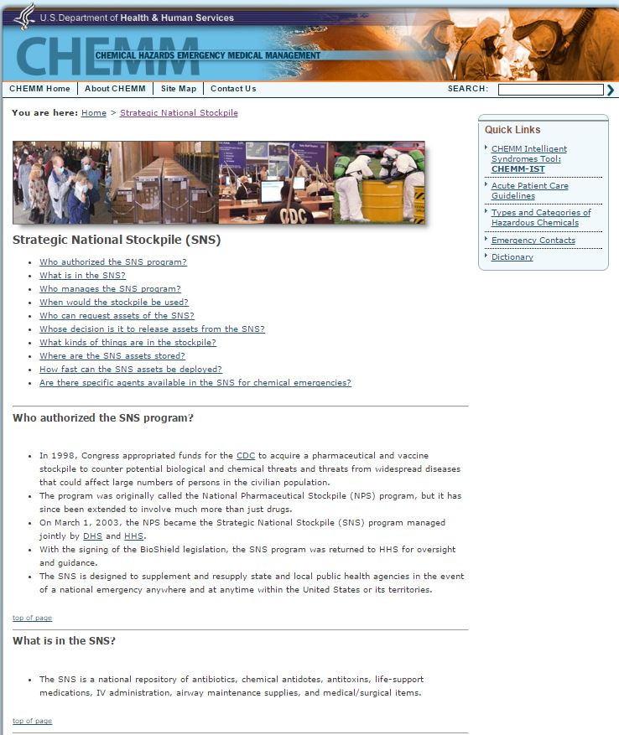

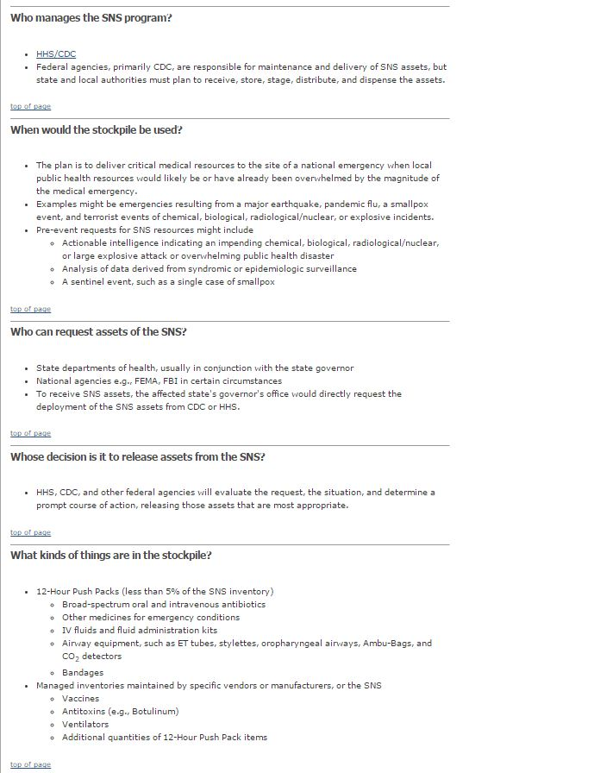

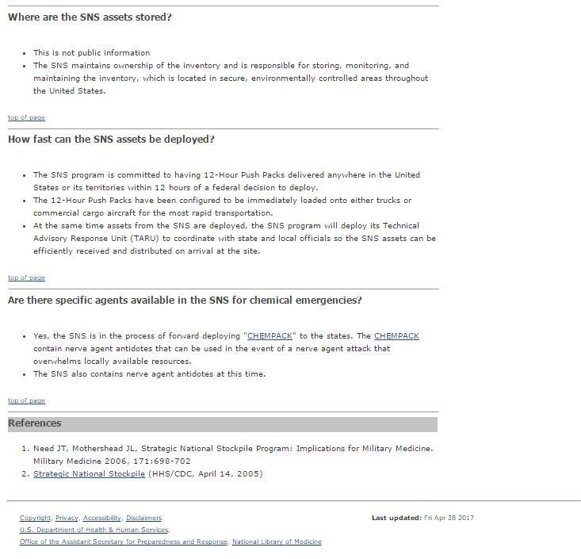

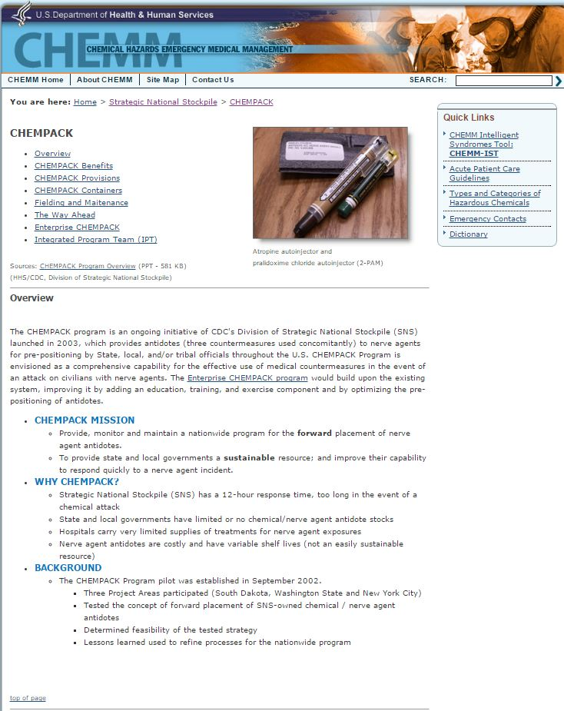
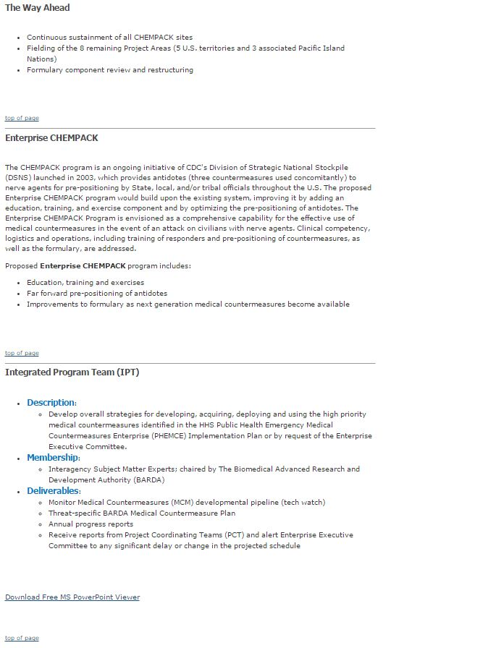

This page intentionally blank.

Annex I

LAW ENFORCEMENT

PURPOSE
This annex identifies law enforcement responsibilities, coordination requirements, and management procedures for the protection of life and property during emergencies to include crisis relocation operations.

SITUATION AND ASSUMPTION
The City of Bethany employs a full-time, paid professional police department of approximately 30 commissioned officers and 2 support personnel. The Police Department also manages the 911 center with 6 dispatchers.

BPD patrol manpower is organized into three shifts ("One", "Two", and "Three"), each of which works 8-10-hour shifts. In addition, the Detective Division and administrators work during normal business hours. If additional personnel are needed on large incidents, these investigative and administrative personnel can be utilized. In addition, the operations commander may recall off-duty personnel to duty.

BPD staffs a specialized Emergency Response Team. This group of officers – normally assigned to other departmental duties - utilizes specialized equipment and training to handle high-risk law enforcement situations such as armed and barricaded subjects, hostage incidents, and service of high-risk search and criminal warrants on subjects suspected to be armed and dangerous.

Additional law enforcement personnel are typically available from the Oklahoma County Sheriffs Department, Warr Acres Police Department, Yukon Police Department, Oklahoma City Police Department, Oklahoma Highway Patrol, Southern Nazarene Security and other area law enforcement agencies.

Additional non-commissioned personnel to assist with traffic and crowd control are typically available from the Emergency Management volunteer organization.

CONCEPT OF OPERATIONS
The Police Department will generally be able to provide adequate police control for disaster events using on-duty, call-back, mutual aid, and volunteer personnel.

Emergency operations for law enforcement personnel are simply an expansion of normal daily responsibilities. These include maintenance of law and order, traffic, and crowd control.

If the emergency event involves a barricaded subject and/or hostage situation, the PD Emergency Response Team (ERT) will be activated and a trained negotiation team will immediately be notified.

The patrol division commander or the Police Department’s Command Duty Officer will determine when control of the operation, as far as containment and/or apprehension of the subject, will be delegated to the ERT commander.

Operations will be conducted in accordance with PD SOPs. The Fire Department and EMS-STAT will stage away from the scene for a potential medical response, and the Emergency Management Director will provide the City’s command post vehicle for support of the Incident or ERT Commander and operations.

If the emergency event involves an active shooter, the Police Department will establish a safe perimeter prior to other responders entering the area.

If the emergency event will involve establishing a community shelter, MPD personnel will provide security for the shelter facility.

TASK ORGANIZATION AND RESPONSIBILITIES
The Bethany Police Department has the responsibility of maintaining law and order and the protection of life and property of the citizens of Bethany. This includes the following emergency and disaster tasks:
    - Maintenance of law and order.
    - Coordination of all law enforcement in the City.
    - Coordination of crisis relocation traffic control.
    - Support emergency public safety activities.
    - Provide security for key facilities to include; financial institutions, markets and one-stop facilities, pharmacies, hospitals (animal hospitals included), liquor stores and taverns, gun and hardware stores.
    - Provide traffic control during shelter operations or other emergencies.
    - Provide crowd control as required.
    - Provide police officers to larger shelters for law enforcement and communications.

DIRECTION AND CONTROL
The Police Chief is responsible for coordinating all law enforcement activities within the City of Bethany. All operations will be conducted using the standard command structure of the Department.

The operations commander will generally be the highest-ranking officer on-scene. Routine operations will be handled by SOP.

Each Chief of law enforcement agencies providing mutual aid assistance will maintain control of his units while operating in the City of Bethany. Each agency shall provide a liaison to be present with the operations commander. The operations commander will direct all operations of both local and mutual aid agencies. State and federal support may be called upon after all local police capability and mutual aid support has been exhausted.

CONTINUITY OF GOVERNMENT
Lines of succession for the Police Department will be according to established departmental procedures. An organizational chart of the Bethany Police Department is located in Appendix 1.

ADMINISTRATION AND LOGISTICS
The Bethany Police Department is dispatched from the City’s 911 Emergency Operations Center.

A list of facilities that may require police protection or increased security, dependent upon the situation, should be maintained by the Police Department.

PLAN DEVELOPMENT AND MAINTENANCE
The Police Chief is responsible for maintenance of this Annex.

AUTHORITY AND REFERENCES
Bethany Police Department Policy and Procedures Manual

APPENDICES
Appendix 1 - Bethany Police Department Organizational Chart

This page intentionally blank.

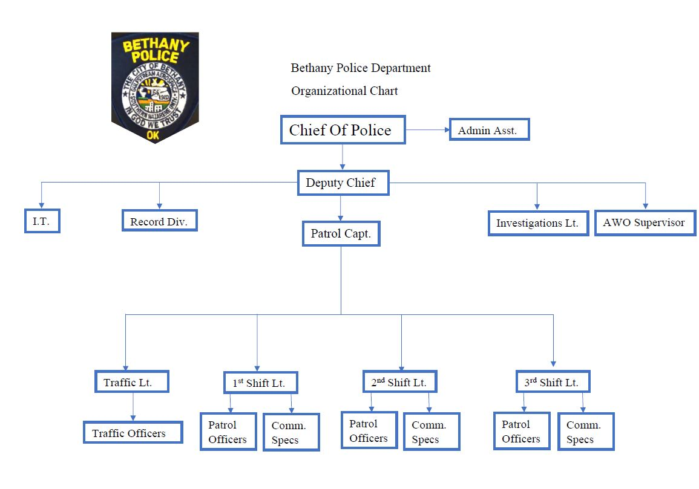

This page intentionally blank.

Annex J

PUBLIC WORKS

PURPOSE
This Annex establishes procedures and priorities for the Public Works and Public Utilities departments in response to an emergency or disaster in the City of Bethany. This annex also supplements the EOP to comply with the Public Health Security and Bioterrorism Preparedness and Response Act of 2002.

SITUATION AND ASSUMPTIONS
For the purposes of this Annex, all of the following will be referred to as “Public Works”, unless otherwise noted.

The City of Bethany Public Works Department consists of the following divisions:
- Streets & Drainage;
- Sanitation;
- Fleet Maintenance;
- Building Maintenance;
- Cemetery and Landscape Maintenance.
- Wastewater Treatment & Collection;
- Water Production & Distribution.

The City of Bethany operates a water production/distribution system consisting of approximately 23 water wells, 4 storage facilities, and a distribution system. Having many wells means that the system is not dependent on any one well for the City’s water. The water system also includes interconnections with the City of Oklahoma City’s water system to provide an additional source of water. The City of Bethany’s water system is not extremely vulnerable to city wide water outages due to the many redundancies built into the system; however the threat of contamination cannot be addressed by mitigation alone.

CONCEPT OF OPERATIONS
Following a large emergency, disaster or attack, Public Works will coordinate tasked responsibilities with the EOC and the Incident Commander. Immediately, these will include:

- Emergency repairs to the City’s critical facilities, including water and sewer infrastructure, buildings, and equipment;
- If necessary, coordinate emergency testing of water supplies to ensure safe drinking water.
- Coordinate emergency public notification information as outlined in Annex D of this Plan;

- If necessary, follow contamination and/or damage Action Plans for the potable water system as outlined in Appendix 1 and 2;
- During events that potentially involve criminal intent, the Incident Commander will ensure immediate notification of proper law enforcement authorities.
- Emergency repairs and refueling to the City’s emergency response equipment;
- Collection of displaced animals, including transportation to a veterinary clinic if injured, or sheltering facility-(see Animal Response Plan Annex F, Appendix 2);
- Provision of heavy equipment to the Incident Commander upon request;
- Provision of, emergency maintenance, and refueling of emergency lighting equipment;
- Provision of information to the Incident Commander, EOC, and Public Information Officer concerning the status of the City’s utilities, including the safety of drinking water.
- Emergency debris removal from streets and City facilities, to include snow and ice during winter storms and trees during windstorms;
- Erection of barricades and other traffic control devices;

As personnel and equipment become available and as coordinated with the Incident Commander, Public Works will also:
- Continue debris removal from streets and City facilities;
- Repair of roads, bridges, and traffic control devices;
- Prepare and post replacement street signs;
- Prepare and post temporary signs and barricades as requested by the Police Dept.
- Additional repairs to City facilities and utilities;
- Photograph all live and deceased animals collected; place the photographs at shelter locations and other public locations to assist in the identification and reunion of animals with their families, utilize social media to distribute photos and information.
- Adopt unclaimed animals to new homes after all attempts at identification and reunion have failed, and the specified waiting period has passed;
- Provide and service collection bins for spoiled food (dumpsters) in or around the affected areas;
- Provide and service collection bins for hazardous debris items such as propane bottles, automotive batteries, pesticides, etc. in or around the affected areas.

Critical documents, “as-built” plans, GPnS data, and operational and maintenance manuals are maintained at the EOC and the Wastewater Treatment Plant.

TASK ORGANIZATION AND RESPONSIBILITIES
The Public Works and Public Utilities Departments/Veolia Water are responsible during periods of emergency take necessary actions to prevent damage to public services, facilities and streets, and to restore them to normal operations, if damaged. These Departments must also support the City’s emergency service departments with actions to control damage and prevent loss of life. See Section III above for individual responsibilities.

ANNEX J
PUBLIC WORKS

DIRECTION AND CONTROL
Executive authority for Public Works is vested in the City Manager. Operational authority will remain with the Director of Public Works and the Public Utilities Manager as tasked by the Incident Commander and the EOC.

CONTINUITY OF GOVERNMENT
Debris clearance from and emergency repairs to critical City facilities and utilities should be undertaken as soon as the situation allows.

Alternates and lines of succession for all supervisory personnel will be established via Departmental SOP.

ADMINISTRATION AND LOGISTICS
Each individual department will document personnel hours related to the emergency response, as well as materials and equipment used, and equipment time. This documentation will be made available to the City’s Accounting Director as requested.

PLAN DEVELOPMENT AND MAINTENANCE
The Director of Public Works and the Utilities Manager will review this Annex annually, with needed changes submitted to the City’s Emergency Management Director.

AUTHORITIES AND REFERENCES
Relevant EPA, DEQ, Water Resources Board and/or other state, county or local regulations.
APPENDICES
Appendix 1 Water System Contamination Incident Action Plan
Appendix 2 Water System Structural Damage/Physical Attack Incident Action Plan Appendix 3 Critical Water Users
Appendix 4 Top 25 Water Consumers

This page intentionally blank.

Water System Contamination Incident Action Plan

Threat Warning Stage
Threat Warning Received
Special actions and notifications to be taken:
- Notify IC or Alternate Leader
- Record and document all information pertaining to the threat warning
- Do not disturb site if the threat warning could be a possible crime scene
- Return to normal operations if no further action is required (i.e., the threat warning can be explained)
- Begin the "Threat Decision Process" If the threat warning cannot be explained
Is the Threat Possible?
Special actions and notifications to be taken:
- Notify Bethany Police Chief, Emergency Management Director and City Manager
- Notify DEQ, Water Quality Division
- Evaluate threat warning and make decisions in Consultation with DEQ,City Manager, Police Chief, and Emergency Management Director
- Initiate basic precautionary measures:
  - Alert Staff and personnel about threat warning
  - Prepare additional notification lists if the situation escalates to the "Is the
  - Heighten security at critical facilities
If this threat is not possible, then return to normal operations.
Otherwise, proceed to "Is the Threat Credible" Stage.
Threat Decision Process Stage

Is the Threat Credible? | Special actions and notifications to be taken:  - Evaluate whether the threat is credible in consultation with assisting agencies.  - Visually inspect physical evidence and determine whether there is a change in normal systme operating parameters. (i.e. chlorine residuals, turdity, odor, color, pH, etc.)  - Contact the Oklahoma National Guard 63rd WMD/CST and the City's contracted lab for testing and sampling

If this threat is not credible, then
return to normanl operations. Otherwise, proceed to "Has the Threat been Confirmed" Stage.

Has the Incident Been Confirmed? | Special actions and notifications to be taken:  - Initiate full EOP activation  - Follow State Incident Command System  - Isolate portion of the system and/or backflush  - Shut down system if obvious or confirmed contamination warrants
 | - Issue public notices and issue follow-up media press releases
 | - Continue sampling and water monitoring
 | - Assess the need to remediate storage tanks, wells, pipe, pumps, etc.

Is the Threat Possible?
Special actions and notifications to be taken:
- Notify Bethany Police Chief, Emergency Management Director and City Manager
- Notify DEQ, Water Quality Division
- Evaluate threat warning and make decisions in Consultation with DEQ,City Manager, Police Chief, and Emergency Management Director
- Initiate basic precautionary measures:
  - Alert Staff and personnel about threat warning
  - Heighten security at critical facilities
  - Prepare additional notification lists if the situation escalates to the "Is the Threat Credible Stage"
If this threat is not possible, then return to normal operations.
Otherwise, proceed to "Is the Threat Credible" Stage.
Has the Incident Been Confirmed?
Special actions and notifications to be taken:
- Initiate full EOP activation
- Follow State Incident Command System
- Deploy damage assessment team
- Isolate damaged facility from rest of water system
- Coordinate alternative water supplies
- Issue public notices and issue follow-up media press releases
- Repair damaged facilities
- Assess need for additional protection/security measures
Structural Damage Incident Action Plan

Threat Warning Stage

Threat Warning Received | Special actions and notifications to be taken:  - Notify IC or Alternate Leader  - Record and document all information pertaining to the threat warning  - Do not disturb site if the threat warning could be a possible crime scene  - Return to normal operations if no further action is required (i.e., the threat warning can be explained)  - Begin the "Threat Decision Process" If the threat warning cannot be explained
Threat Decision Process Stage

Is the Threat Credible? | Special actions and notifications to be taken:  - Physically secure water system facilities  - Evaluate whether the threat is credible in consultation with assisting agencies

If this threat is not credible, then return to normanl operations.
Otherwise, proceed to "Has the Threat been Confirmed" Stage.

Annex J / Appendix 3
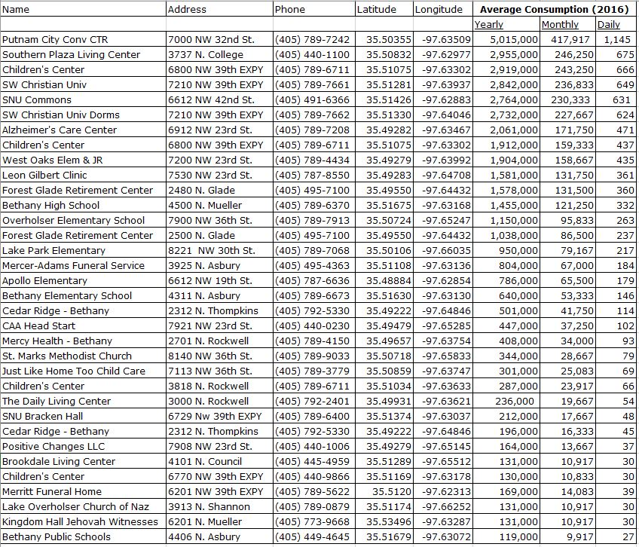
CRITICAL WATER USERS

Annex J / Appendix 3
Critical Water Use
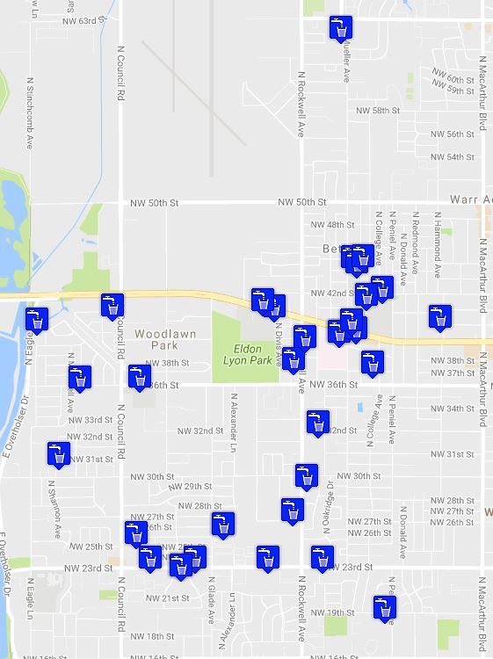

Annex J / Appendix 4
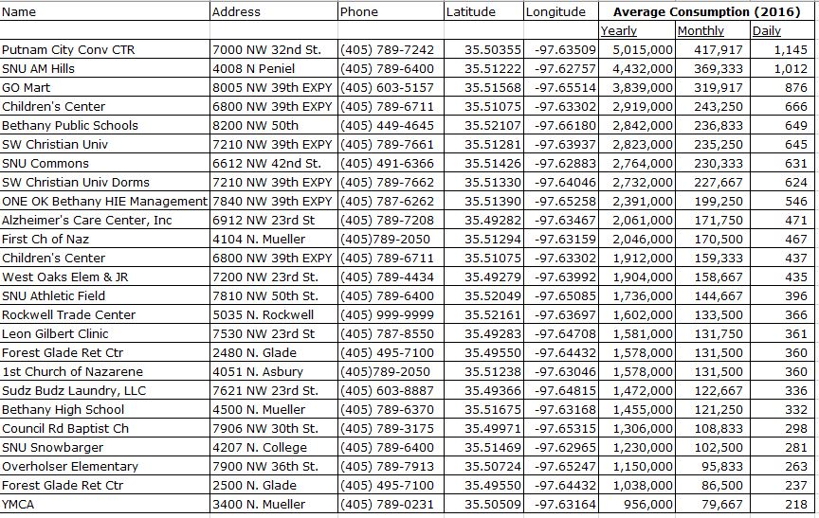
Top 25 Water Consumer

Annex J / Appendix 4
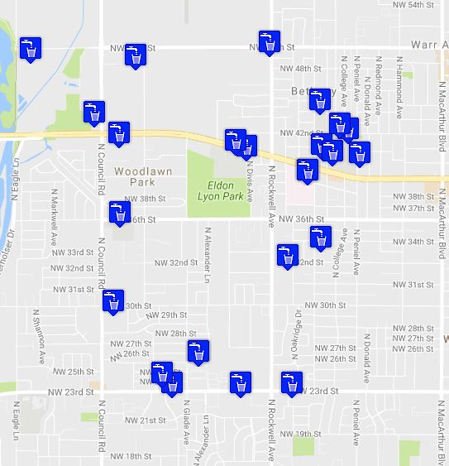
Top 25 Water Consumer
Annex K

FIRE AND RESCUE

PURPOSE
This annex establishes a fire and rescue plan to be used in emergency or disaster situations.

SITUATION AND ASSUMPTIONS
The City of Bethany employs a full-time, paid professional fire department of approximately 21 firefighters, 1 Fire Chief, 1 Deputy Chief for a total of 23 personnel.

BFD manpower is organized into three shifts ("Blue", "Green", and "Red"), each of which work 24-hour shifts. If additional personnel are needed on large incidents, the Incident Commander can initiate a recall of off-duty personnel.

BFD operates from a single station at 3919 N. Rockwell.

The Oklahoma Homeland Security Region 6 CBRNE Hazardous Materials Unit is available to provide support above the Operations level. This unit is capable of responding to chemical, biological, radiological, nuclear, and explosive events, is available for both local and statewide response. See Annex H for additional information on this unit, and activation procedures for all of the assets of the Oklahoma Regional Response System.

Additional fire manpower and resources are available via Automatic Aid or Mutual Aid from the Warr Acres, Yukon, Oklahoma City and other area Fire Departments.

CONCEPT OF OPERATIONS
The Fire Department will generally be able to provide adequate fire suppression, rescue, and medical first-responder services for disaster events through the use of on-duty, recall, and mutual aid personnel and resources. Emergency operations for fire personnel are simply an expansion of normal daily responsibilities, and are guided by Departmental SOGs.

At hazardous materials events, the Fire Department will (as able):
- Perform emergency rescue of persons within the immediate area;
- Isolate and cause evacuation of the immediate area, assuring the safety of people and the environment;
- Identify the hazard, the approximate amount spilled, and the approximate amount left in any container;
- If necessary, request assistance from a qualified hazardous materials response team;
- Assist in containing spilled product and stopping any further spills;
- Ensure that a qualified hazardous materials cleanup team is notified by the generator of the spill, or if no generator can be located within a reasonable amount of time, request a cleanup team;
- Ensure that the generator has made notifications to the Local Emergency Planning Committee, the Oklahoma Dept. of Environmental Quality, the National Response Center, and other agencies as may be required by law.

- Assist the response and cleanup teams as requested.

TASK ORGANIZATION AND RESPONSIBILITIES
The Bethany Fire Department has the responsibility of the protection of life and property of the citizens of Bethany. This includes the following primary tasks during large emergencies and disasters:
- Fire suppression;
- Emergency medical triage and treatment;
- Hazardous materials operations;
- Search and rescue operations;
- Emergency public information.

DIRECTION AND CONTROL
The Fire Chief is responsible for coordinating all fire and rescue activities within the City of Bethany. All operations will be conducted using the standard command structure of the Department. Routine operations will be handled by SOP.

All on-scene fire/rescue operations will be conducted using the Incident Management System. The Incident Commander will generally be the on-duty Battalion Chief. Command may be passed to any other emergency responder as the need arises. All radio traffic should be directed through the Incident Commander, or if established, the designated on-scene Fire Communications Officer.

Each Chief of a fire agency providing automatic aid or mutual aid assistance will maintain control of his units while operating in the City of Bethany. Each agency shall provide a liaison to be present with the Incident Commander. The Incident Commander will direct all operations of both local and mutual aid agencies. State and federal support may be called upon after all local fire capability and mutual aid support has been exhausted.

CONTINUITY OF GOVERNMENT
Lines of succession for the Fire Department will be according to established departmental procedures.

ADMINISTRATION AND LOGISTICS
The Bethany Fire Department is dispatched from 911 Emergency Operations Center at the Bethany Police Department.

The City will attempt to recover incurred costs for hazardous materials response as set forth by City ordinances.

PLAN DEVELOPMENT AND MAINTENANCE
The Fire Chief is responsible for maintenance of this Annex.

AUTHORITIES AND REFERENCES
- U.S. Dept. of Transportation, “2016 Emergency Response Guidebook”
- City of Bethany Code of Ordinances, Chapter 34 “Fire Department”
- City of Bethany Code of Ordinances, Chapter 36 “Civil Defense; Emergencies”

APPENDICES
Appendix 1 – Fire and Medical Facilities and Response Districts Map

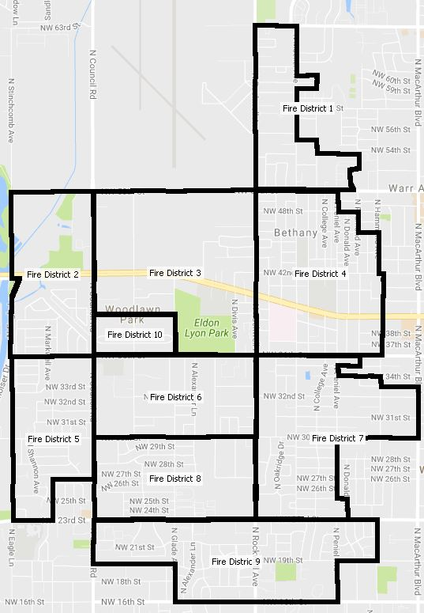
City of Bethany Fire Districts

This page intentionally blank.

Annex N

RESOURCE MANAGEMENT

PURPOSE
The purpose of this Annex is to describe the means, organization, and process used to find, obtain, allocate, distribute, and track resources needed during a disaster response.

SITUATION AND ASSUMPTIONS
Emergency response may require large amounts of resources, including but not limited to:
- Skilled and unskilled personnel;
- Transport vehicles;
- Heavy machinery for public works applications;
- Consumables such as fuel, plastic sheeting, gloves, etc;
- General tools, such as shovels, chainsaws, etc.
- Mass care supplies, such as potable water, food, bedding, medical and sanitation supplies, etc.
- Portable power generators.

All response agencies must have sufficient resources to self-sustain for at least the first 24 hours of an emergency. It should be assumed that commercial power, telephone, and data communications (email/internet) will not be available during at least the first 24 hours of an emergency.

Early perimeter control will be critical. Large numbers of spontaneous, unaffiliated volunteers – both skilled and unskilled – will present themselves during the first few days of the event.

Large amounts of unsolicited donations – of both needed and unneeded items – will be received. If not properly managed, these will overwhelm available warehousing space.

CONCEPT OF OPERATIONS.
The Incident Commander of an event will typically establish a resource section for emergency personnel and resources, typically headed by a Staging Officer. Once established, all requested incoming personnel and emergency equipment will report to the Staging Officer, and remain in the staging area until tasked by the Staging Officer. The Staging Officer should be mindful that outside personnel will likely need detailed directions, maps, and local communications once tasked.

Depending on the size of the event, a separate staging area may be needed for public works equipment. This staging area will need to accommodate trucks with large trailers. Communications should be established between this staging area and the Incident Commander.

VOLUNTEERS
To manage a large influx of spontaneous, unaffiliated volunteers, the Incident Commander may request activation of a Volunteer Reception Center. The OKVOAD

volunteer management committee will accomplish this. The VRC will be established at a location away from the incident scene, and from the regular staging area.
Volunteer registration may also be supported via a phone bank and/or website. Unaffiliated volunteers should be referred to the Volunteer Reception Center for screening.
Through the Public Information Officer, distribute the name and location of the Volunteer Reception Center, as well as any applicable phone numbers or websites. Advise the public to avoid the incident scene, even if they intend to volunteer to help.

Access to the incident scene will be with approved identification only. For unaffiliated volunteers, badges will be provided at the VRC.

DONATIONS
If large amounts of donations begin to arrive, the Incident Commander should establish a donations section, preferably at an area away from the command post and staging areas. If the emergency is on-going, the EOC should assume responsibility for the donations section and task a person to this assignment.
Typically, this assignment will be given to the Economic Development Director. In general, the donations section should:
- Liaise with the Incident Commander to identify resource needs that might be met with donated items;
- Receive offers of and actual donations;
- Match offers and supplies to needs, ensuring that all responders and agencies receive equitable distribution; as incident allows
- Through the Public Information Officer, disseminate information to ensure that offers are not impropriate to needs;
- If necessary and appropriate, solicit specific donations of needed items from suppliers;
- Work with the City’s Purchasing Agent to assist in procuring items that need to be purchased;
- Arrange for warehousing of donations;
- Arrange for transportation of resources from the donations area to the needed area as necessary;
- Arrange for disposition of unused donations after the emergency is concluded.

The Public Information Officers should have constant communication with the Incident Commander, staging officers, and the donations section officer to determine if a public call for resources should be disseminated, and if so, the exact items and quantities needed.

TASK ORGANIZATION AND RESPONSIBILITIES
The Incident Commander is responsible for establishing a Staging section. He is further responsible to identify resource needs and to liaise with the donations unit leader.

The Economic Development Director is responsible for all donations activities. The OKVOAD VRC Team is responsible for management of unskilled volunteers.

DIRECTION AND CONTROL
The City Manager will retain executive authority for all issues related to resource management. The Incident Commander will have operational authority for resource management at the direct incident. The donations unit leader will have operational authority for management of the donations section.

VRC staff will assign unaffiliated volunteers to existing response partners.

CONTINUITY OF GOVERNMENT
At least three people should be trained to assume management of the donations section so as to ensure continuity of the section should any particular person be unavailable.

ADMINISTRATION AND LOGISTICS
All materials brought to the incident scene should be re-directed to the donation reception area. All donations must have their financial status determined prior to acceptance (free donation, cost if used, etc).

All materials to be purchased must follow established City purchasing regulations. Preference should be given to local suppliers, if possible.

The Incident Commander/Staging Officer and donations unit leader will keep records of any material, supplies, and equipment used from private sources during an emergency and forward them to the City Purchasing Agent for settlement following the emergency, if required.

PLAN DEVELOPMENT AND MAINTENANCE
The Emergency Management Department is responsible for maintaining and updating this Annex annually.

AUTHORITIES AND REFERENCES
FEMA, SLG 101: “Guide for All-Hazard Emergency Operations Planning”

This page intentionally blank.

Annex P

DAMAGE ASSESSMENT

PURPOSE
This annex provides guidelines for the determination of areas and status of residences and facilities affected by an emergency or disaster.

SITUATION AND ASSUMPTIONS
It is necessary to quickly determine the physical extent of emergencies and disasters, and the status of buildings, facilities, and infrastructure within the affected area. This intelligence will assist the Incident Commander and Emergency Operations Center in determining the amount and types of resources needed to bring the emergency under control.

It is also necessary to complete a more detailed assessment of damage on each specific structure. This assessment is necessary to ensure that all affected areas receive assistance; to assist the Mayor, Governor, and President in determining if a disaster declaration is necessary; and to document the disaster event for later programs.

Numerous entities conduct damage assessments and rely upon damage assessment information. Damage assessments should be conducted jointly, if possible, to reduce the amount of manpower needed and reduce the impact upon the disaster area.

CONCEPT OF OPERATIONS
The Incident Commander will initiate damage intelligence operations as part of the incident size-up. Collection of damage intelligence may be via responding public safety units, or tasked to the EOC for formal damage intelligence teams. The City’s Communications Dispatchers will also collect damage intelligence as part of their emergency communications duties, and ensure that such information is forwarded to the IC and Emergency Management Director.

The Emergency Management Department will initiate a complete damage assessment as soon as emergency debris clearance and search and rescue activities have concluded. If Incident Command is still established when damage assessment activities begin, the IC will assist the damage assessment teams with access to the affected areas via coordination with the EOC.

The City of Bethany and the American Red Cross have defined a working relationship to work together to perform damage assessment. This agreement has established operational protocols as follows:
- Both the City and the ARC will identify a primary point of contact to facilitate coordination of activities;
- Both groups will independently analyze the size and scope of the event, and compare data to determine the number of damage assessment teams needed;
- Both groups will poll personnel for availability to serve on teams, and determine a meeting time and location.
- At the staging location, teams assigned to areas and deployed (note that ARC

teams will not routinely conduct damage assessment in commercial areas, and that City teams should be assigned);
- Completed assessment forms from the teams will be copied and shared between the City and ARC, and aggregated data collected by either entity may be shared.

The City’s Risk Management Director will initiate a complete damage assessment of City owned property for insurance claim purposes. Information gathered will be shared with the IC and EOC as necessary.

The City’s damage assessment will be compiled onto State Emergency Management forms and a summary sent to ODEM as soon as completed.

TASK ORGANIZATIONS AND RESPONSIBILITIES
The Incident Commander will be responsible for initiating damage intelligence operations, and assisting with damage assessment as needed.

The Emergency Management Director will be responsible for
- Establishment and training of personnel to accomplish damage assessment;
- Completion of a full damage assessment;
- Liaise with the ARC damage assessment leader;
- Provision of damage assessment information to responders, City Department Heads, the ARC, and State/Federal agencies upon request.

The Risk Management Director will be responsible for collection of specific information concerning damage to all City of Bethany facilities and equipment.

DIRECTION AND CONTROL
Operational authority for damage assessment operations will rest with the City’s Emergency Management Director and the City Manager.

CONTINUITY OF GOVERNMENT
Damage to City facilities and property should be noted as soon as possible so that emergency repairs can be made and limit the amount of disruption to the provision of City services.

ADMINISTRATION AND LOGISTICS
Official damage assessment report forms will be established by the Oklahoma Emergency Management Department. Current copies of these forms will be kept in Appendix 1 of this annex, on clipboards in the EOC, and in the City’s Emergency Operations vehicle.

Quarter-section parcel maps of the City will be provided to damage assessment teams as part of the pre-action briefing.

All maps and damage assessment forms will be maintained by the Emergency Manager to document all physical effects to the community caused by the disaster.

PLAN DEVELOPMENT AND MAINTENANCE
This damage assessment annex will be reviewed yearly as part of the annual review of the City of Bethany Emergency Operations Plan as outlined in Section VIII of the Basic Plan. The Emergency Management Department is responsible for this annex.

AUTHORITIES AND REFERENCE
FEMA SLG-101, “Guide for All-Hazards Emergency Operations Planning” ODEM Local Government Guide To Disaster Recovery Operations
ODEM Documenting Disaster Damage for Public Assistance

APPENDICES
Appendix 1 - Letter of Understanding between the American Red Cross and the City of Bethany
Appendix 2 – State of Oklahoma Structural Damage Assessment forms

This page intentionally blank.

Letter of Understanding

Between

The American Red Cross

and

City of Bethany

I. Purpose

The purpose of this Letter of Understanding (LOU) is to define a working relationship between The American Red Cross (hereinafter "Red Cross") and City of Bethany, Oklahoma and its agencies, hereinafter "City”, In preparing for, assessing and responding to disasters. This LOU specifically provides the broad framework for cooperation and support between the Red Cross and the City in completing Disaster Assessment (DA) in disaster-impacted areas.

II. Parties

- City of Bethany
- American Red Cross

III. Concept of Operations

Each party to this LOU is a separate and independent organization. As such, each organization retains its own identity in providing service, and each organization is responsible for establishing its own policies and financing its own activities.

- Cooperative Actions

  - It is agreed 'that effective upon signature of this LOU, Red Cross and the City will work together to perform DA, including Detailed Damage Assessment (DDA), in the aftermath of disasters impacting the City of Bethany, Oklahoma.

  - Red Cross and City EM will establish operational protocols as follows:

    - Each party will identify a primary point of contact to facilitate coordination of activities.
    - After a disaster occurs, the Red Cross and City will independently analyze the size and scope of the event.
    - The Red Cross and the city will compare data to determine the number of teams needed for DA.
    - The Red Cross and the city will each poll volunteers or City employees for availability to serve on DA teams.
    - The Red Cross and the city will determine a meeting time and staging location for DA teams.
    - The Red Cross and City will contact their respective team members and provide staging details.
    - At the staging area, the affected area will be divided and DA teams will be assigned to areas and deployed.
    - DA Teams that complete their area surveys may be reassigned to assist other teams in their area,
    - Teams will return upon completion to staging area and street-sheets will be copied and shared between the Red Cross and City.
    - Aggregated data collected by the Red Cross may be made available to the City as map data.

  - Red Cross teams will not routinely conduct DA in commercial or business districts. The City will assign teams to work in these areas.

  - The Red Cross will identify and recruit additional DA resources to support local activities if indicated.

  - The Red Cross will advise the City, if requested, on best practices regarding the setup of a texting or paging system for volunteer and employee notification.

  - The Red Cross will provide basic DA training for City employees and volunteers designated to engage in DA activities.

  - City volunteers who choose to work as registered Red Cross volunteers during specific events must adhere to Red Cross protocols and activity guidance, display Red Cross Identification, and work under Red Cross supervision. In these instances, they will be considered Red Cross volunteers only.

  - Registered Red Cross volunteers who choose to work as City volunteers during specific events must adhere to City protocols and activity guidance, display City identification (and no Red Cross identification), and work under City supervision. In these instances, they will be considered City volunteers only.

V. Periodic Review
The parties will, on an annual basis, on or around the anniversary date of this LOU, jointly evaluate the progress in implementing this Letter of Understanding and revise and develop new plans or goals as appropriate.

- Term and Termination

This LOU is effective as of __________________. This LOU may be terminated by written notification from either party to the other at any time and for any reason or for no reason.

- Miscellaneous

This LOU does not create a partnership or a joint venture and does not create any financial commitments from one party to the other. Neither party has the authority to bind the other to any obligation. It is not intended that this LOU be enforceable as a matter of law in any court or dispute resolution forum. The sole remedy for non-performance under this LOU shall be termination, with no damages or penalty.

City of Bethany The American Red Cross

By: ___________________________

Name: ________________________

Title: __________________________

Date: _______________

By: ___________________________

Name: ________________________

Title: __________________________

Date: __________________

'

By: ___________________________

Name: ________________________

Title: __________________________

Date: _______________


Structural Damage Assessment
State of Oklahoma • Department of Emergency Management Telephone (405) 521-2481 • FAX (405) 531-4053

Type of Event: | Date of event: |  |  | Date of Assessment: |  |  | Assessment Team Members:
Type of Event: | Time of event: |  |  | Time of Assessment:
City: County:
Street Location/Other:
Street Number | Damage Level |  |  |  | Primary Residence |  |  |  | Insurance  F P N |  |  | Notes
Street Number | Affected | Minor | Major | Destroyed | Yes | No | Own | Rent
1
2
3
4
5
6
7
8
9
10
11
12
13
14
15
S |  |  |  |  | USE THE CODES TO COMPLETE THIS FORM  S - Single Family Dwelling Type of Insurance  M - Mobile Home F - National Flood Insurance  A - Apartment Building (number of Units) P - Property & Casualty Insurance P - Public Building (Specify in notes, N - No Insurance  Church, School, Hospital, Etc.) B - Businesses  PLEASE USE BLACK BALLPOINT PEN • PLEASE PRINT LEGIBLY
M
A
P
B
Category Total
Page Total

OEM Form DA-1 (Rev. October 2003) Front

This page intentionally blank.


Structural Damage Assessment Summary Worksheet State of Oklahoma • Department of Emergency Management Telephone (405) 521-2481 • FAX (405) 531-4053

JURISDICTION: | DATE: |  | TIME: |  | SUBMITTED BY:
JURISDICTION: | IMPORTANT NOTE: DO NOT include outbuildings - such as barns, equipment, storage sheds, pol barnes, gazebos, fences, and/or similar structures. |  |  |  | DATA SOURCE (EMD, DA, ARC OTHER)  - SPECIFY
LEGEND: EMD-EMERGENCY MANAGEMENT DIRECTOR DA - DAMAGE ASSESSMENT ARC - AMERICAN RED CROSS INSTRUCTIONS: COMPLETE THIS FORM USING THE CUMMULATIVE TOTAL OF ALL ODEM FORM DA-1's FOR YOUR PARTICULARF DISASTER
TYPE STRUCTURE: | Affected: Minor: |  | Major: | Destroyed: |  | Occupant Profile
TYPE STRUCTURE: |  |  | Major: |  |  | Ins | No Ins | Own | Rent
SINGLE FAMILY HOMES - S
MOBILE HOMES - M
APARTMENTS AND OTHER MULTI-FAMILY UNITS - A
BUSINESSES - B
PUBLIC BUILDINGS - P
TOTAL

OEM Form DA-2 (REV. October 2003

DAMAGE LEVEL

Affected. This category includes dwellings with some damage to structure and contents but which are habitable without repairs.

Minor. Minor damaged encompasses a wide range of damage and is generally the most common type of damage. Minor damage exists when the home is damaged and uninhabitable, but may be made habitable in a short period of time with home repairs. Some of the items that determine minor damage are listed below:

- Can be repaired within 30 days.
- Has less than 50% damage to structure.

Major. Major damage is when the home has sustained structural or significant damages, is uninhabitable and requires extensive repairs. Any one of the following may constitute major damage.

- Substantial failures to structural elements of the residence (e.g., walls, floors, foundation, etc.).
- .Has more than 50% damage to structure.
- Damage that will take more than 30 days to repair.

Destroyed. Destroyed means the structure is a total loss or damaged to such an extent that repairs are not economically feasible. Any one of the following may constitute a status of destroyed:

- Structure is not economically feasible to repair.
- Structure is permanently uninhabitable
- Complete failure of major structural components (e.g., collapse of basement walls/foundation, walls, or roof).
- An unaffected structure that will require removal or demolition (e.g., beachfront homes that will be removed due to local ordinance violations as a result of beach erosion, other issues that cause a permanent state of imminent danger, such as mudslides, etc.).

OEM Form DA-1 (Rev. October 2003) Back

NOTICE OF INTEREST (NOI) FOR PUBLIC ASSISTANCE
DECLARATION NUMBER  OKLA - - DR | PROJECT APPLICATION NUMBER  - | NOI DATE

The purpose of this form is to list damages to property and facilities so that inspections may be appropriately assigned for formal survey.

REQUIREMENTS FOR OKLAHOMA DAMAGE SURVEYS

A. DEBRIS CLEARANCE B. PROTECTIVE MEASURES
D On public Roads & Streets D Life and Safety
D Other public property D Property
D Private property (When undertaken D Health
by local government forces) D Stream/Drainage Channels
D Structure Demolition

C. ROAD SYSTEMS D. WATER CONTROL FACILITIES
D Roads D Culverts D Dikes D Dams
D Bridges D Traffic Control D Drainage Channels D Levees
D Streets D * D Irrigation Wks D *

E. BUILDINGS AND EQUIPMENT F. PUBLIC UTILITY SYSTEMS
D Buildings and Equipment D Water
D Supplies and Inventory D Sanitary Sewerage
D Vehicles or other equipment D Storm Drainage
D Transportation Systems D Light/Power
D * D *

G. OTHER D Park Facilities D Recreational Facilities
* Indicate type of facility

NAME OF POLITICAL SUBDIVISION OR ELIGIBLE APPLICANT PRIVATE NONPROFIT COUNTY
(Note: If private Nonprofit, provide name of facility and/or Private Nonprofit Owner.)

D YES D NO Oklahoma
AGENT/TITLE

BUSINESS ADDRESS (Include Zip Code)

BUSINESS TELEPHONE (Include Area Code and Ext.) │ HOME TELEPHONE (Area Code)

ODCEM Form 94-1

GENERAL INSTRUCTIONS FOR COMPLETING ODCEM FORM No. 94-01

- General Information:

  - Complete this form using information obtained from damage surveys of public facilities and structures.

  - The completed form along with any continuation sheets should be forwarded to the State Department of Civil Emergency Management by Fax (405-521-4053) or by telephone (405-521-2481 or 1-800- 800-2481).

  - Upon receipt of the information the State Office will contact you to schedule a joint preliminary damage survey, obtain more information, or to discuss your assistance requirements.

- DAMAGE INFORMATION (Top of the Form):

  - Under each of the categories check the number of boxes that you feel apply to the damages you have incurred.

  - When you check a box and additional information is required, (such as number and type of culverts, size of bridge, type of bridge, number and size of buildings, number of electrical power poles down, etc.) write in the information next to the checked box. If there is not enough space on the form then use a sheet of plain paper.

- APPLICANT INFORMATION:

  - Give complete name of your jurisdiction or organization, and indicate whether you are a private nonprofit organization.

  - Give the name of the County that your jurisdiction or organization is located in. If any of the damaged facilities are in a different county then include a note as to which counties they are in.

  - Give the name and title of the person that the State Office can contact to schedule damage surveys or to obtain additional information.

  - Provide business address and telephone number and home telephone number of person to be contacted. Additional numbers should be provided if available i.e. Pager numbers, alternate work numbers etc.

  - Leave the declaration number and project application number blank.

  - Date and sign the form next to the "NOI DATE".

